T3 Games
Teacher’s Guide

by
Jessica McDowell
Lucia Hasty
Steve Landau

version 1.0 (January 2024)
Table of Contents

T3 Games Introduction 5
1 To the Teacher SHAPES 6
Module 1 Elements Introduction 7
1 Questions SHAPES 8
1 To the Teacher SHAPES 9
2 Questions FILLS 10
2 To the Teacher FILLS 11
3 Questions LINES 12
3 To the Teacher LINES 13
4 Questions POINTS 14
4 To the Teacher POINTS 15
5 Questions FACES 16
5 To the Teacher FACES 17
Module 2 Variations Introduction 18
6 Questions LINE TYPES 19
6 To the Teacher LINE TYPES 20
7 Questions SHAPE / SCALE 21
7 To the Teacher SHAPE / SCALE 22
8 Questions ARROWS 23
8 To the Teacher ARROWS 25
9 Questions SHAPE / TEXTURE 26
9 To the Teacher SHAPE / TEXTURE 28
10 Questions HOUSES 29
10 To the Teacher HOUSES 31
Module 3 Categories Introduction 32
11 Questions LEAVES 33
11 To the Teacher LEAVES 34
12 Questions FRUIT 35
12 To the Teacher FRUIT 37
13 Questions SHARKS 38
13 To the Teacher SHARKS 39
14 Questions INSECTS 40
14 To the Teacher INSECTS 41
15 Questions BICYCLES 42
15 To the Teacher BICYCLES 44
Module 4 Point-of-View Introduction 45
16 Questions MUG AND MUFFIN 46
16 To the Teacher MUG AND MUFFIN 47
17 Questions WATERMELON AND ORANGE 48
17 To the Teacher WATERMELON AND ORANGE 49
18 Questions SHOE 50
18 To the Teacher SHOE 51
19 Questions TOY CAR 52
19 To the Teacher TOY CAR 54
20 Questions TURTLE 55
20 To the Teacher TURTLE 57
Module 5 Zoom Out Introduction 58
21 Questions A STEAK DINNER 59
21 To the Teacher A STEAK DINNER 60
22 Questions DINING ROOM TABLE 61
22 To the Teacher DINING ROOM TABLE 62
23 Questions DINING ROOM 63
23 To the Teacher DINING ROOM 64
24 Questions HOUSE FIRST FLOOR PLAN 65
24 To the Teacher HOUSE FIRST FLOOR PLAN 67
25 Questions NEIGHBORHOOD MAP 68
25 To the Teacher NEIGHBORHOOD MAP 70
Module 6 Maps Introduction 71
26 Questions FREER CHINA GALLERY 17 72
26 To the Teacher FREER CHINA GALLERY 17 73
27 Questions FREER GALLERY FIRST FLOOR MAP 74
27 To the Teacher FREER GALLERY FIRST FLOOR MAP 76
28 Questions FREER GALLERY & NEIGHBORS Map 77
28 To the Teacher FREER GALLERY & NEIGHBORS MAP 78
29 Questions NATIONAL MALL DETAIL MAP 79
29 To the Teacher NATIONAL MALL DETAIL MAP 81
30 Questions NATIONAL MALL MAP 82
30 To the Teacher NATIONAL MALL MAP 84
Module 7 Mazes Introduction 85
31 Steps PLAY BALL! Steps 86
31 To the Teacher PLAY BALL! 87
32 Steps TREASURE MAP Steps 88
32 To the Teacher TREASURE MAP 89
33 Steps LUNCH TIME Steps 90
33 To the Teacher LUNCH TIME 91
34 Steps FOOD SHOPPING Steps 92
34 To the Teacher FOOD SHOPPING 93
35 Steps CATCHING A FLIGHT Steps 94
35 To the Teacher CATCHING A FLIGHT 96
Module 8 STEM Applications Introduction 97
36 Questions BUTTERFLY LIFE CYCLE 98
36 To the Teacher BUTTERFLY LIFE CYCLE 100
37 Questions PLANETS 101
37 To the Teacher PLANETS 103
38 Questions WATER CYCLE 104
38 To the Teacher WATER CYCLE 106
39 Questions UNITED STATES MAP 107
39 To the Teacher UNITED STATES MAP 109
40 Questions SKELETON 110
40 To the Teacher SKELETON 112
Appendix: List of Student Objectives 113
Module 1 Elements 113
Module 2 Variations 114
Module 3 Categories 114
Module 4 Point-of-View 115
Module 5 Zoom Out 115
Module 6 Maps 115
Module 7 Mazes 116
Module 8 STEM Applications 116

T3 Games and T3 Tablet were developed under a Small Business Innovation Research Phase 2 grant (90BISB0012) from National Institute for Disability, Independent Living, and Rehabilitation Research, Administration for Community Life, US Department of Health and Human Services.

Copyright 2024 by Touch Graphics Inc

T3 Games Introduction

Description
T3 Games is a fun way to learn to read tactile graphics. This course is organized into eight modules, each of which consists of five T3 Game tactile overlays. All forty overlays are organized in a three ring binder, where they should be stored when not in use. You and your students will remove an overlay from the binder, and place it on a T3 Tablet, a large Android touchscreen, with three metal pegs on the left side that line up with holes punched in each overlay. If the T3 Tablet is plugged in, turned on, and connected to the Internet, you will hear the narrator announce the title of the T3 Game shown on that overlay. Then, you should listen to instructions for what to do next. All spoken information is also displayed in a caption box to the right of the overlay.

How it works
After placing an overlay on the T3 and hearing its name spoken, your student will enter “explore mode,” which allows them to learn about the tactile graphic before actually starting the game. As they explore the raised lines, points and textures with both hands, you should encourage them to get the verbal description for any element by holding one finger on it for about one second. The T3 responds when there is only one point of contact. The student will learn to lift their other fingers slightly to make a selection. The term “press” will be used but you can clarify that no downward pressure is needed. The T3 tablet is not pressure sensitive. Once they have explored the entire graphic this way, they will swipe one finger to the right to start the game, which consists of a series of questions they will attempt to answer, by pressing on parts of the graphic in response to the Narrator’s prompts.

As they move through the increasingly-difficult challenges, they receive immediate feedback: if they are correct they will score a point and move on to the next question, and if they are wrong, they will receive a hint, and be allowed to try again. After three incorrect responses, they will automatically advance to the next question without scoring a point. If they forget a question, they may swipe to the left to hear it repeated. Once they complete all the questions, the Narrator announces their score, and your student may remove the current overlay and replace it with the next one from the binder, starting the process again.

Purpose
While T3 Games is designed as a series of challenging puzzles, it will introduce skills and vocabulary that all good tactile readers must know. By starting with simple concepts and figures, students can advance at their own pace; completing all 40 T3 Games means that your student will be prepared to read and interpret other tactile graphics they may need in their general coursework. Learning and practicing tactile skills with T3 Games will lead to better overall tactile awareness.

Using this Teacher’s Guide
The T3 Games Teacher’s Guide provides an introduction to each Module describing the group of activities, skills addressed, and rationale. For each T3 Sheet there is a Questions page and a To The Teacher page titled with the sheet number first. For example,
1 Questions SHAPES

1 To the Teacher SHAPES
The Questions page is a transcript of the spoken prompts that will be heard while playing T3 Games. The To the Teacher page describes the T3 Sheet and provides student objectives, vocabulary, and teaching strategies. Images of the print and tactile layout of the T3 Sheets are shown.

Other T3 apps
Touch Graphics is developing more content for the T3 Tablet, on topics like geography, astronomy, braille literacy and design. Please check touchgraphics.com/store for information on the latest T3 content!

Module 1 Elements Introduction

Description and Activities
The five sheets in Module 1 present basic components of tactile graphics including areas, shapes, textures and fills (textured, empty and solid), line types, and point symbols. All the sheets present elements in a grid pattern of rows. Orientation of shapes and symbols may change but size is constant. The fifth sheet in this module brings together all the elements in rows of varied faces.

The game asks the student to find specific targets and find matching elements. Orientation references include right/left, above/below, and going to specific rows. Students will also be asked to look for shapes with a specific number of sides or corners and distinguish tall and wide shapes. Please see Guide for student learning objectives for each sheet.

Why this is Important
Tactile graphics are composed of abstract symbols that are representations. When students are first learning to read braille and tactile graphics, they are learning efficient hand mechanics and to make distinctions between similar feeling details. When students learn the basic building blocks of written language, letters and words, they are in the process of “learning to read.” Later they will be able to ‘read to learn.” This is the same for the braille reader and it is the same for understanding and using tactile graphics. Building a strong foundation of recognition and understanding of basic components in tactile graphics supports the student who will later use tactile graphics to learn and get information.

1 Questions SHAPES
Level: Novice

This is a grid of shapes. There are 12 questions on this sheet, worth a total of 18 points. Explore the graphic with both hands. Press and hold lightly on any shape with one finger to hear its name. Swipe to the right when you are ready to play the game.

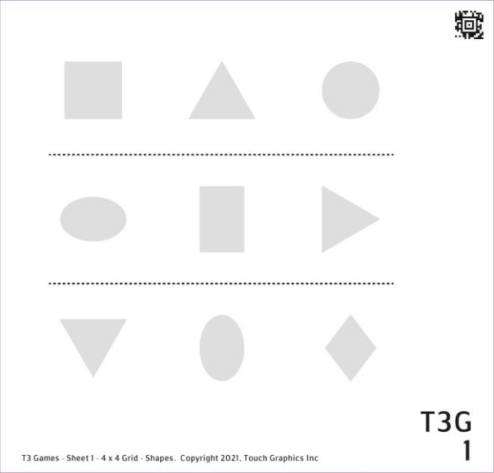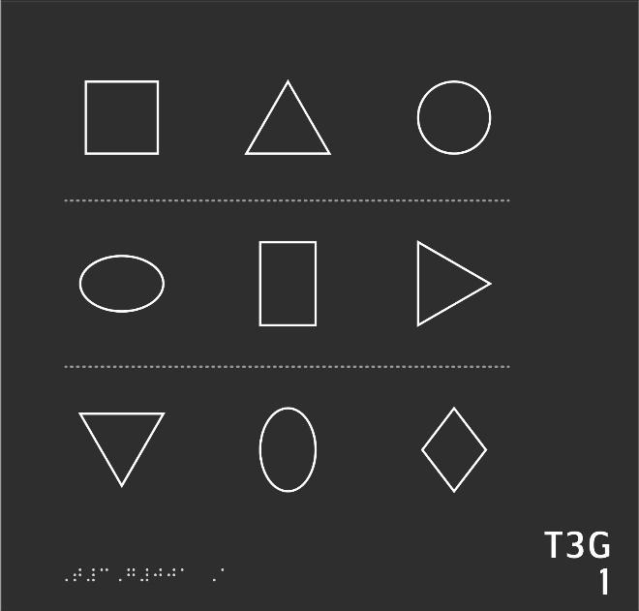

- Find a circle in the top row and press and hold on it lightly with one finger.
- Now, please press the oval in the second row.
- Can you find a triangle in the second row and press on it?
- Find a diamond in the last row.
- Can you find a square somewhere on the sheet?
- Now can you find a rectangle?
- Can you press the shape to the right of the rectangle?
- How about the shape directly below the rectangle? Can you press it?
- Can you identify the shape in between the square and circle?
- Now press all the shapes without corners.
- Can you find all the shapes with three sides?
- Finally, please press all the shapes with four corners.

1 To the Teacher SHAPES

Sheet Description and Objectives
This sheet has nine shapes arranged in a 3x3 grid. Triangles and ovals have varied orientations. There are dashed separator lines.

Student will identify shapes, will find shapes by number of sides and corners, and use left/right orientation and row numbers to find elements.

Vocabulary
Square, triangle, circle, oval, rectangle, diamond, row, horizontal, top, middle, bottom, corner, side, second row, last, between

Teaching Strategies
- Student will need practice with “press and hold on it lightly with one finger.” The selection is triggered by having only one point of contact - the other fingers are not touching the page.
- Work to fine tune how making a selection works so the student doesn’t exert effort pressing down. Student could practice this movement on the table with left and right hand.
- Encourage the reader to select an occasional incorrect answer just to see how the program responds.
- As always, encourage the reader to use both hands to explore, then to use one or more fingers to look at details.
- Discuss directionality of the triangles and ovals.
- Experienced tactile readers as well as beginners need to complete this sheet to get vocabulary and procedures established. It will be easy for many readers, but is intended as a get-acquainted activity.

2 Questions FILLS
Level: Beginner

This is a grid of shapes of different textures. There are 15 questions on this sheet, worth a total of 40 points. Explore the graphic with both hands. Press on any shape with one finger to hear its name. Swipe to the right when you are ready to play the game.

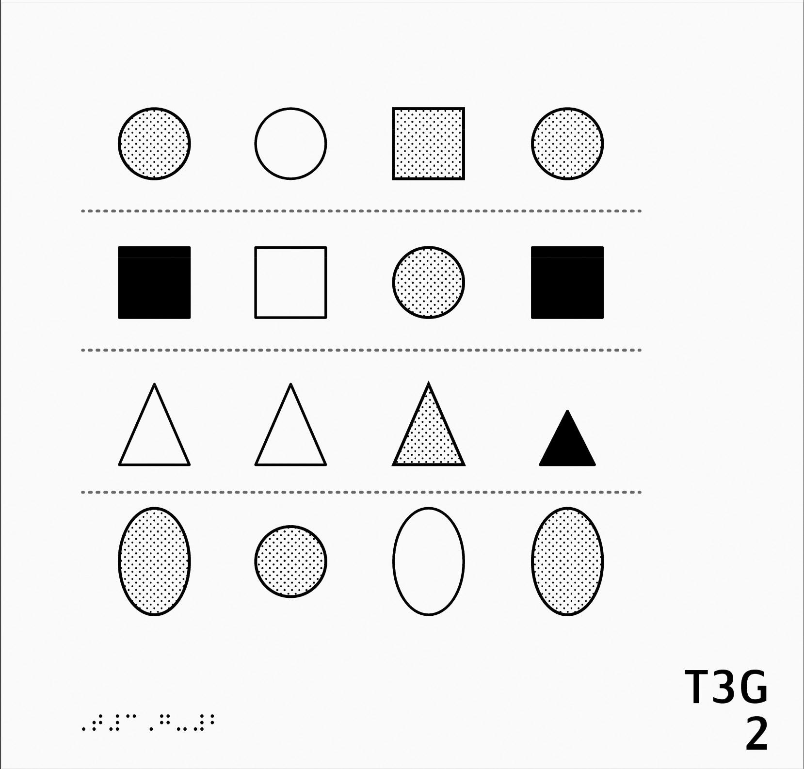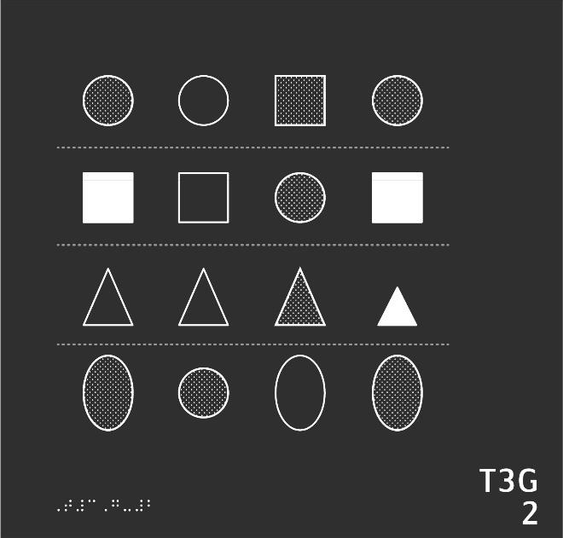

- Find the textured circle near the upper left corner and press it with one finger.
- Now, find another textured circle in the top row.
- Please find the filled square at the beginning of the second row.
- Now, find the matching filled square in the second row.
- Press with one finger on the empty triangle at the beginning of the third row.
- Find the matching triangle in the third row.
- Now, press with one finger on the textured oval at the beginning of row 4.
- Please find the matching oval in the fourth row.
- If you can find all the circles on this entire page you can earn 5 more points! Don't be fooled by texture.
- Collect more points by identifying all the squares.
- How many triangles can you find? Press each one. Don't let size fool you.
- Let's identify all the ovals.
- Let's focus on the interior area of each shape. Can you press each of the three filled shapes on this page?
- Search for all five empty shapes.
- Last question, worth up to eight points, can you identify all of the textured shapes on this page?

2 To the Teacher FILLS

Sheet Description and Objectives
This sheet has sixteen shapes in a 4x4 grid. Fills/textures are introduced as well as solid versus outlined shapes.

Student will identify shapes, will identify filled empty and textured shapes, will use left/right orientation and row numbers, and will match shapes and textures.

Vocabulary
Circle, square, triangle, oval, textured, filled, empty, first through fourth rows, page corners, upper, lower

Teaching Strategies
- Encourage the reader to figure out an efficient searching system to use consistently.
- Have student identify the separator lines.
- It may be helpful to use one hand or finger as a placeholder while looking for a matching shape on another line with the other hand.

3 Questions LINES
Level: Intermediate

This is a grid of lines. There are 10 questions on this sheet, worth a total of 20 points. Explore the graphic with both hands. Press on any shape with one finger to hear its name. Swipe to the right when you are ready to play the game.

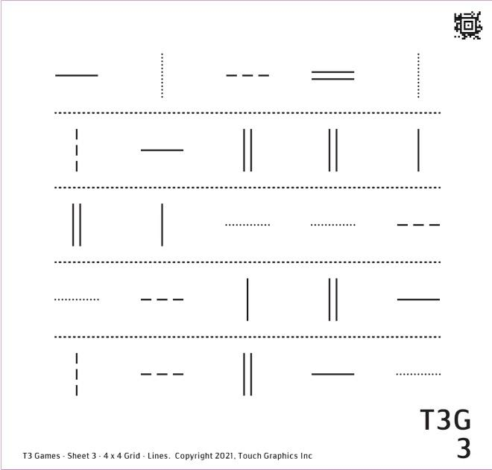

- Please find a vertical dotted line in the top right corner and press it with one finger.
- Can you find another vertical dotted line in the top row?
- Find a dashed line in the first row.
- Let's go to row 2. There is only one horizontal line in this row. Can you find it?
- In the second row, two of the lines are identical. Can you press on the two lines that match?
- Look at the lines at the beginning of each row. Two of these lines match. Can you find them?
- Can you find all four matching horizontal solid lines on this sheet? Press each one.
- Please find all four horizontal dotted lines on this sheet.
- There is only one horizontal double line on the whole sheet. Can you find it?
- Finally, find all the vertical solid lines on this sheet.

3 To the Teacher LINES

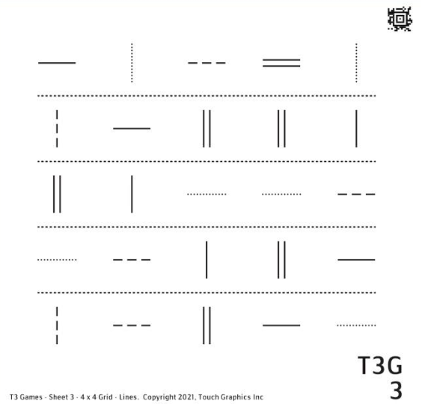

Sheet Description and Objectives
This sheet presents twenty five horizontal and vertical line types in five rows. Lines are solid, dotted, and dashed and also single and double. There are dashed separator lines.

Student will identify line types, use left/right top/bottom orientation, identify rows by number, and find matching lines.

Vocabulary
Line styles include straight/smooth, dotted/rough/bumpy, dashed, double. Direction of lines includes horizontal and vertical.

Teaching Strategies
- Encourage student to use both hands to get a general idea about what’s on the page. This is a skill that will be used throughout school and beyond.
- Noticing the layout is important. Bring attention to the grid or array as it is often called in school.
- Student could identify the number of rows
- An efficient search pattern on this type of page would be to use left to right, top to bottom hand movements
- In later games, the reader will begin to attach meaning to each line style. Ask the reader if any of the lines might easily symbolize an important meaning. What would the reader use each line to symbolize?

4 Questions POINTS
Level: Advanced

This is a grid of point symbols. There are 13 questions on this sheet, worth a total of 30 points. Explore the graphic with both hands. Press on any shape with one finger to hear its name. Swipe to the right when you are ready to play the game.

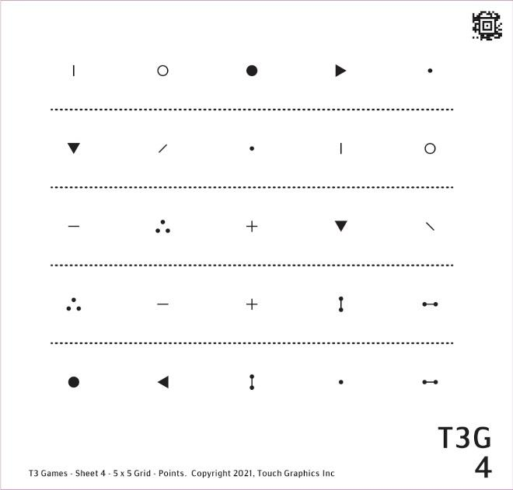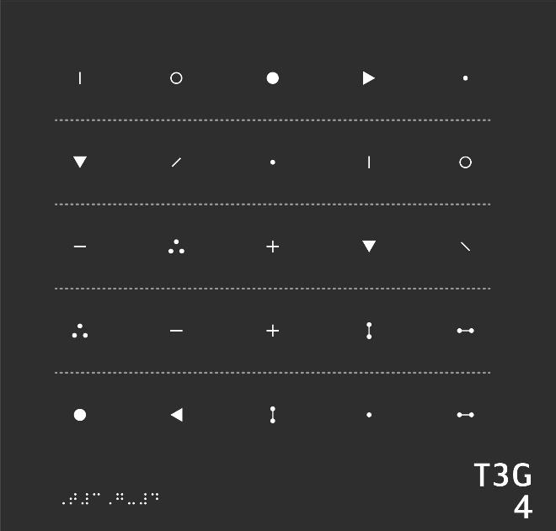

- Please find an empty circle in the first row and press it.
- Can you find another empty circle on this sheet?
- Find two vertical lines and press each one. Hint: look in the top rows.
- Can you find four filled triangles? Don't be fooled by orientation.
- There are two dots in the top row. Press the larger one.
- Can you find another large dot on this sheet?
- Now press all the small dots on this sheet. Hint: there are three in total.
- Can you find two plus signs? Hint: there's one in the center of the grid.
- Identify two triangles pointing down.
- Can you find a group of three dots in the shape of a triangle? There are two of these groups on the sheet. Press on each one.
- Can you find four dumbbells, regardless of orientation? Hint: there's one in the bottom right.
- How many lines can you find, regardless of orientation?
- Can you press the smallest symbol in the last row?

4 To the Teacher POINTS

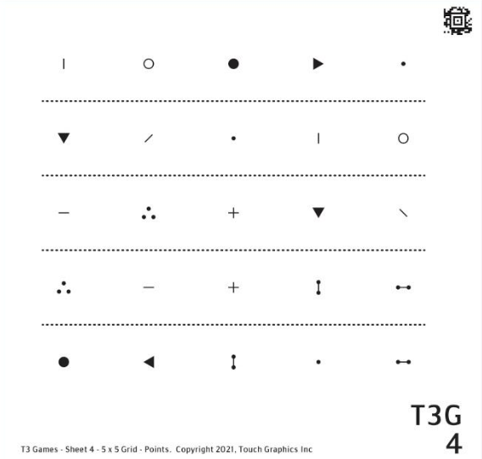

Sheet Description and Objectives
This sheet presents 25 point symbols arranged in five rows. Point symbols include empty circles, small lines, filled triangles, large dots, small dots, plus signs, 3 dots in the shape of a triangle, and dumbbells. Orientation of symbols changes.

Student will identify several point symbols, find the same symbol in varied orientation, will navigate by row numbers and will scan to find multiples of the same element.

Vocabulary
Empty circles, small lines, filled triangles, large dots, small dots, plus signs, 3 dots in shape of a triangle, dumbbells, filled, empty, large, small, orientation

Teaching Strategies
- Encourage using both hands to explore the whole page before focusing on details.
- Small equilateral triangles pointing down or to the side may be difficult to distinguish. Students may need practice with accurate vertical and horizontal motions when feeling where the triangle is pointing.
- A small plus sign may not always feel like two intersecting lines. Explore and explain further if needed.
- Point symbols are important and quick recognition is important as they will be used in many applications in school and beyond. For added experience, provide larger graphics and manipulatives of the symbols. A manipulative can help student explore recognizing a symbol even when it is rotated.
- Explore other activities to recreate symbols including drawing with tactile drawing tools.

5 Questions FACES
Level: Expert

This is a grid of faces. There are 19 questions on this sheet, worth a total of 25 points. Explore the graphic with both hands. Press on any shape with one finger to hear its name. Swipe to the right when you are ready to play the game.

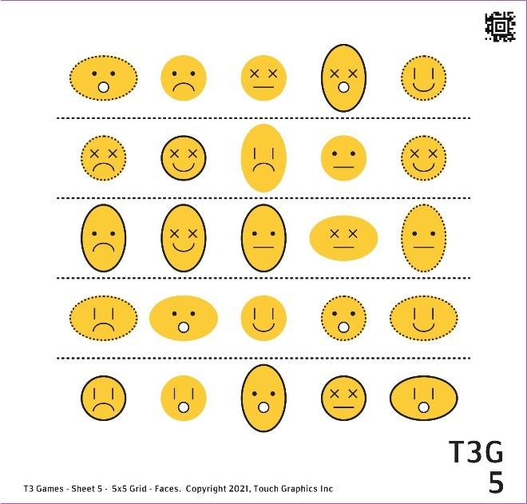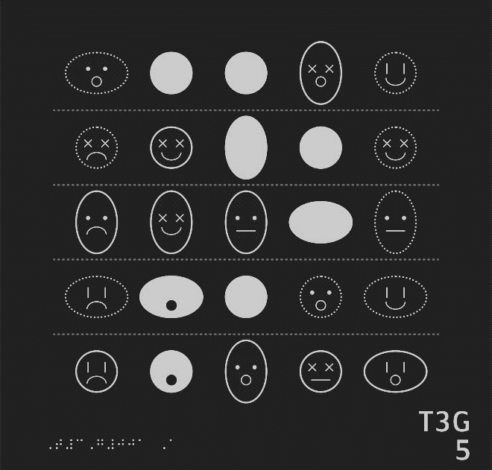
- Find a smiley face in the first row. Its mouth is curved up at the edges.
- Now can you find a sad face in the top row? Its mouth is curved down at the edges.
- There are two surprised faces in the first row, with O shaped mouths. Can you press each one?
- Now find the bored face in the top row, with a straight line for a mouth.
- Let's move on to the second row. There is one face with dots for eyes. Can you find it?
- Find the face with vertical lines for eyes in row 2.
- Now press all the faces in the second row with x's for eyes.
- Let's go to row 3. Can you find the filled face that is raised above the others?
- Find an empty face in the third row with a solid outline.
- Now find the textured faces in row 3.
- Can you identify the face in row 3 that is empty with a dotted outline?
- Let's skip all the way down to the final row. Three of the faces are circular. Can you press them?
- Press the widest face in the bottom row.
- Press the tallest face in the bottom row.
- There is only one happy filled face on this sheet. Can you find it?
- Can you find a bored textured face?
- Look at the faces in the four corners of the grid. One has different eyes than the others. Can you find it?
- Can you find the textured face furthest to the right?
- Final question. There is one row where all the faces are tall -- except for one wide face. Can you find the wide face that is out of place?

5 To the Teacher FACES

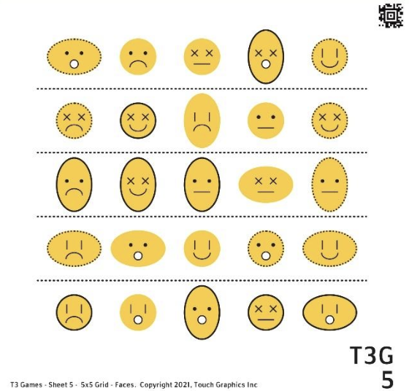

Sheet Description and Objectives
This sheet has 25 emoji-like faces in rows. Lines and points symbols are used as well as fills and textures. Face outlines might be dotted or solid. Faces appear happy, sad, surprised, bored.

Student will distinguish multiple elements, including points, symbols, line types, textures, and fills to identify specific graphic representations of faces and will use details to interpret what emotion is implied.

Vocabulary
Happy, sad, surprised, bored, mouth curved up, mouth curved down, filled, textured, empty, dotted, outline, wide, tall, vertical, horizontal

Teaching Strategies
- See if the reader has an understanding of smiley faces, emoticons, and emojis.
- Discuss how different symbols are used to represent features, such as eyes or mouths.
- In addition to variations of the point symbols, different textures and line styles are used.
- Again remind the reader to develop a system for consistently exploring the graphic. Perhaps it could be looking at the overall shape of the face, then the line style, then the mouth. Let the reader decide the sequence, but encourage using a plan.

Module 2 Variations Introduction

Description and Activities
The five sheets in Module 2 provide more practice with the basic building blocks of tactile graphics: areas, shapes, lines, and textures and fills. The size of shapes are now varied. Graphics are still presented in rows. Sheet 8 introduces arrows and Sheet 9 combines elements and uses new textures which adds complexity. Sheet 10 uses all the elements to view representations of houses with variations in texture and details.

Finding and matching specific targets and elements is still the focus in these activities. Orientation references include right/left, above/below, and going to specific rows. Please see Guide for student learning objectives for each sheet.

Why this is Important
Students are building skills recognizing details and moving around the pages. They are working with more varied and complex details. They are also building a shared vocabulary. Understanding how the lines, textures and symbols represent things in our world requires guidance and repetition.

6 Questions LINE TYPES
Level: Novice

This is a grid of lines. There are 14 questions on this sheet, worth a total of 18 points. Explore the graphic with both hands. Press on any shape with one finger to hear its name. Swipe to the right when you are ready to play the game.

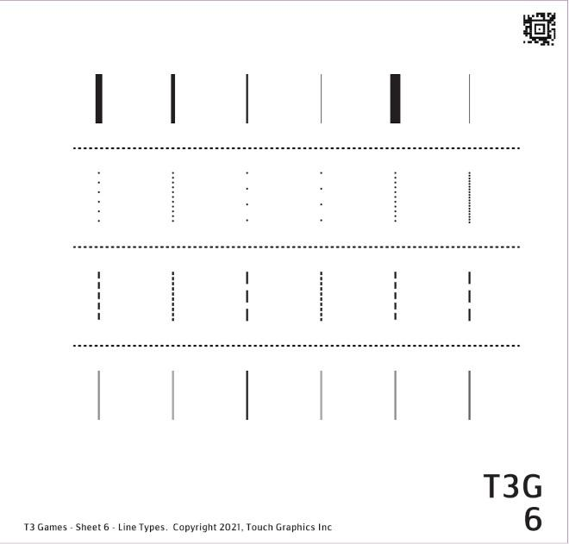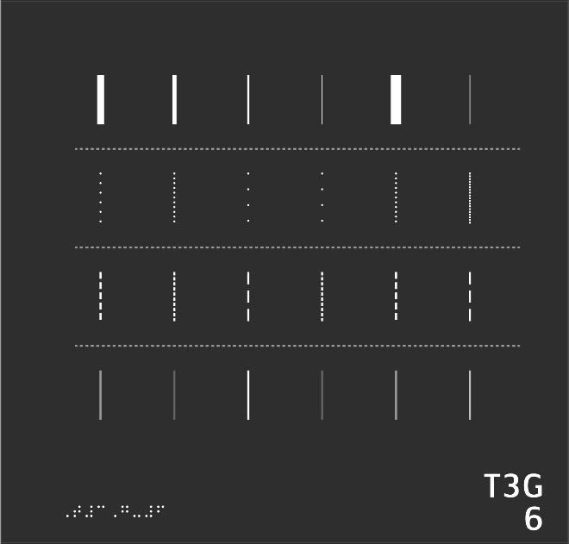

- The lines in row 1 vary in thickness. Can you find the thickest line in the whole row?
- Feel the first and last lines in row 1. Which one is thicker? Press it.
- How about the second line and the last line of row 1? Can you press the thicker line?
- Now find the thinnest lines in all of row 1. Hint: there are two equally thin lines!
- Let's move on to row 2. These lines vary in number of dots. Can you find the line with the most dots?
- Now can you find the lines with the fewest dots? Hint: there are two!
- Feel the first two lines in the row. Which one has more dots? Press it.
- Let's go to row 3. These lines are made up of dashes of different lengths. Feel the first and last lines, and press the one with the shorter dashes.
- Can you find another line that matches the first line in row 3?
- Can you find the line that matches the last line in row 3?
- Can you press the two lines with the shortest dashes in row 3?
- Let's move on to the last row. These lines vary in height. Can you find the highest line?
- Can you find the two lowest lines?
- Which line is higher, the first or last in the row? Press the higher one.

6 To the Teacher LINE TYPES

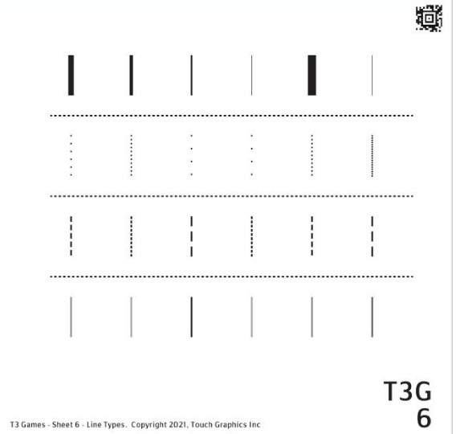

Sheet Description and Objectives
This sheet has 4 rows of 6 vertical lines. Each row has variations of a feature: 1 thickness, 2 number of dots, 3 dashes of different lengths, and 4 variation in height.

Student will find subtle variations in line thickness and height and will compare various dashed and dotted lines.

Vocabulary
Thick, first, last, second, thin, dotted, most, fewest, dashes, longer, shorter, height

Teaching Strategies
- Have reader get the overall layout with two hands first.
- If beneficial, you could explore concept of thick and thin with objects (like thin and thick books that could be laid flat and held sideways to compare width).
- Some of the variations in lines may become more apparent by tracking across the row at a slow and steady speed.
- The densely dotted and densely dashed lines may feel very similar, feeling a fingernail bounce over the dots or dashes may allow student to notice the length in a dash compared to the little bumps in a dotted line.
- Students may interpret line height as how tall the line is in a 2D plane and try to compare length. The lines in row 4 are low and high from the surface of the page up towards the ceiling (like a speed bump). Objects at hand can be used to show this concept.
- Using a fingernail here can also help student perceive height by observing how the nail makes a bigger “jump” as it gets over the higher lines.
- Faint and bold may be words that come to mind when feeling the lines in row 4.

7 Questions SHAPE / SCALE
Level: Beginner

This is a grid of shapes. There are 21 questions on this sheet, worth a total of 30 points. Explore the graphic with both hands. Press on any shape with one finger to hear its name. Swipe to the right when you are ready to play the game.

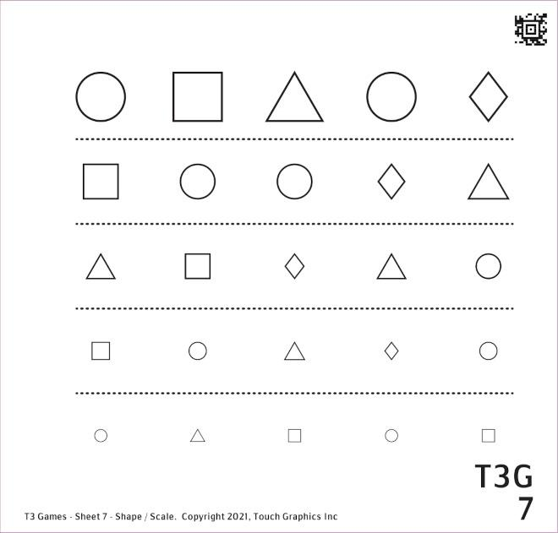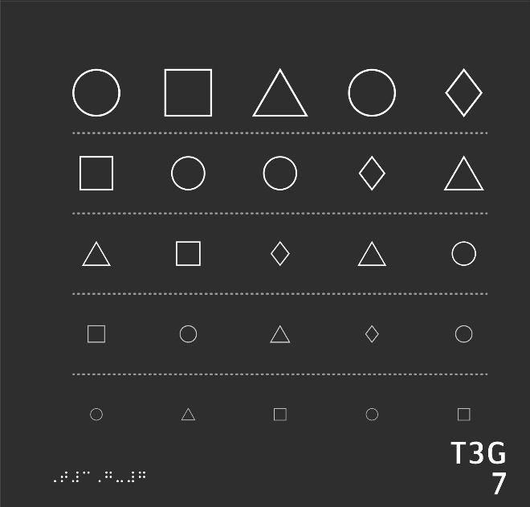

- This game involves finding the right shape as fast as possible. Let's start with row 1. Press every triangle in this row.
- Now press on each square in the first row.
- Can you find every circle in row 1?
- Find every rhombus in the first row.
- Let's move to row 2. Can you find every triangle in this row?
- Which triangle is larger, the one in row 1 or the one in row 2? Press the larger one.
- Please press on every square in row 2.
- Can you find every circle in the second row?
- Press on each rhombus in row 2.
- Let's go to row 3. Press on each triangle you find in the row.
- How many squares can you find in row 3? Press each one.
- Can you find every circle in the third row?
- Find every rhombus in row 3.
- Move to row 4. Can you find every triangle in the row?
- Now press on each square in row 4.
- Can you please find every circle in the fourth row?
- Now find every rhombus in row 4.
- It's time to move to the final row. Press on each triangle you find there.
- Now press on each square in the last row.
- Can you find every circle in the final row?
- Last question: Can you press on every rhombus on the sheet?

7 To the Teacher SHAPE / SCALE

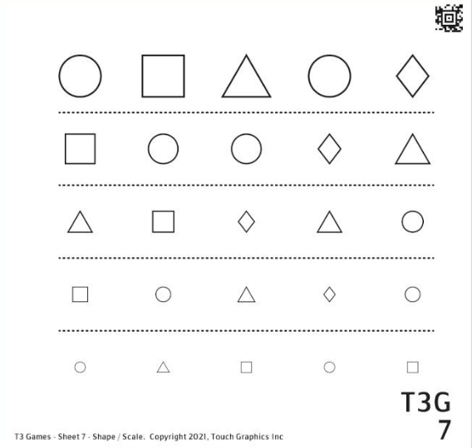

Sheet Description and Objectives
This sheet has 5 rows of 5 shapes. Sheet has 4 shapes: circle, square, triangle, and rhombus. All shapes maintain the same orientation. In each row the shapes are a little smaller than those in the row above. There are dashed separator lines between the rows.

Student will identify shapes of different sizes and will use row numbers and first/final for orientation.

Vocabulary
Triangle, square, first row, circle, rhombus, larger, second row, etc., final row

Teaching Strategies
- Have student notice the layout of the page.
- This page encourages speed with finding these shapes that they have seen on previous sheets.
- Sheet 1 referred to a diamond shape. This sheet uses the term rhombus which is the label that will typically be used in geometry lessons.
- As shape size changes, student may need to alter hand and finger position. Largest shapes may be recognized with multiple flat fingers. The smallest shapes may be perceived with just the tip of one finger. Explore the various ways hands and fingers can be used to recognize the shapes.

8 Questions ARROWS
Level: Intermediate

This is a grid of arrows. There are 20 questions on this sheet, worth a total of 27 points. Explore the graphic with both hands. Press on any shape with one finger to hear its name. Swipe to the right when you are ready to play the game.

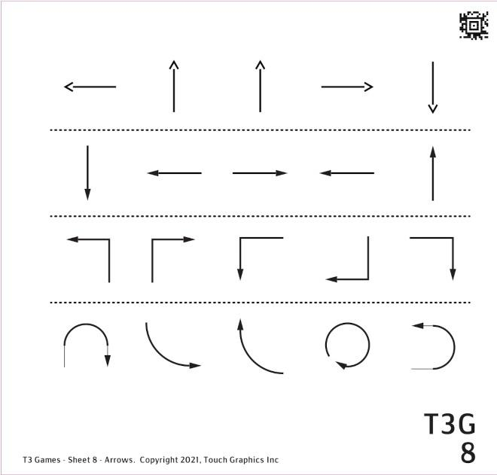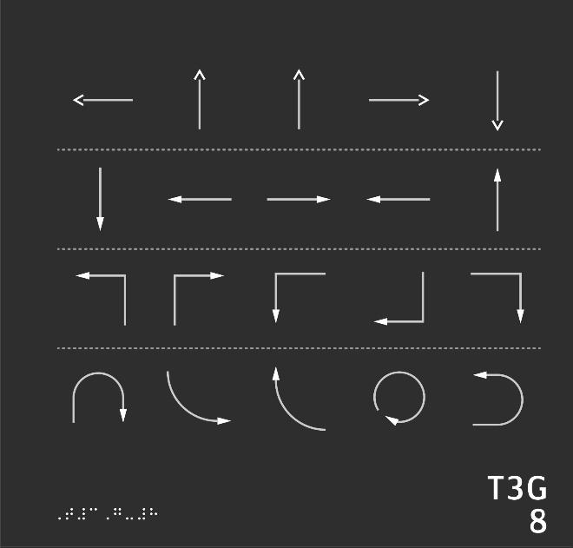

- Let's start with row 1. Can you find two identical arrows in this row? Press on each one.
- There is an arrow in the first row with its tip pointing left. Can you find it?
- Now can you find an arrow in the first row pointing to the right?
- You already found an arrow in row 1 pointing right. Follow that arrow. What is it pointing to?
- You already found an arrow in row 1 pointing down. Follow it. What is it pointing to?
- This second row contains more arrows. Notice that the arrow heads are solid instead of open. Can you search row 2 for an arrow pointing down?
- Can you press all the vertical arrows in row 2?
- Can you find two matching arrows in row 2?
- Now, can you press the arrow in row 2 that is in between the matching pair?
- Let's move to row 3. This row contains arrows that make a sharp turn. For example, the first arrow in the row points up, then turns to the left. Can you press it?
- Now can you find an arrow in row 3 pointing down and to the left?
- There's only one arrow in row 3 with a tip pointing right. Can you find it?
- Can you find two arrows in row 3 with tips pointing down? Hint: they may not be identical.
- Let's move to the final row. This row contains curved arrows. Can you find an arrow that forms a circle?
- Like the angled arrows in row 3, some of the curved arrows in row 4 start pointing one direction and end up in another. Can you find an arrow in row 4 that curves to the left then up?
- How about an arrow in the final row that curves down and to the right?
- Follow the arrow you just found. What is it pointing to?
- Some arrows make a u-shaped turn. For an example, find the first arrow in row 4 and press on it.
- Can you find another arrow in the final row that makes a u-shape?
- Final challenge: Can you find all the arrows on this page with tips pointing straight up? Hint: there are 4.

8 To the Teacher ARROWS

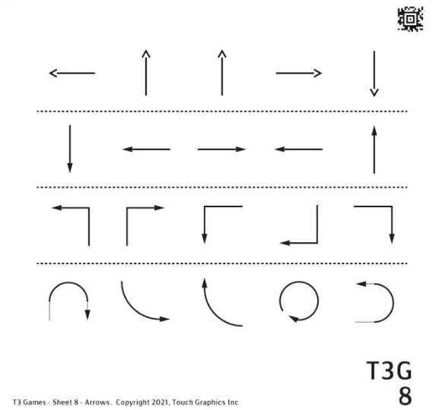

Sheet Description and Objectives
This sheet of arrows introduces lines with points. The first line has “open” points (an open V at the end of the line) and the other 3 lines have “solid” points (small solid triangles). The arrows in row 3 make a sharp turn (90 degrees) and the arrows in row 4 are curved or make a u-turn or form a circle.

Student will identify several variations of arrows and determine direction they are pointing, will use left/right/up/down orientation, and will find horizontal/vertical arrows.

Vocabulary
Identical, first row, tip pointing left and right, pointing up and down, solid and open arrow heads, vertical and horizontal arrows, sharp turn, angled and curved arrows, u-shaped arrows

Teaching Strategies
- Have the student describe the whole sheet
- Arrows are an essential element of tactile graphics. Has the student encountered them before?
- Why is the u-shaped arrow called that?
- All the arrows in row 4 are curved but we can use more specific descriptions (u-shaped and circle- shaped).
- Does the student know where they might see arrows like these in graphics? (maps, diagrams with labels, recycling logo, water cycle diagram)
- Can student describe which way the arrows that change directions start out and how they change? (starts going to the right, curves up and and ends pointing to the left)
- Is the student familiar with the u-turn symbol and what that means when walking or riding in a car?

9 Questions SHAPE / TEXTURE
Level: Advanced

This is a grid of textured shapes. There are 20 questions on this sheet, worth a total of 25 points. Explore the graphic with both hands. Press on any shape with one finger to hear its name. Swipe to the right when you are ready to play the game.

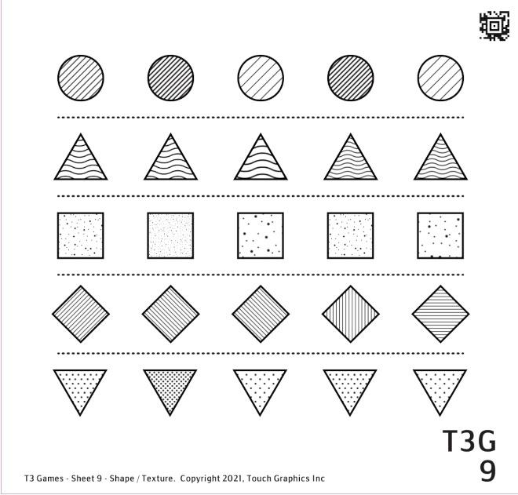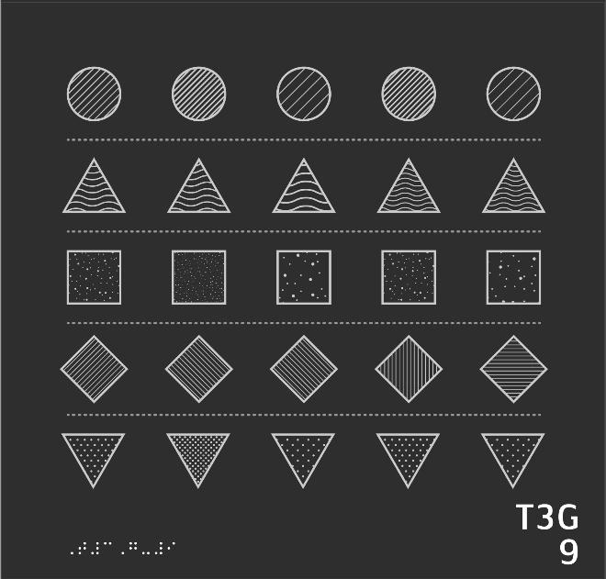

- Go to the first row and feel the first and second circles. Which circle has denser lines? Press it.
- How about the first and third circles in the top row? Press the circle with denser lines.
- Can you find another circle that matches the third circle in the top row?
- Please find the circles with the densest lines in all of row 1. Hint: there are two!
- Let's move to row 2. Feel the last triangle in the row as well as the third or middle triangle in the row. Which one has the denser, finer texture?
- How about the first and last triangles in the second row? Which has the denser waves?
- Can you find another triangle in the second row that is most similar in texture to the first triangle?
- Which triangle has the sparsest, or coarsest, waves in the row?
- Go to row 3. Which square is rougher and denser: the first, or the second?
- How about the first and last squares in the row? Which is rougher? Press it.
- Here's a challenge: can you press all the squares that are rougher than the last square in the row?
- Now let's move on to row 4. Can you find a diamond made of horizontal lines?
- Press on a diamond in the fourth row made of vertical lines.
- Can you find two diamonds with identical textures in row 4?
- Can you find a diamond in row 4 with lines going the same direction as the circles in row 1?
- Time to explore the final row. Which triangle has denser dots: the first, or the second?
- Which triangle has denser dots: the first in the row, or the third?
- Press the triangle with the densest dots in all of row 5.
- Can you find another triangle that matches the first triangle in the row?
- Finally, can you press all the triangles less dense than the first triangle in the row?

9 To the Teacher SHAPE / TEXTURE

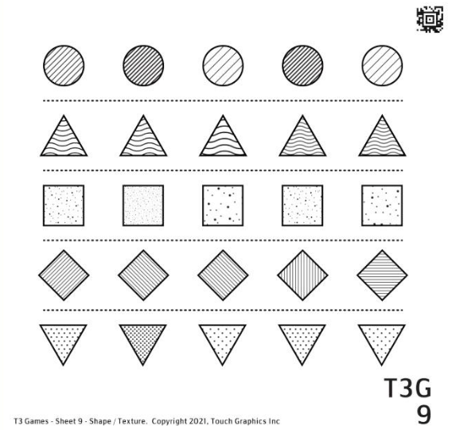

Sheet Description and Objectives
This sheet has 5 rows of five shapes. There is a dashed line separating the rows. Each shape has a texture. All the shapes are the same size

Student will find subtle variations in texture, will find alike and different textures, will use vocabulary to describe dense, fine, sparse, coarse, rough, and will use row numbers and first/second for orientation.

Vocabulary
Matching, identical, denser and finer (texture, lines, dots, waves), sparsest or coarsest waves, rougher, horizontal and vertical lines, slant up, circle, triangle, square, diamond

Teaching Strategies
- Have student describe the layout of the whole page.
- If student has any difficulty determining horizontal or vertical line texture, using a fingernail in a grove can help make it clear.
- Some of the textures are made up of slanted lines. If the student has difficultly determining vertical lines from slanted lines, they can be compared to the horizontal divider lines. Vertical lines would meet the horizontal line perpendicularly.
- For the dot textures that are identified as levels of roughness, the student may notice if their finger tip is still that they feel just 2 or 3 dots at one time with a less dense texture. With denser textures, you can’t count individual dots, it just feels rougher.

10 Questions HOUSES
Level: Expert

This is a grid of houses. There are 19 questions on this sheet, worth a total of 25 points. Explore the graphic with both hands. Press on any shape with one finger to hear its name. Swipe to the right when you are ready to play the game.

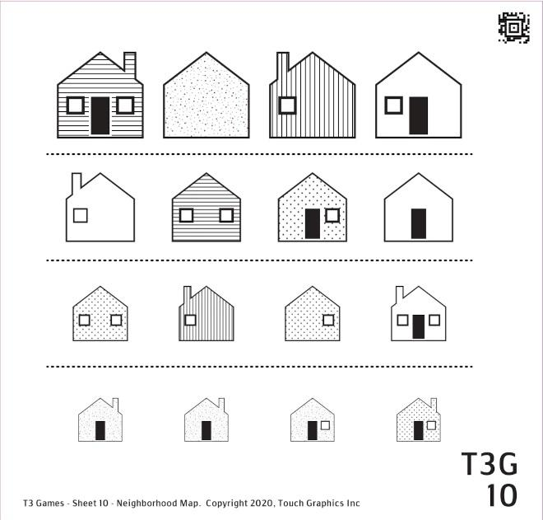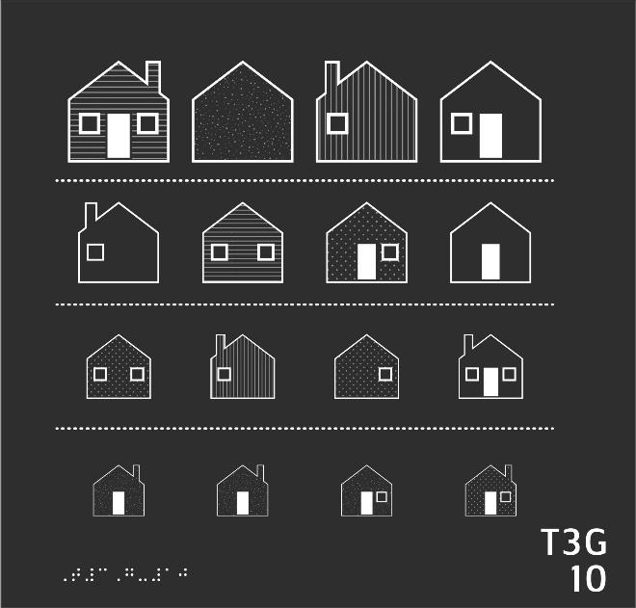

- Start by finding and pressing the last house in the first row.
- Feel the outline of the last house. Can you find another house in the top row with the same shape?
- Can you find a house in the first row with a chimney on the left side?
- Let's find a house in the top row with a rough texture.
- Find a pair of houses with horizontal stripes. Hint: start at the top of the sheet. Don't be fooled by doors or windows in the way.
- Which house with horizontal stripes is smaller? Press it.
- Let's continue exploring row 2. Can you find the only house in row 2 with a dotted texture?
- Can you find two houses in row 2 that have a raised door? Don't be fooled by texture.
- Now find the house in row 2 with the most windows. Don't be fooled by the doors.
- Can you find a house in the second row with no windows?
- Let's move to the final row. Two of these houses are identical. Can you press each one?
- There is one texture in the final row that does not match the others. Can you press it?
- Let's explore the whole sheet. Can you find the dotted house with the most windows?
- How about the only dotted house on the sheet with a chimney? Can you press it?
- Can you find the only striped house with no chimney?
- There are four houses on this sheet with both a left and a right window. Can you press on each of the four?
- Find a house with no windows and no doors.
- Now can you find a house with a door but no chimney and no windows?
- Final question: There is one row in which only one house has a chimney. Can you press that house?

10 To the Teacher HOUSES

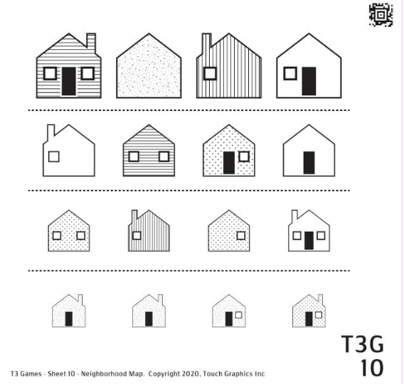

Sheet Description and Objectives
This sheets show representations of houses that have various textures and features (windows, door, chimney). There are 4 rows of 4 houses. The houses get smaller on each row.

Student will find subtle variations in texture, will compare similar items and determine whether they match, and will use row numbers, left/right and first/second for orientation.

Vocabulary
Identical, matching, rough texture, chimney, horizontal stripes, vertical stripes, smaller/larger, dotted texture, raised area

Teaching Strategies
- While getting an overview of page, did the student notice the differences in the houses?
- This page requires the student to discriminate fine details in the graphic. Using explore mode before starting activity may be helpful.
- Many questions have more than one element that the student needs to keep track of to find the answer. Student may need to have directions repeated.

Module 3 Categories Introduction

Description and Activities
In this module representations of real plants, animals, and objects are shown. Sheets progress in complexity starting with leaves where leaf shape and vein structure are salient features. The student will have experience with objects represented on the first two sheets, leaves and fruit can be held in one or two hands. Sharks and insects are also presented which is a different experience for the learner. It is difficult for the tactile learner to get a clear picture of very large and very small (or dangerous or fragile) things that cannot be explored with the hands. The last page with bicycles incorporates many fine details and more complex descriptions and distinctions.
For a younger student or someone inexperienced with tactile graphics, what they feel will not immediately convey what that object is. Discussions about student’s experience touching all or part of any of these representations of real objects are important (a student can hold an apple and know the shape but maybe they have only felt the skin of a shark or large fish at an aquarium). Discussing why a recognizable graphic has certain details is vital. Early drawings of children (blind or sighted) typically include stick figures with four simple lines for arms and legs or a cat with a round face and pointy ears. These are the basic salient features that are easily identified tactilely and visually.
Teachers know their students. There are times when you might wait for a student to explore and share ideas about a new graphic they are looking at. If the student does not have the background to understand a graphic, don’t quiz them. This can be discouraging. Tell your student what they are seeing. When the student is asking over and over, “what’s that?” applaud their curiosity. Your details and guidance in interpreting the picture will help build their foundation in understanding the complex shapes, lines, and textures under their fingers. Please see Guide for student learning objectives for each sheet.

Why this is Important
In learning to read tactile graphics and make their own tactile drawings, students use their experience, making meaning from drawing and pictures is a shared experience and is a progression from decoding and labeling simple shapes, lines, areas, and textures to using those elements to represent more complex real and imagined things. Observation, categorizing, comparing and contrasting real objects is an important part of a student’s curriculum that will apply to understanding and using tactile graphics.

11 Questions LEAVES
Level: Novice

This sheet contains leaves. There are 12 questions on this sheet, worth a total of 20 points. Explore the graphic with both hands. Press on any leaf with one finger to hear its description. Swipe to the right when you are ready to play the game.

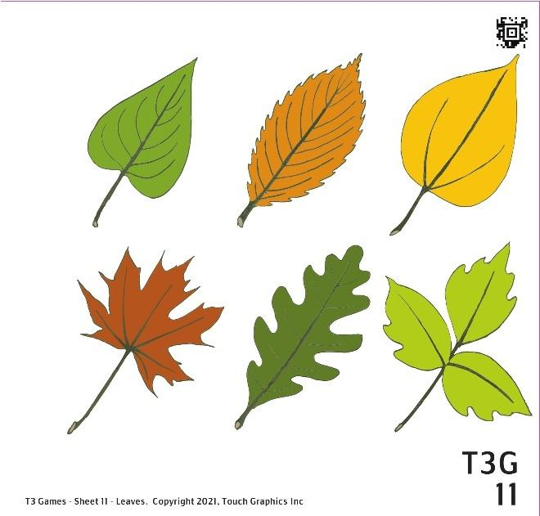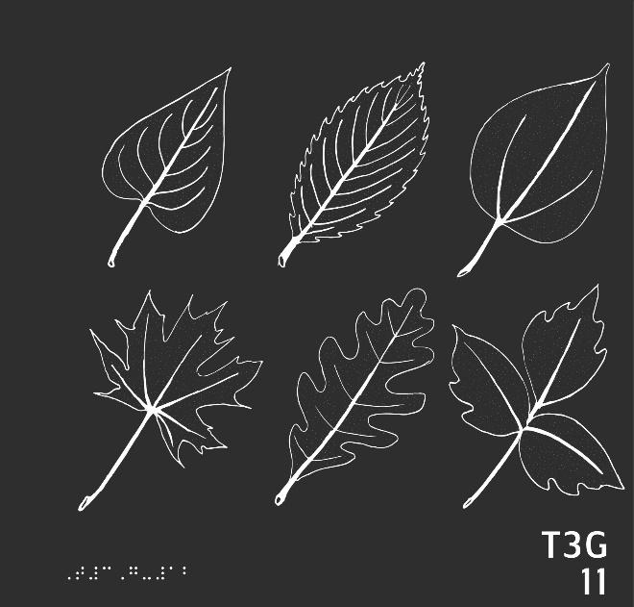

- Let's get familiar with the six leaves on this sheet. Find each leaf, and press and hold on it with one finger.
- Some leaves can be identified by their edges. An elm leaf has toothed edges, like a saw. Find an elm leaf, feel its edges, and press it to move on.
- Some leaves have smooth edges the entire way around. Can you find two leaves that have completely smooth edges?
- An oak leaf is divided into rounded lobes. They curve in and out as you trace the edges of the leaf. Can you find the oak leaf, feel its edges, and press it to move on?
- You can tell a maple leaf apart because of its star-like shape and its jagged, pointy edges. Feel the maple leaf. Press it to move on.
- There's a saying that goes: "leaves of three, let them be!" Poison ivy plants are made of groups of three little leaves, called leaflets. Can you find the poison ivy on this sheet?
- Each leaf on this sheet has a stem, which connects to the base of the leaf. Can you find the leaf in the top row with the shortest stem?
- Now can you find the leaf in the bottom row with the longest stem?
- Can you find the leaf on this sheet with the most veins on its surface?
- Some veins spread out from a single point at the base of the leaf. Can you find two leaves with this vein pattern? Hint: there is one in each row.
- Sometimes, the veins of the leaf connect to a central line. The lilac leaf in the top left is one example. Can you find two more leaves on this sheet with veins like the lilac?
- Finally, on this sheet, there is one single leaf that has exactly three veins on it. Can you find that leaf?

11 To the Teacher LEAVES

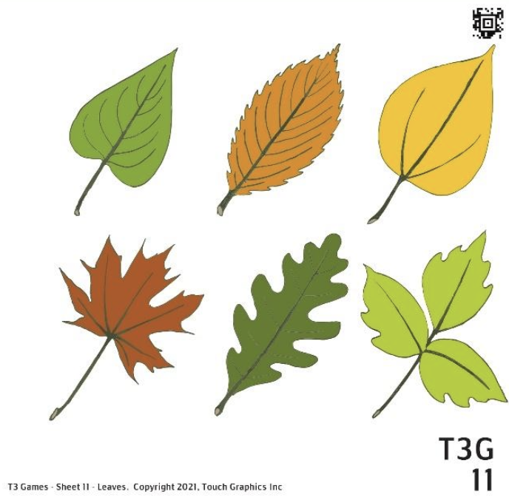

Sheet Description and Objectives
This sheet shows six leaves with different shapes, structures and areas with different textures, providing the reader the opportunity for more practice discriminating features of similar items. The leaves are lilac, elm, aspen, maple, oak, and poison ivy. Distinguishing features are toothed and lobed edges and type of vein structure.

Student will identify complex line types that represent leaf edges such as toothed and lobed, use vocabulary to describe characteristics of leaves (and elements of tactile graphics), compare length and quantity, and will identify elements using concepts such as radiating from a single point and along a central line.

Vocabulary
Smooth, heart shaped, stem, veins, curves, toothed, oval, round, pointy, jagged, lobes, notches, base, single point, radiate, central line

Teaching Strategies
- See if the student can identify the number of objects on the sheet using both hands to recognize the perimeter of each leaf. What differences does the student immediately recognize?
- Compare the tactile graphic to real leaves. Discuss similarities and differences.
- Explore and compare the outside edges of each leaf, then the stem and veins of each leaf.

12 Questions FRUIT
Level: Beginner

This sheet contains fruit. There are 15 questions on this sheet, worth a total of 19 points. Explore the graphic with both hands. Press on any fruit with one finger to hear its description. Swipe to the right when you are ready to play the game.

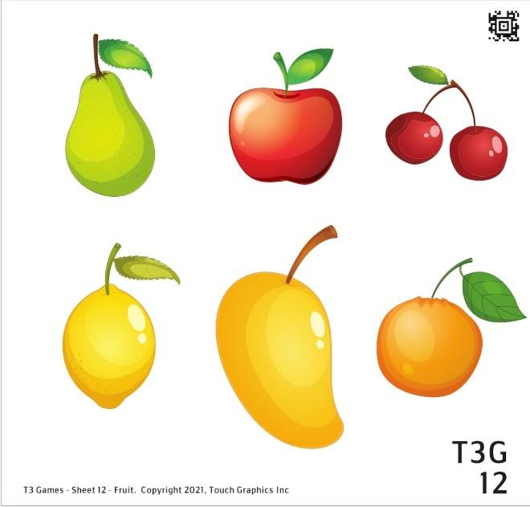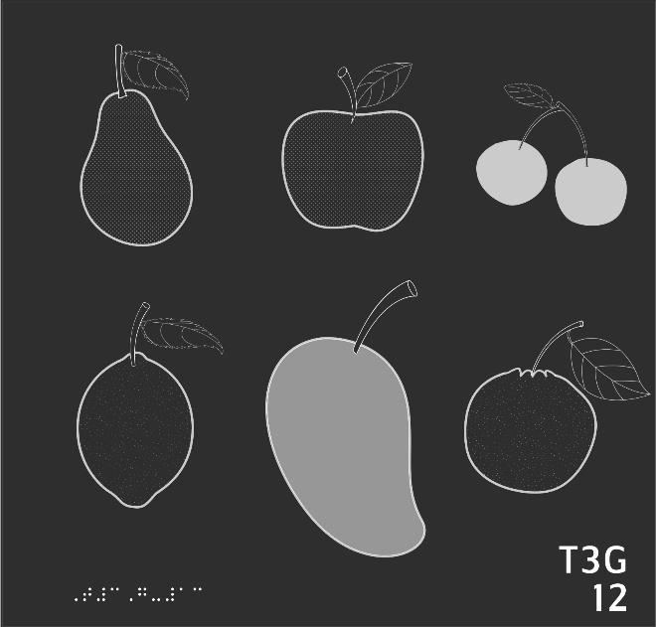

- First, can you find the largest piece of fruit on the sheet? Press and hold on the fruit with one finger.
- What fruit is directly above the mango? Press and hold on it to hear the answer.
- Now, find a fruit to the right of the apple. What do you think it is? Press it to find out.
- Directly below the cherries is a fruit with a rough texture. What could it be? Press to find out.
- A pear is narrower on top than it is on the bottom. Can you find a pear shape on this sheet?
- This pear has a stem on top with a leaf coming off of it. Feel the stem and leaf, and press them to move on.
- There is another fruit on this sheet with the same texture as the pear. Can you find it?
- A lemon is shaped like a circle that tapers at the top and bottom. Can you find a lemon like that on this sheet?
- Can you find another fruit on this sheet with the same texture as the lemon?
- What fruit is in between the lemon and the orange on this sheet? Press it.
- Can you find a pair of cherries on this sheet?
- Two kinds of fruit on this sheet have a smooth texture. Can you find them and press each one?
- There is only one fruit on this sheet that has a stem but no leaf. Can you press that fruit?
- Two fruits on this sheet have leaves with totally smooth edges. Can you press on each?
- Final question. Three fruits on this sheet have leaves with toothed edges. Can you find and press each one?

12 To the Teacher FRUIT

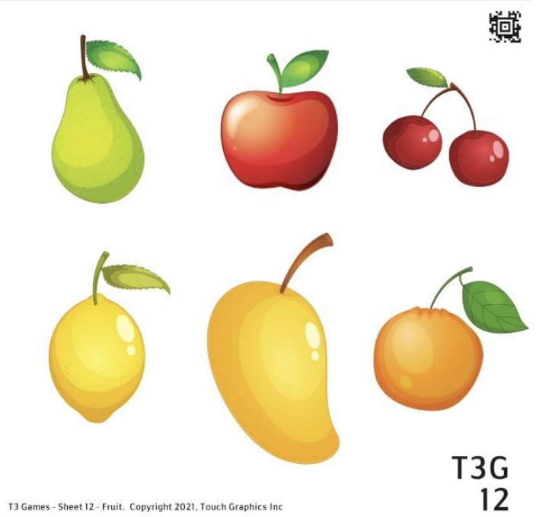

Sheet Description and Objectives
This sheet shows six fruits (pear, apple, cherries, lemon, mango, orange) with different shapes, textures and features. Stems and leaves are shown.
Student will identify complex shapes, find areas with rough and smooth textures, will use left/right/between and top/bottom orientation, will compare and contrast like representations (such as leaves) with unique details but still fit into one category
Vocabulary
Oval, round, rough, rougher, smooth, stem, leaves, veins, texture/fill, smooth/no texture, narrow, pear-shaped
Teaching Strategies
- Have the student use both hands to get an overview of objects on the page before exploring details.
- Compare the tactile graphic to real fruits. Discuss similarities and differences.
- Explore shape of each fruit, features (stems, leaves), textures/fill or outline
- Discuss various sizes of real fruit, discuss with tactile graphics the object may be shown as smaller or larger. Are these fruits “actual size”? Which ones are close?

13 Questions SHARKS
Level: Intermediate

This sheet contains sharks. There are 15 questions on this sheet, worth a total of 15 points. Explore the graphic with both hands. Press on any part of the shark with one finger to hear its description. Swipe to the right when you are ready to play the game.

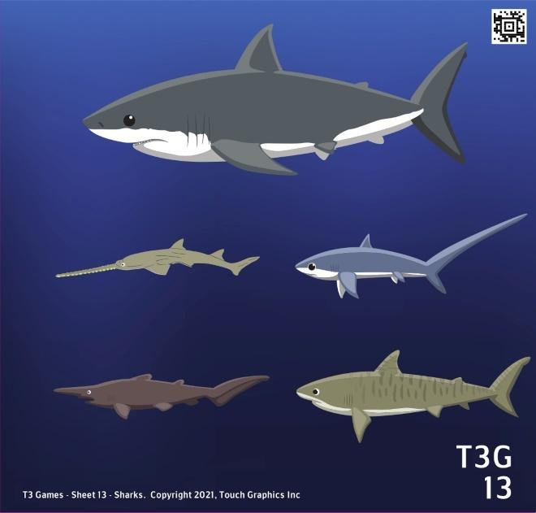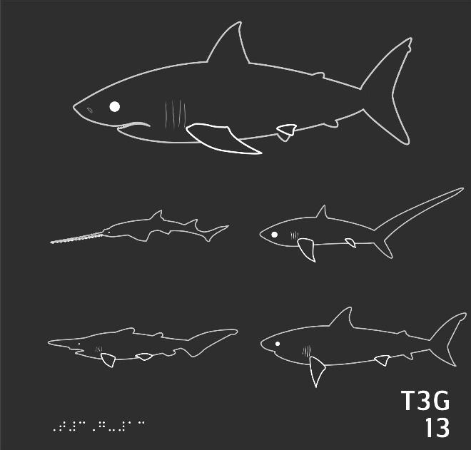

- First, can you find the largest shark on the sheet? Press and hold on it with one finger.
- Sharks have distinctive fins on their backs. Can you find the big fin on the great white shark's back and press it?
- This great white shark is swimming across the screen from right to left. Can you find its face and press on it?
- Please find and press the great white shark's tail fin.
- Feel the belly of the great white shark. Can you find more fins on the belly side? Press the great white to move on.
- Let's move on to the second largest shark on this sheet: a tiger shark. Can you find it?
- Can you find the tail of the tiger shark?
- Can you find the shark on this sheet with the longest snout?
- Can you find a goblin shark swimming directly below the sawshark?
- The goblin shark is named for its unusual snout. Feel it and press it to move on.
- Which shark on this sheet has the longest tail fin?
- Which shark is the smallest?
- Which shark has the largest fin on its back?
- Which shark in this illustration has only one fin on its back?
- Last question. All the sharks on this sheet except for one shark have gills. These feel like small vertical lines on the side of the head. Can you find the one shark who has no gills?

13 To the Teacher SHARKS

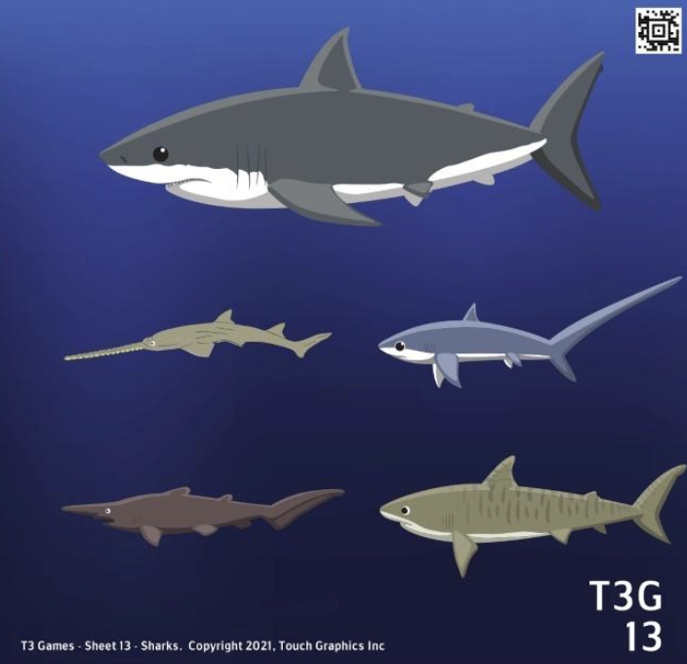

Sheet Description and Objectives
This sheet shows five sharks (great white shark, sawshark, thresher shark, goblin shark, tiger shark). Details of each shark including the nose, tail shape, fin shapes. One shark does not have gills shown.
Student will find large and small items, will compare salient features for similarities and differences, will identify directionality and which way a representation of a shark is facing.
Vocabulary
Side view, fins, gills, back, belly, direction, tail fin, snout
Teaching Strategies
- Unlike the previous two sheets, this sheet shows representations of something too large to hold in the hands. The inexperienced student will likely need orientation to the salient features, e.g., pointy fins along top and bottom, pointy snouts with a dot for the eye.
- Notice that each shark's left eye is an indicator to the direction it is swimming.
- The reader may have experience with toys and models of sharks. Use models if more comparison to 3D manipulative would be beneficial.
- Discuss actual size. Help student get a feel for size by comparing the size of sharks to the table size or length of the room.
- Sharks may have names that relate to physical features. How do you think some of these sharks got their names?

14 Questions INSECTS
Level: Advanced

This sheet contains insects. There are 15 questions on this sheet, worth a total of 20 points. Explore the graphic with both hands. Press on any part of the insect with one finger to hear its description. Swipe to the right when you are ready to play the game.

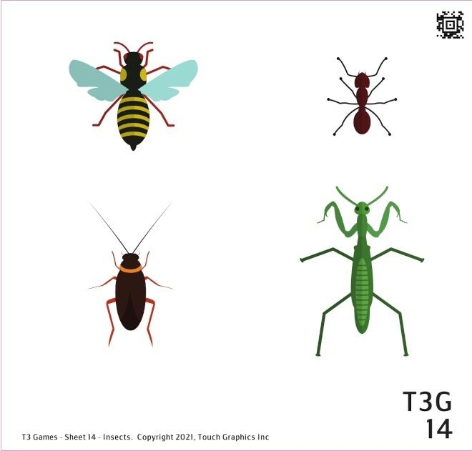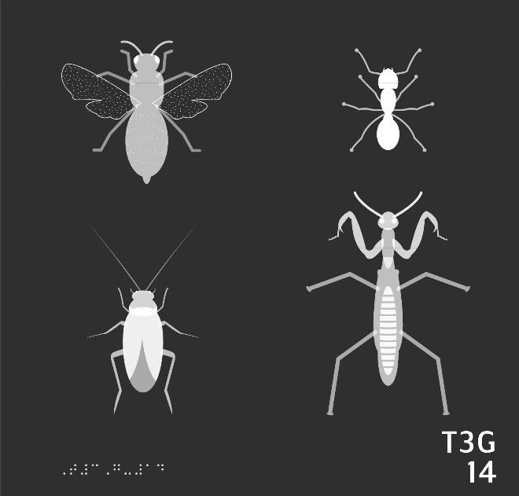
- Feel the insect in the top left corner. What do you think it is? Press it with one finger to hear the answer.
- The bodies of insects, like bees, are divided into three parts. The head. The thorax. And the abdomen. Can you press each of the bee's three body parts?
- This bee has textured wings which are extended to either side of its body. Feel them, and press them to move on.
- There is an insect immediately to the right of the bee. What is it? Make your guess, then press the mysterious insect to hear the answer.
- Feel the ant's head. Can you find and press the two lines pointing away from the head?
- Insects typically have six legs. Please feel the six legs of the ant, then press them to move on.
- Find a big insect below the ant. Press to hear its name.
- Feel the legs of the praying mantis. How are they different from the ant's, or the bee's? Press the legs to hear more.
- There is one more insect on this sheet, to the left of the mantis. What is different about this insect? Press it to hear more.
- Find and press the antennae of the beetle. Are they short or long?
- Can you press the biggest insect on the whole sheet?
- How about the shortest insect?
- Can you press the only insect with its wings out?
- Which of these insects has the longest antennae?
- Last challenge: Can you press the thorax of each insect? Hint: the thorax is the insect's middle section!

14 To the Teacher INSECTS

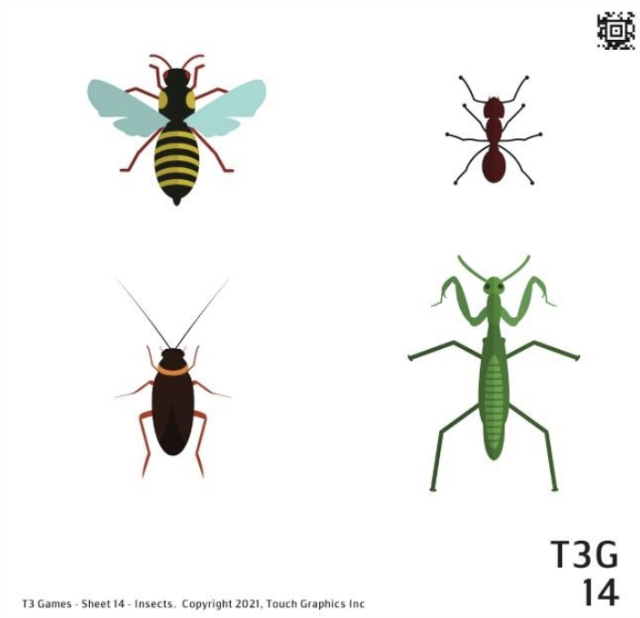

Sheet Description and Objectives
This sheet shows 4 insects (bee, ant beetle, praying mantis). All the insects have three body parts, legs and antennae. These representations are more complex and combine areas with different textures, shapes and lines in each insect.
Student will compare and contrast complex graphic representations, will use right/left and top/bottom orientation, will identify salient features of group examples (antennae, six legs), will count lines and elements, will categorize information and apply that to a related example (find thorax on each insect).
Vocabulary
Antennae/feelers, body of insect, head, thorax, abdomen, wings, legs antenna, sides, extended
Teaching Strategies
- This sheet shows rather small insects that are hard to touch in a detailed way because it would be unsafe or they are too small and fragile. Like the large sharks, it would be hard to build an accurate mental picture from only a few details.
- What does the student initially notice when using both hands to explore the page?
- Does the student recognize these are representations of insects? Would models help the student understand the 2D tactile image?
- There are common or salient features between these insects but there are also differences. How do we know it is still an insect? Compare the insects to the sharks to extend this idea of salient features and categories.
- Which insects can fly? How can you tell?
- Note that the beetle has wings but they are more subtle to the touch than the fly and are not extended.

15 Questions BICYCLES
Level: Expert

This sheet contains bicycles and other ways to move around. There are 20 questions on this sheet, worth a total of 23 points. Explore the graphic with both hands. Press on any bicycle with one finger to hear its description. Swipe to the right when you are ready to play the game.

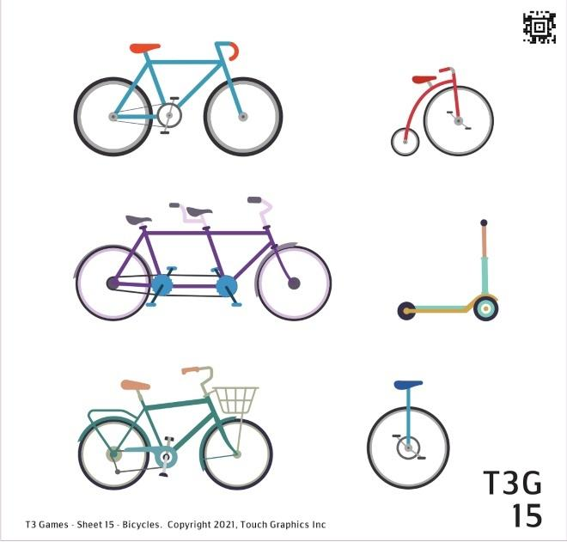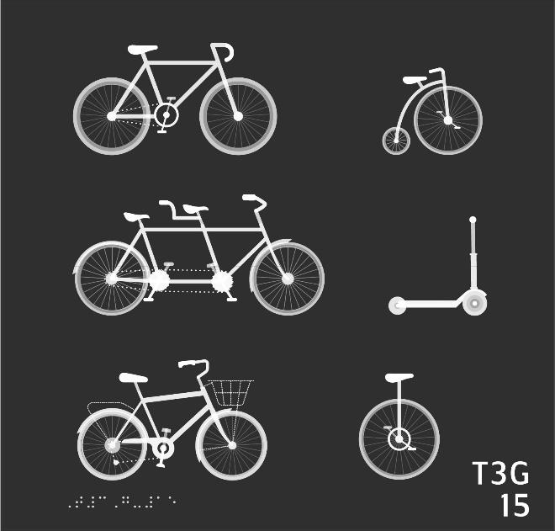

- Let's start with the bicycle in the top left. Find that bicycle and press on it to move on.
- The bicycle you found is shown in a side view. It is facing right. It has two wheels. Can you press on each of the wheels?
- Can you find the handlebar of the bike? Hint: try above the front wheel.
- Now let's find the seat of the bike. Hint: the seat is to the left of the handlebar.
- Let's move on. Can you find another bike in the same row?
- A penny farthing bicycle has a big wheel in front and a little wheel in back. Can you press on each of the wheels of the penny farthing?
- Let's find the handlebar of the penny farthing.
- How about the seat of the penny farthing? Can you press it?
- Now let's find a tandem bicycle. A tandem is made for two people to ride, so it is very long from front to back. Can you find a bike like that below?
- A tandem is unique because it has two seats. Can you find both seats and press on each one?
- Next, let's find a scooter. From the side, a scooter forms an L-shape. Can you find a shape like that on this sheet?
- Like a bike, a scooter has a handlebar. Can you find where the handlebar should be?
- What's directly beneath the scooter on this sheet? Find it, feel it, then press it to hear the answer.
- What is to the left of the unicycle? How many wheels does it have? Press it to hear the answer.
- The bike you found has a basket on it. Can you find the basket?
- Let's scan the whole sheet. Can you find the vehicle with the smallest wheel and press it?
- How about the vehicle with the fewest wheels?
- Can you find a vehicle with no seat?
- What about a vehicle with no handlebar?
- Finally: Can you find the vehicle that is the longest?

15 To the Teacher BICYCLES

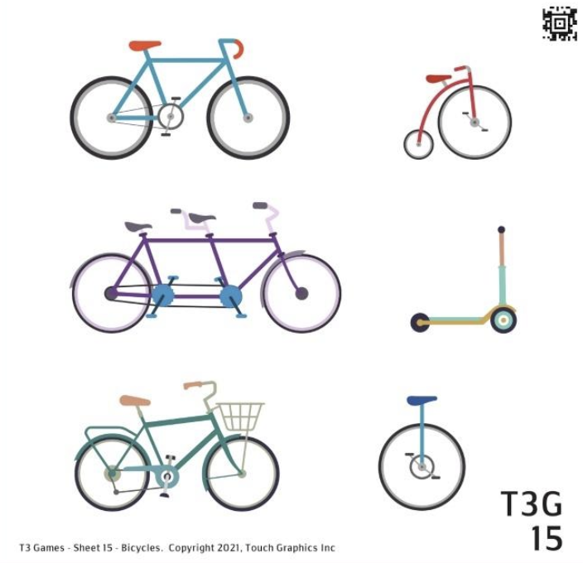

Sheet Description and Objectives
This sheet shows four bicycles, one scooter and one unicycle. There are further distinctions like a penny farthing and a tandem bike. There are many details to compare and contrast like wheels, handlebars, and seats.
Student will find shapes, lines and tactile features as representations of bicycles, will identify similarities and differences between items in the same category, will use right/left and top/bottom orientation, will count elements, will recognize salient, common features of items in a group.
Vocabulary
Bicycle, unicycle, scooter, penny farthing, tandem bicycle, L shape, wheels, handlebars, basket, vehicle, front wheel, back wheel, direction
Teaching Strategies
- Does the student recognize these representations as bicycles?
- Explore the bigger category of vehicles, not all of these vehicles are bicycles. What other categories of vehicles are there?
- What are the salient features of these ways to move around?
- Does the student have any of these at their house? If a bike is available, explore how the side view is represented. Switch perspective or point-of-view - the wheel feels very different if you look from the front.

Module 4 Point-of-View Introduction

Description and Activities
This module presents representations of objects from different points of view or perspective. Other ways to describe this to a student is to imagine a bird’s eye view or top down view. The first sheets present three perspectives like top, side, bottom of things students have handled like a mug and fruit. Pair the sheet showing a shoe from different angles with a real shoe. The pages with a car and turtle present one object from five points of view and explore fine details.

It is important for the student to understand a 2D tactile graphic or picture or photo cannot show all sides at one time. Students need to see how this works by touching one plane or the face of objects and comparing that to tactile graphics. The outline of a toy horse from the side or above is very different. Salient features that make the graphic recognizable in one view may be lost in a different view.

These are the first sheets to combine braille as the views are labeled. Labels are another important component of tactile graphics. When the student initially explores the page, they should key into the braille, reading what it says. It will typically be important information they should review before moving on. Tactile graphics need to make efficient use of the space so any labels have been selected carefully. On these pages, the braille tells the reader the perspective the object is viewed from so the reader gets a head start understanding the representation. Please see Guide for student learning objectives for each sheet.

Why this is Important
Point of view becomes complex as features move out of view or shapes change as vantage point shifts. Three dimensional depth is difficult to represent in a tactile graphic so the reader must know some rules for interpreting an image. Lots of hands-on experiences and descriptive skills will help the student build a strong foundation. Comparing these views to real objects will help the student build this conceptual understanding. Students who have eaten a muffin in a paper liner will quickly understand the difference between the rough irregular top and the smooth round bottom of the muffin. Knowledge gained from those more concrete experiences will eventually apply to graphics and tactile maps of things like a diagram of the butterfly life cycle or neighborhood block. Being able to imagine various points of view and orientations is vital to successful use of tactile graphics.

16 Questions MUG AND MUFFIN
Level: Novice

This sheet shows a coffee mug and a muffin viewed from the side, top, and bottom. There are 12 questions on this sheet, worth a total of 16 points. Explore the graphic with both hands. Press on any shape with one finger to hear its description. Swipe to the right when you are ready to play the game.

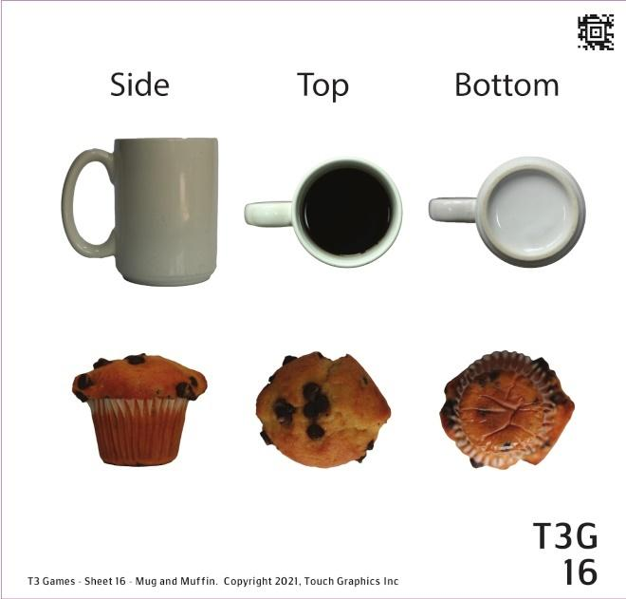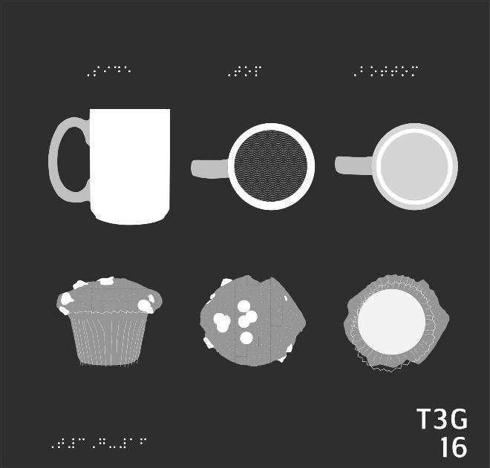

- The top row contains pictures of coffee mugs. The top left picture is a side view. Press and hold on it with one finger to hear more.
- The top middle picture is a coffee mug viewed from above. Feel it and press it to hear more.
- On the far right is a coffee mug viewed from the bottom. Press and hold it to hear more.
- Let's move on to the muffins in the bottom row. Press the side view of a muffin on the far left.
- Can you find the top view of the muffin? Hint: Search for the crumbly texture.
- Now find the bottom view of the muffin.
- Can you find all the muffin liners on this sheet? Press each one.
- Now can you find all the mug handles?
- Where's the coffee?
- Which is taller, the coffee mug or the muffin? Hint: use the side view!
- In general, which is smoother: the coffee mug or the muffin?
- Final challenge: can you press all the coffee mugs that appear circular?

16 To the Teacher MUG AND MUFFIN

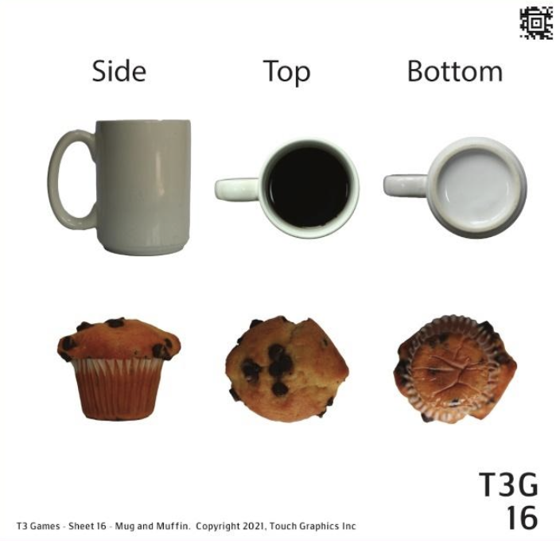

Sheet Description and Objectives
This sheet introduces side, top, and bottom views of a coffee mug with coffee and a chocolate chip muffin. There are braille labels above 3 columns for side, top, and bottom.
Student will associate specific graphics with a braille label, use left/right/middle orientation, will explore representation of object from top, side and bottom views, will use descriptive words for textures and shapes, and will share how the salient features of a tactile graphic relates to their experience with those objects.
Vocabulary
Coffee mug, handle, side view, top view, bottom view, muffin, smooth, circle, rod, wavy lines, striped, creases, crinkly
Teaching Strategies
- Help the reader identify features of each series of graphics. They may benefit from having the real object along with the tactile graphic.
- Notice the braille labels and discuss how those are labels above a column, so the two images below the label are that view.
- Name the object and ask the reader to identify the features in each series. Talk about why the side view of the cup "looks" curved on the bottom. Note similarities in texture of paper muffin cup from side and from bottom. Talk about using a fingernail to see the ridges of the paper muffin cup from the bottom view since the texture of the muffin and the paper cup are very close together.

17 Questions WATERMELON AND ORANGE
Level: Beginner

This sheet shows a watermelon in the top row and an orange in the bottom row. The fruits are shown from a side view, from a cross section view, and as a wedge. There are 12 questions on this sheet, worth a total of 20 points. Explore the graphic with both hands. Press on any shape with one finger to hear its description. Swipe to the right when you are ready to play the game.

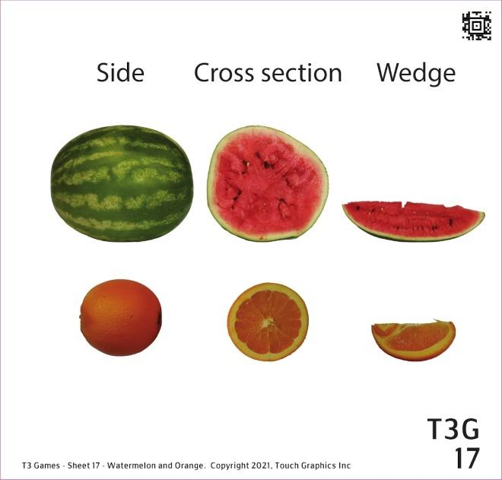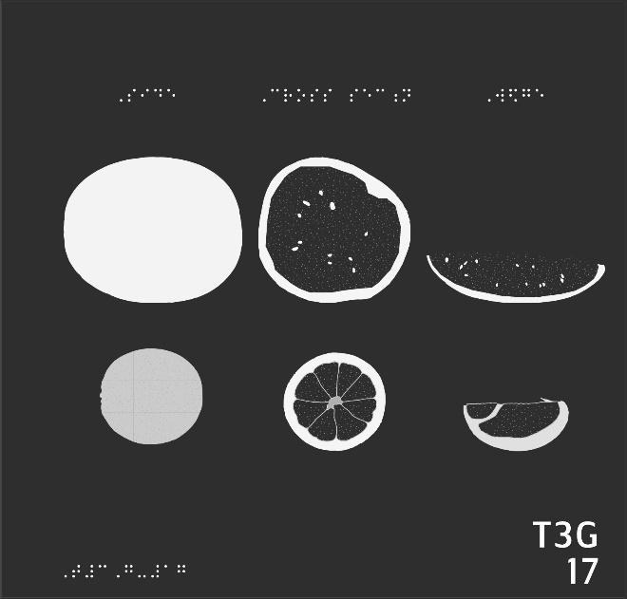

- In the top left, you can feel the outside of a watermelon. In the bottom left, you can feel the outside of an orange. Which is bigger? Press it with one finger.
- Which of the two fruits feels rougher on the outside?
- Feel the side views one more time. Which fruit is more like a circle?
- Imagine you cut the watermelon in half with a knife, revealing the delicious inside. The middle of the top row shows what you would find. Can you press it?
- We can also cut the orange in half. In the middle of the bottom row is a cross section of an orange. How is it different from the watermelon? Press it to hear more.
- Which cross section is larger?
- Which cross section shows hard little seeds?
- Feel the orange cross section. The orange is made up of many segments, which can be peeled apart. How many segments does this orange have? Press each one.
- When you peel off one of these orange segments, you get a little wedge, ready to eat! Can you find an orange wedge all by itself in the bottom row?
- A watermelon can also be sliced into wedges, like in the top row on the right. Which is larger, the watermelon wedge or the orange wedge?
- Can you press all the watermelon views on this sheet where you can feel the seeds?
- Last question: which watermelon would be easiest to bite into?

17 To the Teacher WATERMELON AND ORANGE

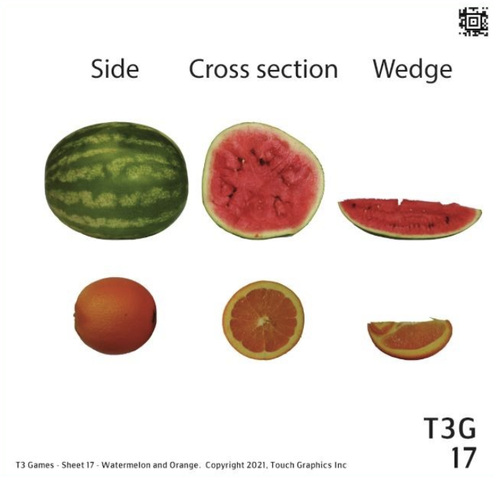

Sheet Description and Objectives
This sheet also has two representations of an object seen from three views. A watermelon and an orange are seen from a side view, a cross section, and a wedge.
Student will use top/bottom/left/right/middle orientation, will identify braille labels, will explore representation of object from top, side and bottom views, will use descriptive words for textures and shapes, will compare sizes and shapes.
Vocabulary
Side view of whole object, cross section, wedge, seeds, segments, rough, rind, dimpled texture
Teaching Strategies
- In conjunction with presentation of graphics, real objects may help the reader understand the concept. Encourage the reader to fully explore details e.g. seeds, orange sections.
- Tracing the outline of the real thing can help the student understand the 2D tactile representation.
- Identify the whole object, each of the cut pieces. Note the features in each row.
- Comparing the watermelon and the orange, are important features presented like the seeds of the watermelon and the rind and sections of an orange?

18 Questions SHOE
Level: Intermediate

This sheet shows a shoe from the top, bottom, and side. There are 14 questions on this sheet, worth a total of 20 points. Explore the graphic with both hands. Press on any shape with one finger to hear its description. Swipe to the right when you are ready to play the game.

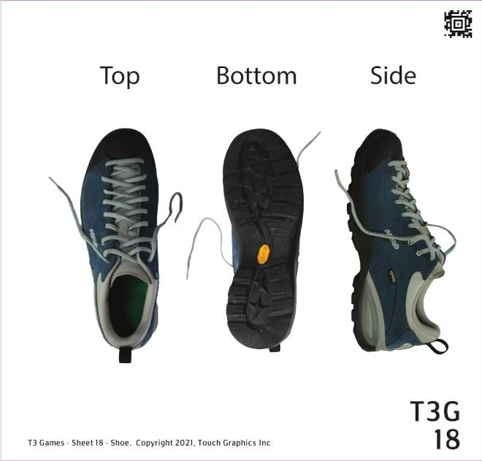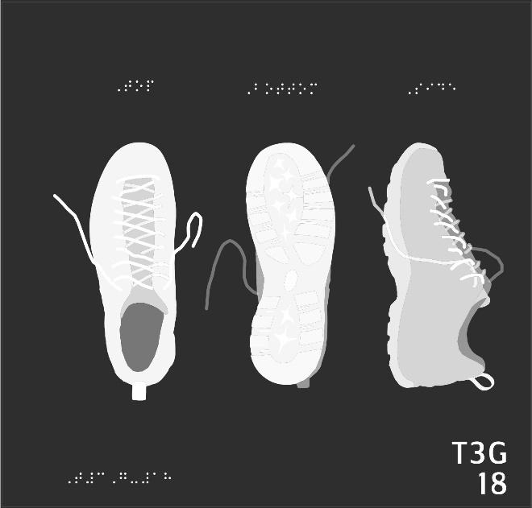
- On the left is an illustration of a shoe as felt from the top. Can you find the criss-crossed shoelaces? Press and hold on them to move on.
- Continue exploring the top view. Find the opening where you'd place your foot into the shoe, and press on it.
- Where would your toes be in this top view?
- In the middle of the sheet is a shoe viewed from the bottom. Examine it, then press it to move on.
- Can you find the heel on the bottom of the shoe?
- Can you find both the left and right shoe laces in the bottom view? Press on each one.
- On the right side of the sheet is a side view of the shoe. Can you find the shoe laces there?
- Now, explore the side view to find the opening where the foot goes.
- Can you find the rubbery bottom of the shoe in the side view?
- Imagine reaching down to touch your feet from a standing position. Which of the shoes on this sheet most closely resembles what you would feel?
- What about if you thought you stepped in a wad of gum? Where would you check?
- Find and press the toe of each shoe on this sheet.
- There's a loop of fabric hanging off the ankle of each shoe. Can you press each one?
- Final challenge: The flap of fabric underneath the laces is known as the tongue. Can you find all the tongues on this sheet?

18 To the Teacher SHOE

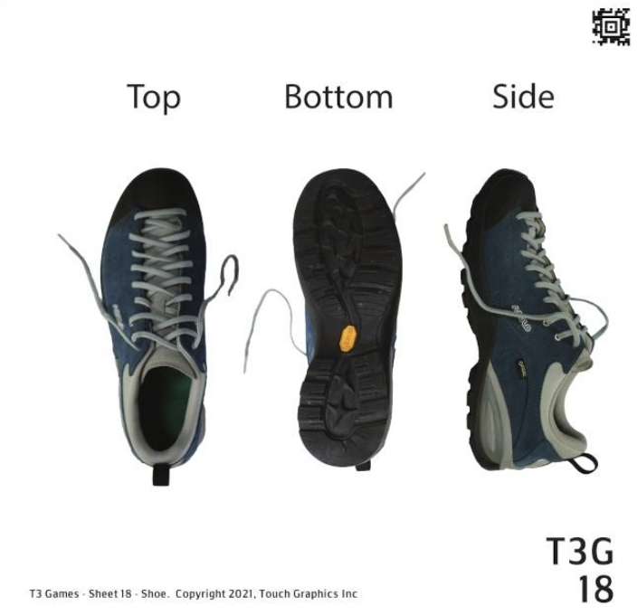

Sheet Description and Objectives
This sheet also presents various views of a familiar object. A shoe with laces is shown from the top, bottom, and side views.
Student will use left/right orientation, will show understanding of different perspectives in 2D tactile images and identify top, bottom, and side views, will locate specific tactile details on tactile representation of a shoe and make connections to the real object, and use detailed language to label an object.
Vocabulary
Top view, bottom view, side view, laces, tongue, tread, traction, toe, heel, sole, lining, loop, insole, criss-crossed
Teaching Strategies
- Does the student notice and read the labels associated with the three views?
- Explore several shoes looking for the same and different features, locating a point of reference in each shoe.
- Determine the features of the shoe (vocabulary above), use the laces and/or heel tab as a point of reference for each view

19 Questions TOY CAR
Level: Advanced

This sheet shows a toy car from all angles. The left column contains a front view and a back view of the car. The right column contains a side view, a top view, and a bottom view. There are 18 questions on this sheet, worth a total of 25 points. Explore the graphic with both hands. Press on any shape with one finger to hear its description. Swipe to the right when you are ready to play the game.

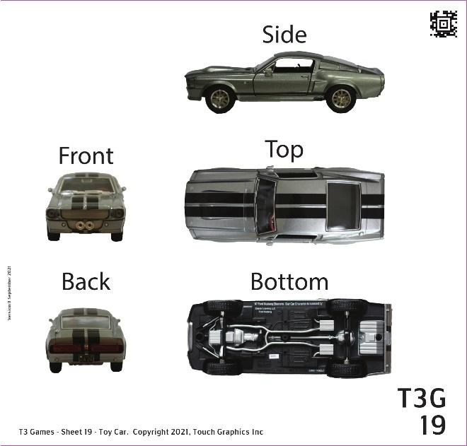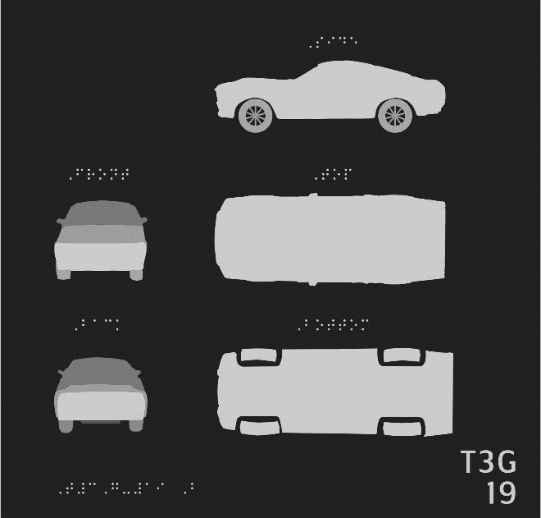

- At the top of this sheet is a side view of a car. Press and hold on it for one second with one finger.
- In a side view of a car, only two of the four tires can be felt. Can you press and hold on each of the tires shown in the side view?
- On this sheet, glass is represented with horizontal stripes. Can you find the driver's side window in the side view?
- Below the side view is a top view of the same car. The car is still facing left in the top view. Using what you now know, can you press the front windshield in the top view?
- How about the driver's side window? You already found it in the side view. Now can you find it in the top view?
- There are two mirrors jutting out from the sides of this car. One is on the driver's side, and one is on the passenger's side. Can you press and hold on each mirror in the top view?
- Now, return to the side view of the car and find the driver's side mirror in that view.
- The bottom right image on this sheet is a bottom view of the car. Press and hold on each of the four tires in the bottom view.
- Let's move on to the front view of the car. This can be found on the left side of the sheet, in the middle row. Press the windshield to indicate you've found it.
- Can you find the headlamps or headlights on the front of the car? Hint: look for two relatively large circles.
- How about the striped grille on the front of the car? Press and hold on it for one second.
- Below the front view is a back view. Use the back view to find the rear license plate of the car.
- There are oblong tail lamps or tail lights on the back of the car. Which are wider, the headlights or tail lights on this car? Press the wider lights.
- The back window of this car can be found in both the back view and the top view. Feel both views. Press the back window that feels larger.
- Explore the whole sheet. Press on the point of view only a mechanic would have.
- Now find the bird's eye view.
- What view would you have if you were working at a drive through and this car pulled up to your window?
- Last question. Only one perspective on this sheet shows the circular shape of a tire. Can you find and press all the tires that appear like circles on this sheet?

19 To the Teacher TOY CAR

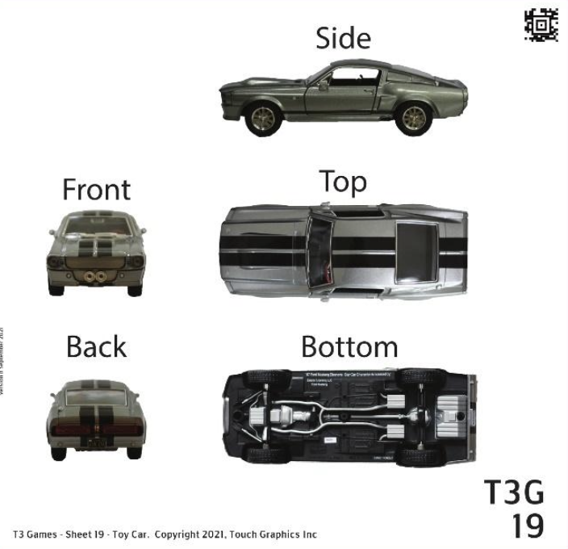

Sheet Description and Objectives
This sheet presents five different views of a toy car (front, back, side, top, bottom). Views are labeled. Several details and features of the car are represented.
Student will use left/right side, front/back, and top/bottom orientation related to a represented object, will use detailed vocabulary to describe features, will identify specific textures, will relate features in tactile graphic to their own experience with real and toy cars.
Vocabulary
horizontal, stripes, driver side, direction, tire, window, windshield, mirrors, passenger side, front view, headlight, taillight, license plate, fuel tank, back view, oblong, ribbed texture, grille
Teaching Strategies
- Thoroughly explore the side view, name features, look for textures of tires.
- A real toy car may be needed to recognize the individual features.
- Front view - find texture/shape of head lights, compare to back view and tail lights.
- Top view - windshields are the primary feature, but also the side mirrors are shown prominently, and shown (less prominent) in front and back views.
- Discuss how the size and shape of features like a window on a real car never change. But in 2-D images, those things can be distorted when viewed from different perspectives.

20 Questions TURTLE
Level: Expert

This sheet shows a turtle from multiple angles. There are 15 questions on this sheet, worth a total of 18 points. Explore the graphic with both hands. Press on any shape with one finger to hear its description. Press the braille labels at any time to hear them read aloud. Swipe to the right when you are ready to play the game.

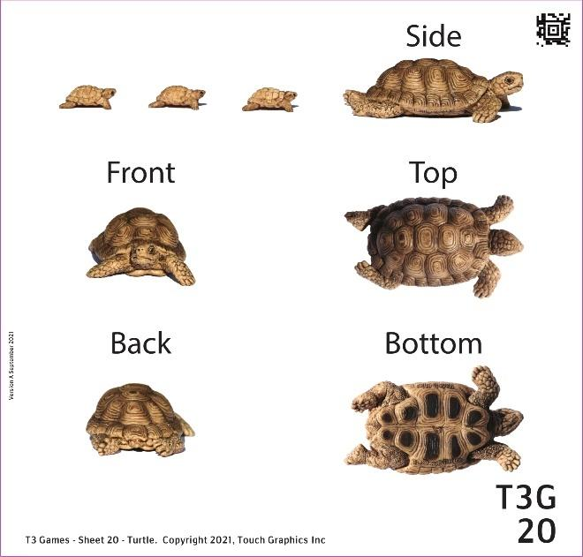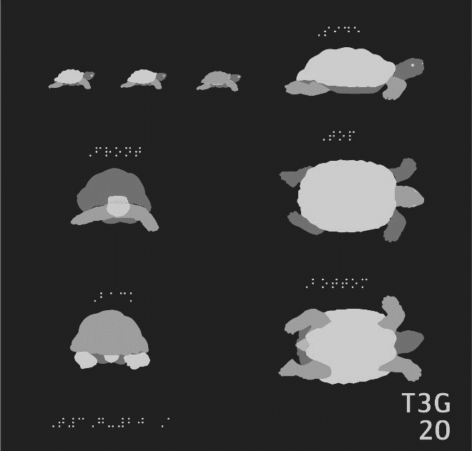

- To start, find the side view of a turtle in the top right and press and hold on it for one second.
- Can you find the head of the turtle in this side view? Press and hold on it for one second.
- Now find the legs of the turtle in the side view. Press and hold on each one.
- Can you guess what part of this animal is called the beak? Make your guess, and press the beak in the side view.
- Oh my. There are some baby tortoises following behind the parent. Can you find each baby?
- If you were touching a tortoise from the top, you could feel all four legs, a bumpy shell, and two hard eyes. Can you find a top view on this sheet? Press the braille labels if you need a hint.
- The shell of a tortoise is part of its skeleton. Can you find the tortoise shell in the top view?
- Tortoises can smell using an organ on the roof of their mouth. Find the head of this tortoise where its smell organ would be.
- The big bumps on the top shell are scales called scutes. How many scutes does this tortoise have? Feel the shell in the top view, then press it to hear the answer.
- Another challenge: can you find a bottom view of this tortoise on this sheet? Hint: the shape should be very similar to the top view.
- Please press the underbelly of this tortoise.
- Can you find the tail in the bottom view? The tail is a little pointy triangle.
- There's a back view on this sheet that also shows the tail. Can you find the back view and press on the tail? Press the braille if you need a hint.
- Can you find the front view of the turtle on this sheet, and press its right leg?
- Last question: Imagine you're one of the baby tortoises on this sheet. What view would you have of the tortoise ahead of you? Side, top, bottom, front, or back? Press the right answer.

20 To the Teacher TURTLE

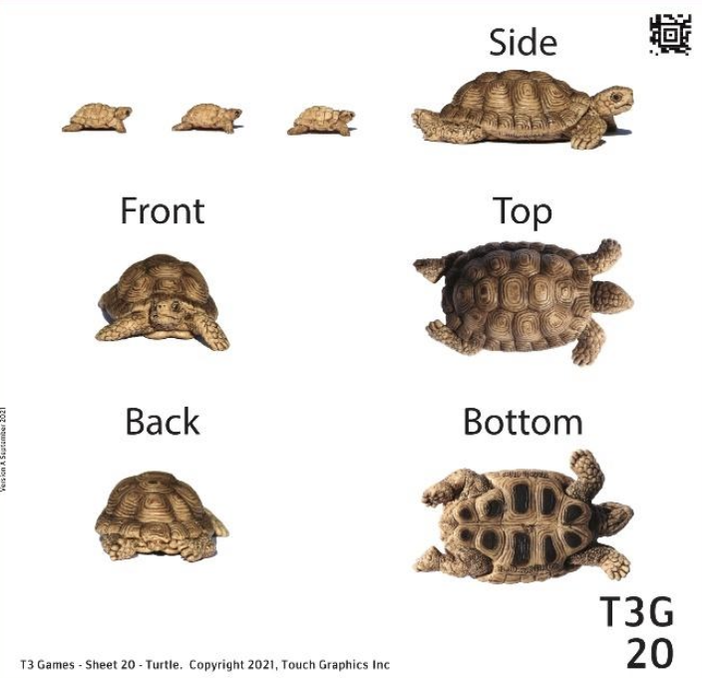

Sheet Description and Objectives
This sheet presents five different views of a turtle (front, back, side, top, bottom). Views are labeled. Many details and features of the turtle are explored.
Student will use left/right side, front/back, and top/bottom orientation related to a represented object, will use detailed vocabulary to describe features, will identify specific textures.

Vocabulary
Shell, tail, head, legs, beak, scales, scutes
Teaching Strategies
- A model of a turtle to accompany the tactile graphics may help the reader identify the features. The pattern in the shell (all views) is subtle. Encourage the reader to search gently in a circular motion to find that texture.
- The turtle's eyes and nose can be used as a point of reference, as well as his legs.

Module 5 Zoom Out Introduction

Description and Activities
This module starts from an aerial point of view of a meal and place setting. Sheets two and three zoom out to show the whole table and then the whole dining room. The fourth and fifth sheets zoom out further to show a whole floor of a house and a whole neighborhood.
Many more aspects of directionality and orientation are used on these sheets. Students will build a mental map and explore the concept of zooming out where you are viewing more area and previously large details become smaller and simpler. A floor of a house with all the rooms and furniture becomes a simple rectangle when viewed on a whole block. Each progressive page incorporates the previous page so the student can explore how the view expands. Please see Guide for student learning objectives for each sheet.

Why this is Important
Tactile maps are an important type of tactile graphic for students to learn to read and use for school curriculum and throughout life. These sheets hint at the next module by presenting “maps” of familiar experiences like a dinner plate or single room. This helps the student understand what’s represented in a map of their neighborhood.

21 Questions A STEAK DINNER
Level: Novice

This sheet shows a steak dinner from above. There are 8 questions on this sheet, worth a total of 10 points. Explore the graphic, pressing on any object with one finger to hear its name. Swipe to the right when you are ready to play the game.

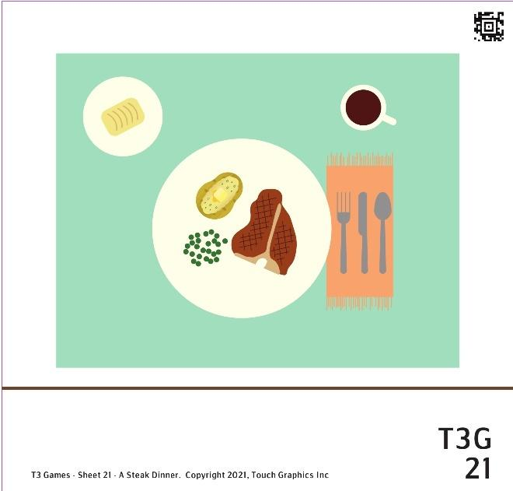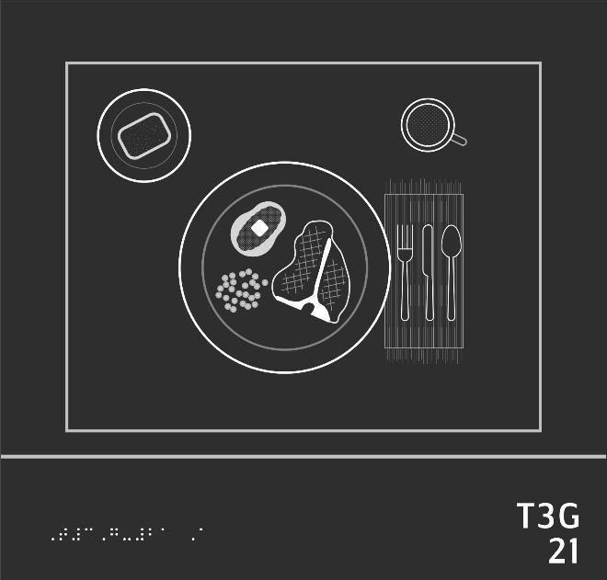

- Use one finger to press the coffee mug in the upper right. It is circular, with a little handle sticking out.
- Now find a striped rectangular napkin on the right and press it with one finger.
- There are two smooth, round plates on this table. Can you find the larger of the two plates?
- Now can you find the smaller of the two plates?
- Find a rough piece of bread on top of a plate.
- Now press on a piece of steak, with grill marks all over.
- Let's find some long skinny silverware in order to cut the steak.
- There is a small square of butter somewhere on this plate. Can you find it?
- Can you find a pile of small round objects?
- Finally, can you find all three circular containers? Press each one with one finger.

21 To the Teacher A STEAK DINNER

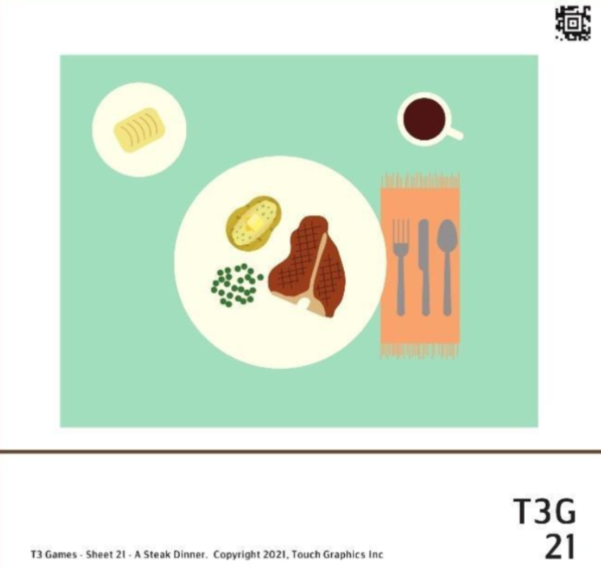

Sheet Description and Objectives
This is the first of five sheets that start from an aerial point of view of a meal and place setting. Sheets two and three zoom out to show the whole table and then the whole dining room. The fourth and fifth sheets zoom out further to show a whole floor of a house and a whole neighborhood.
Student will identify areas, shapes and textures (rough and smooth), compare sizes, and use left and right directions.
Vocabulary
Aerial view (also top down, bird’s eye), upper right, on the right, circular, rectangular, rough, smooth, larger, smaller
Teaching Strategies
- Reinforce getting an overview of the graphic with two hands.
- Connect content to real life by comparing and contrasting this place setting to the student's experience.
- Possible extension: discuss how clock-face orientation could be used to note location of items on placemat and large plate.
- Other concepts to explore include: the detail of the fringe that identifies the napkin, how a “pile” of small round objects is represented (compared to a 3D pile).

22 Questions DINING ROOM TABLE
Level: Beginner

On the previous sheet, you can explore a close-up view of a steak dinner. On this sheet, we'll zoom out to get a bigger picture of dinner time. There are 8 questions on this sheet, worth 16 points. Explore the graphic with both hands. Press on a shape with one finger to hear its description. Swipe to the right when you are ready to play the game.

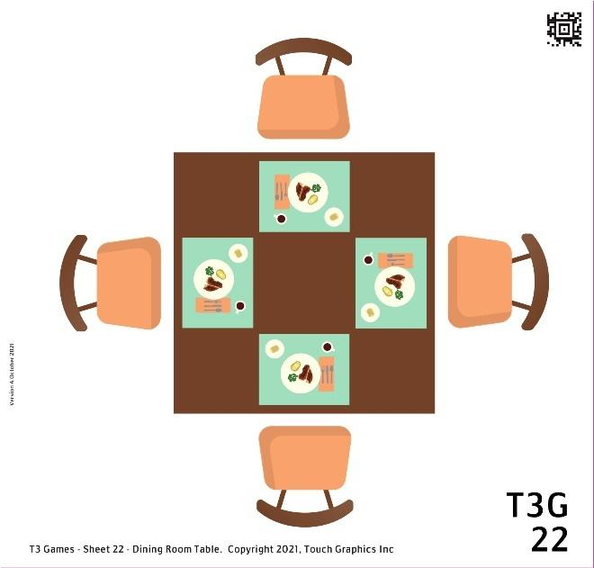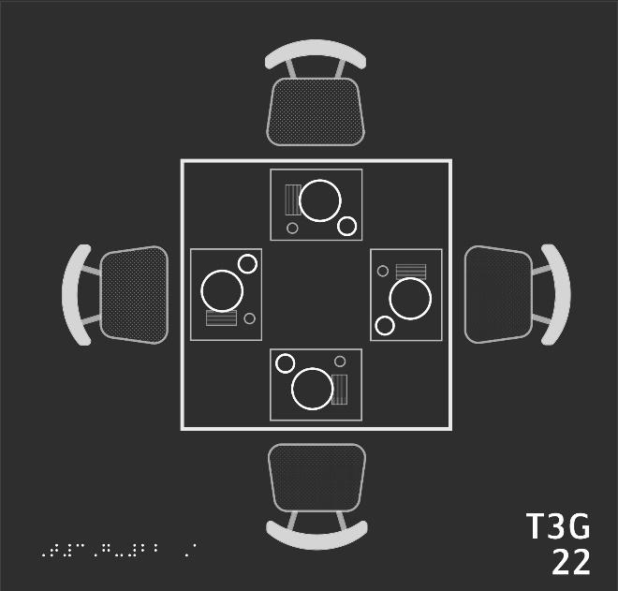

- This sheet shows a dining room table from above. Can you find the big square table, and press it with one finger for one second?
- Let's find a place to sit. Can you press and hold on each of the chairs surrounding the table? How many can you find?
- Looks like this table is set for four. Can you find four rectangular placemats on the table? Don't be fooled by the way the mats are turned.
- We'd better pick a spot before the food gets cold. Please find the placemat closest to the bottom of the sheet, and press on it.
- Let's explore this steak dinner further. Can you find a big circle on this placemat? What do you think it is?
- Now can you find a little hollow circle in the top right of the placemat? What could it be?
- You might want a napkin for a messy meal. Can you find a napkin folded up in a little rectangle on this placemat?
- Final challenge: Can you find the other three napkins on this table? Don't be fooled by rotation!

22 To the Teacher DINING ROOM TABLE

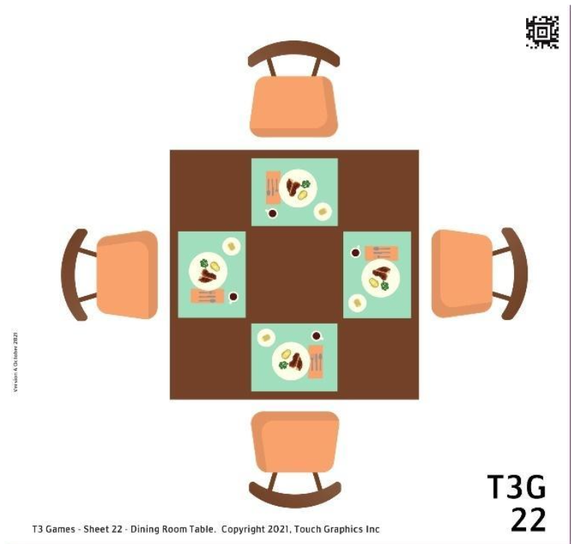

Sheet Description and Objectives
This is the second of five sheets from an aerial point of view. Sheet 21 showed a single place setting and dinner. This sheet zooms out to show the whole table.
Student will demonstrate understanding of "zooming out," identify areas, shapes and textures, and use left and right directions.

Vocabulary
Aerial view (also top down, bird’s eye), top right, on the right, square, rectangle, hollow, textured

Teaching Strategies
- Reinforce getting an overview of the graphic with two hands.
- Explore what is different in this zoomed out view which shows the whole table and the chairs.
- Notice how with a zoomed out view, there are more details and items are smaller and may be simplified.
- Possible extension: explore the orientation of each place setting around the table and the point of view from each chair. From each perspective, where is the chair on the right and left and across the table?
- Other concepts to explore include how the legs of the table and chairs are hidden in the aerial view.

23 Questions DINING ROOM
Level: Intermediate

On the previous sheets, you can explore a dining room table from very close up. On this sheet, we'll zoom out to explore the entire dining room. There are 10 questions on this sheet, worth a total of 18 points. Explore the graphic with both hands. Press on any shape with one finger to hear its description. Swipe to the right when you are ready to play the game.

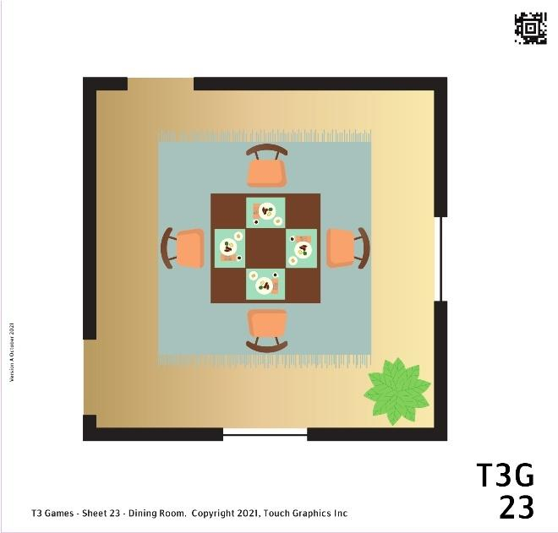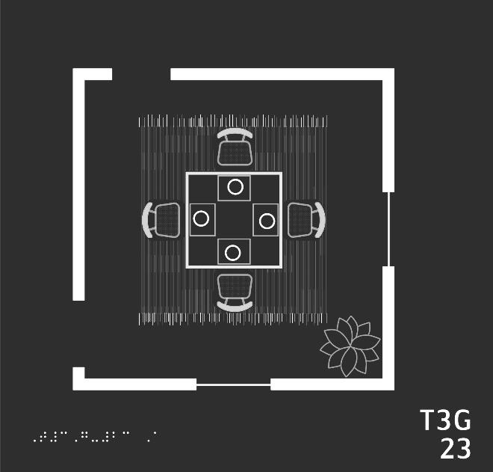

- Let's start by looking for a square dining room table. Can you find the table in the center of the sheet and press it with one finger for one second?
- Can you press and hold on each of the four chairs surrounding the table?
- Of course, dinner is the most important part of the dining room. Can you press on each of the four steak dinners on the table? Each steak dinner can be found on a circular plate.
- Let's move on to the rest of the room. Can you find a big square with a striped texture under the table and chairs? What could it be?
- There is something else in the corner of the room. It's spiky and leafy. What could it be?
- The walls of the room are represented with thick lines. Can you find and press one of these walls?
- There are windows in this room. They are represented by thin lines set in the walls. Can you find two windows on this sheet?
- Doorways are shown as gaps in the walls. How many doors can you find in this room?
- Here's a challenge: If you wanted to sit as far away from the doors as possible, which chair would you choose?
- Last question: There's only one living thing in this picture. Can you find it?

23 To the Teacher DINING ROOM

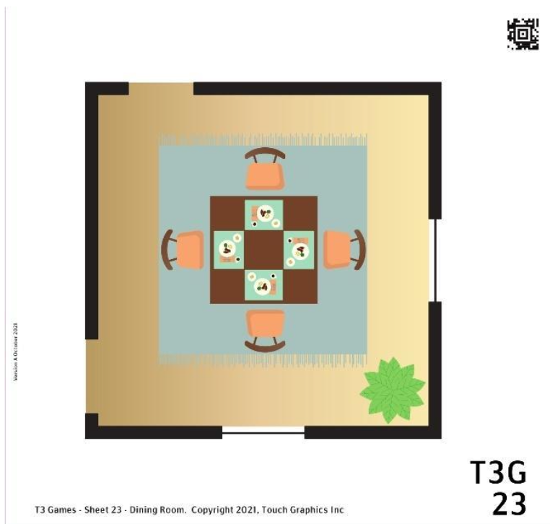

Sheet Description and Objectives
This is the third of five sheets showing an aerial point of view of a meal and place setting. This sheet zooms out to show the whole dining room.

Student will identify areas, shapes and textures, use left/right directions, distinguish thick and thin lines, and find elements that are far and close.

Vocabulary
Aerial, textured, center, pointy, thick and thin lines, gaps, farthest away

Teaching Strategies
- Reinforce getting an overview of the graphic with two hands. Explore the parts of the graphic that are not on Sheet 22.
- Compare and contrast what this view of a room and table shows to the current room and table.
- Notice in this zoomed out view, the table is now a smaller part of the big picture.
- Possible extension: view the graphic as a map, show how to go in and out of the room and give directions to get to each chair. Discuss the corners of the room, table, and placemats on this page.
- Other concepts to explore include how the rug is under the table and chairs.
- The reader is asked to trace the thick walls of the room. Leaving one hand fixed can help reader know they have traced the complete perimeter
- Find other elements that are close to or far away from each other.

24 Questions HOUSE FIRST FLOOR PLAN
Level: Advanced

On sheet 23, you explored the floor plan of a dining room. Now, on sheet 24, let's zoom out to the entire first floor. There are 22 questions on this sheet, worth a total of 32 points. Explore the graphic with both hands. Press on any shape with one finger to hear its description. Swipe to the right when you are ready to play the game.

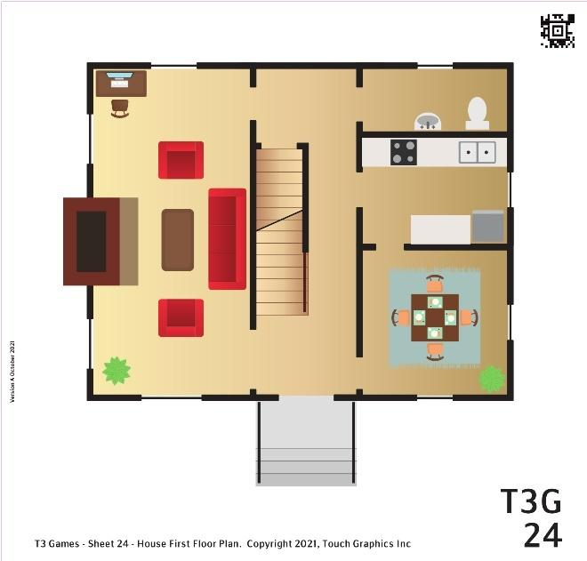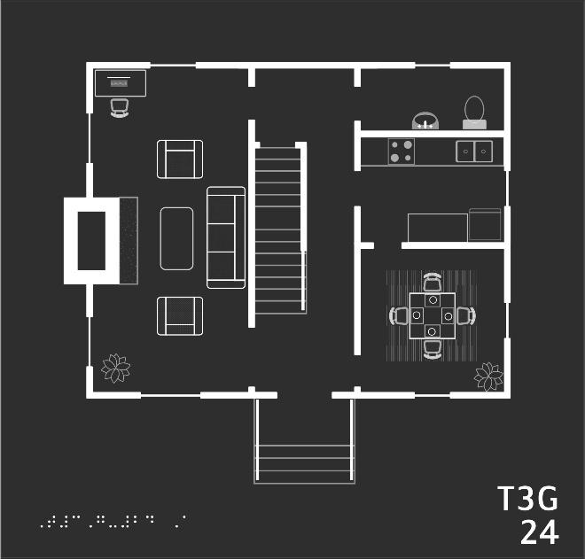

- We'll explore this house room by room. First, can you find the dining room? It's the square room in the bottom right corner. Press it with one finger for one second.
- In the middle of the dining room is a square table, all set for dinner. Can you press on the dining room table?
- Can you find a houseplant in a corner of the dining room?
- Windows are represented by thin lines in the walls. Can you find two windows in the dining room?
- There's a door leading up and out of the dining room. Go through it and into the next room. Press and hold on this new room.
- This kitchen has it all: counterspace, a fridge, a sink, and a stove. The stove feels like four little bumps arranged in a small square. Can you find it?
- Is there a window in the kitchen? Look for a thin line in the thick walls.
- Is there another door connected to this kitchen?
- Go through the door on the left side of the kitchen. Press and hold on the room you find there.
- The bathroom is on the top right of this floor plan. Use your fingers to navigate there, then press and hold.
- From above, a toilet looks like an oval seat connected to a rectangular tank. Can you find a shape like that in the bathroom?
- The living room makes up the whole left side of the house. Cross through the hallway and press on the living room.
- In the top left corner of the living room is a rectangular desk with an office chair in front of it. Can you find the desk?
- Let's turn up the heat! Can you find a big, boxy chimney on the far left wall? Hint: Feel around for a rough hearth in front of the fireplace.
- Let's take a rest. To the right of the fireplace, you'll find a smooth coffee table and a textured couch with three cushions. Can you press on the couch?
- Congrats, you've explored every room! Now, let's find the front door. Trace the outline of the house. Can you find a gap in the thick exterior walls, near the bottom of the sheet?
- How about the stairs leading up to the front door? Can you press and hold on them?
- Can you find and press the other staircase on this sheet? Hint: Look for those horizontal lines.
- How many windows are on the front wall of the house? Remember, windows are represented as thin lines in the thick walls.
- Can you find the two houseplants on this sheet? Hint: there was one in the corner of the dining room. What did it feel like?
- There's a rug on this sheet with very thin vertical stripes. Can you find it? Hint: I think there was a rug in the dining room...
- Final challenge: Can you find all the windows on this sheet? Try tracing the outline of the house and pressing on every thin line.

24 To the Teacher HOUSE FIRST FLOOR PLAN

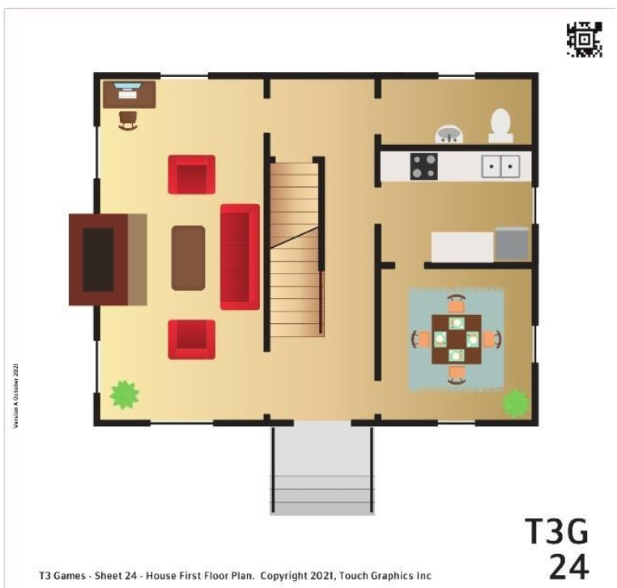

Sheet Description and Objectives
This is the fourth of five sheets showing an aerial view. The dining room is now shown as a room on the first floor of a house.

Student will identify areas, shapes and textures, navigate page using left/right/top/bottom, trace an outline, find horizontal and vertical lines, and find corners.

Vocabulary
Aerial, square, bottom right, circular, thick and thin lines, front and sides, up, top right, oval, rectangular, left side, exterior, gap, bottom, horizontal lines, corner

Teaching Strategies
- Reinforce getting an overview of the graphic with two hands.
- Have the reader explore the thick lines that are used to represent walls.
- This graphic has a lot of details; the student may benefit from tracing the perimeter of each room.
- Possible extension of sheet: view graphic as a map, show how to go in and out of the house and how to get from one room to another.
- The reader is asked to trace the outline of the house. Leaving one hand fixed can help the reader know they have traced the complete perimeter.

25 Questions NEIGHBORHOOD MAP
Level: Expert

On previous sheets, you explored a house at dinner time. Now, we'll zoom out to get a bigger picture of the whole neighborhood. There are 18 questions on this sheet, worth 20 points. Explore the graphic with both hands. Press on any shape with one finger to hear its description. Swipe to the right when you are ready to play the game.

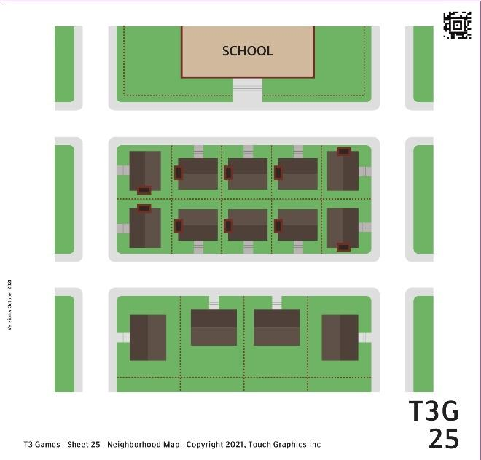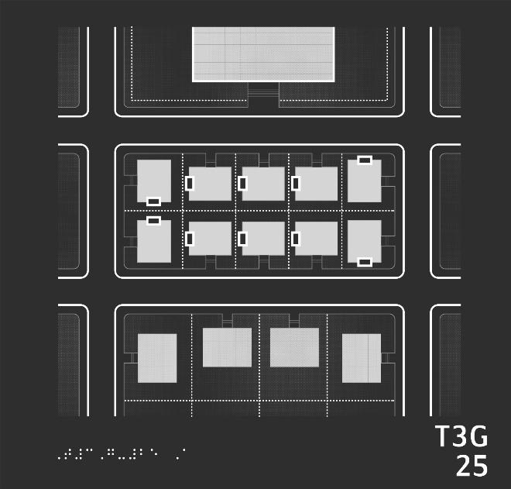

- This sheet shows a neighborhood from above. In the very center is a block of ten houses. Can you press on those houses with one finger for one second?
- There is another block of four buildings closer to the bottom of the sheet. Can you find and press it?
- Are there more buildings in the block of houses with chimneys or in the block without chimneys? Press the block with the most buildings.
- At the top of the sheet is one big building all by itself. What could it be? Press to find out.
- Can you find the walkway leading up to the school? Hint: There are tiny stripes representing stairs.
- Textured areas on this map represent fields of grass. Can you find and press the grassy school yard?
- On this map, the top of the sheet is "north," and the bottom of the sheet is "south." Which is farther north: the school, or the houses? Press your answer.
- Which is farther south: the block of houses with chimneys or the buildings with no chimneys? Press your answer.
- Can you press the street that runs horizontally between the school and the houses? In other words, can you find a street that's south of the school but north of the houses?
- On this map, the left side is "west" and the right side is "east." You already found one street that goes from west to east horizontally. Can you find another?
- Here's a challenge: can you find a street that is east of the school and runs from north to south?
- Hey, some of these houses look the same! Can you find three houses that have entryways on the south side of the house? Press each one.
- Let's go to the library! It is the building closest to the southwest corner of the map. Press it.
- We've got our books, now let's head back out! What street does the library lead out to? Follow the stairs.
- Let's visit a friend's house. She lives on this street, on the northwest corner of her block. Her house has a chimney. Can you find it?
- Another friend lives nearby, just two houses east of this corner. In fact, his house is immediately across from the school. Can you press it?
- Let's leave this friend's house and head to the school. Please press on the street you need to cross in order to get to the school.
- Excellent job! All that's left to do is to go into the school. Press the building and head on in!

25 To the Teacher NEIGHBORHOOD MAP

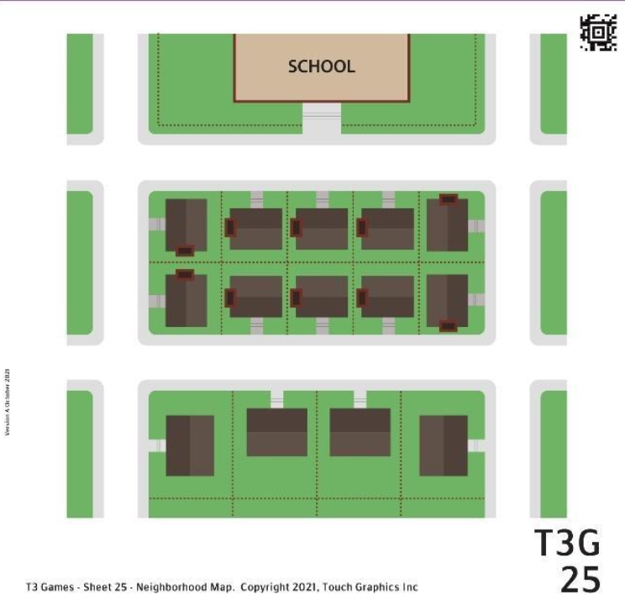

Sheet Description and Objectives
This is the fifth sheet showing an aerial view. It is a view of a whole neighborhood.

Student will identify areas, shapes and textures, explore elements presented in an array, navigate page using left/right/top/bottom, use north/south/east/west orientation, follow horizontal and vertical streets, use directional corners (e.g., northwest).

Vocabulary
Aerial, neighborhood blocks, rectangle, sidewalks, chimney, stairs, corners, top view, north, south, east, west, northwest, northeast, southeast, southwest, horizontal

Teaching Strategies
- Reinforce getting an overview of the graphic with two hands. Notice that the houses no longer have details, they are simple shapes with only a rectangular chimney shown.
- Reinforce the concept of represent - the raised rectangles represent chimneys
- Discuss student’s experience with block travel and maps.
- Explore how the ten houses are in two rows within the one rectangular block. Notice the front of each house faces the street.
- Possible extension of sheet: have student move around the map using left/right or cardinal directions to describe movement.
- This graphic with streets can be explored like a grid with a left to right, top to bottom pattern.

Module 6 Maps Introduction

Description and Activities:
This module also presents a small view that eventually expands out to the whole National Mall in Washington DC. The first map is an area of the Freer Art Gallery. These sheets present many conventional attributes of maps including keys, compass arrows, and scale indicators. There are more braille labels on these sheets. Braille labels are read aloud when pressed and held.
On these pages, efficient graphics reading skills are reinforced such as always finding and reading the title. Also, the student will be practicing many more orientation concepts like use of cardinal directions, finding landmarks on the map and following specific routes between two points. Many more symbols and line types will be encountered. Please see Guide for student learning objectives for each sheet.

Why this is Important:
Students will continue to read tactile diagrams, information, and maps throughout their formal education and outside of school and into adulthood. Experience with graphics and maps supports building mental mapping skills and encoding information through the tactile sense.

26 Questions FREER CHINA GALLERY 17
Level: Novice

Welcome to Gallery 17 of the Freer Gallery of Art in Washington DC! There are 15 questions on this sheet, worth a total of 20 points. Explore the graphic with both hands. Press on any shape with one finger to hear its description. Press the braille labels at any time to hear them read aloud. Swipe to the right when you are ready to play the game.

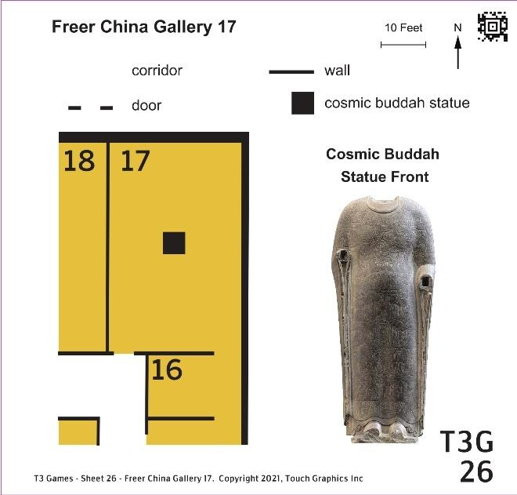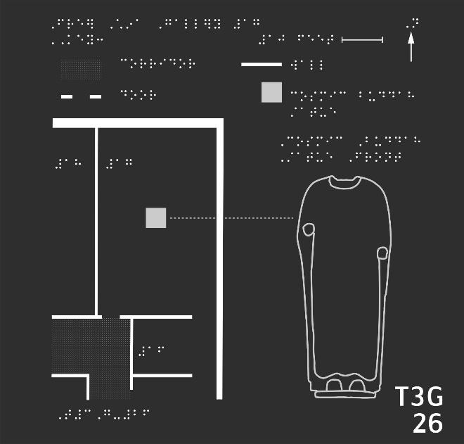
- Let's learn to read this map with a key. There's an arrow pointing up in the top right corner. Can you press and hold on the arrow for one second?
- Just to the left of the compass is a horizontal line. Press the line to hear what it represents.
- The remainder of the space across the top of the sheet is a key. You'll find four items in the key, each with a braille caption to the right. Press on each item to hear its description.
- Below the key and to the left is the map itself. Can you find a corridor there?
- Can you find the square cosmic buddha statue icon on the map?
- What gallery contains the statue? Find the room number in braille, and press it to hear it aloud.
- Can you find two other numbered galleries on this map?
- Which is bigger, gallery 16 or 17? Press the larger room.
- There are two ways to get into gallery 17. Can you press on each doorway?
- Where is the northern wall of gallery 17?
- Let's get to the main attraction: the cosmic buddha. Follow the dotted line to the right of the square to find an illustration of the statue. Press it.
- Can you find the buddha's head? If not, can you find where the head should be?
- Press the hems of the robe, indicated with a wavy line just above the buddha's feet.
- There are two ovals where the hands should be. Can you press the oval indicating the statue's right hand?
- Finally, press the chest of the cosmic buddha to hear why it is so treasured.

26 To the Teacher FREER CHINA GALLERY 17

Sheet Description and Objectives
Introducing map features is the focus of this sheet showing a section of a museum. This sheet introduces a map with a key and a compass arrow pointing north and a scale indicator. In this module braille labels are read aloud when pressed and held. The key includes four items and is arranged in two rows and two columns. On these pages, the student is asked to locate the title. Textures, line types, and icons are used to represent elements. Orientation by room numbers is used.

Student will find title, follow lines, read a map key, find a compass indicator, distinguish areas, texture, line types and shapes, use left/right and cardinal directions for orientation, and explore 3D artwork presented in 2D tactile representation.

Vocabulary
Map key, arrows, top right corner, compass, scale, icon, horizontal line, line types, corridor, gallery, northern wall, oval, room numbers

Teaching Strategies
- Reinforce getting an overview of the graphic with two hands, notice braille labels, symbols at the top, and numbers. The left and right side present different elements, the left side seems to be a map and the right side is a tall vertical shape.
- Student may need orientation to the key. Knowing how many items and how the key is laid out is good to know before exploring each item.
- Discuss how there is just a small section of the museum represented on the map.
- Connect content to real life by discussing museums the student has visited.

27 Questions FREER GALLERY FIRST FLOOR MAP
Level: Beginner

Welcome to the 1st Floor of the Freer Gallery of Art in Washington DC! There are 22 questions on this sheet, worth 34 points. Explore the graphic with both hands. Press on any shape with one finger to hear its description. Press the braille labels at any time to hear them aloud. Swipe right when you are ready to play.

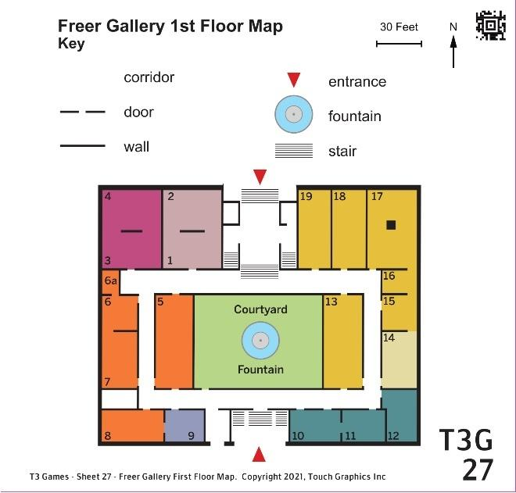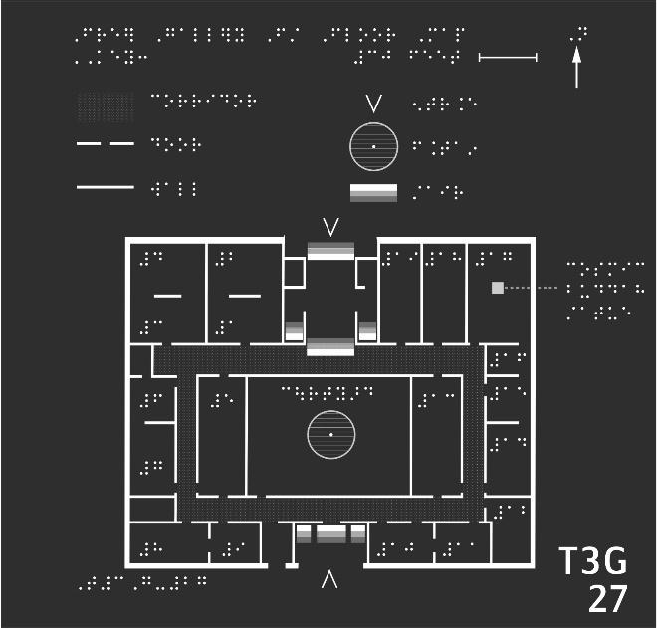

- Once again, the title is in the top left corner. Press and hold on it for one second.
- The scale of the map is the horizontal line in the top right corner. Can you find it?
- Just like on the previous map, the compass rose is shown as an arrow in the top right. Find it.
- Below the title, scale, and compass is the key, organized into two columns. Please press each of the six items in the key.
- The map is usually below the key. This map shows a rectangular building. Can you find the north east corner of the building, in the top right?
- What is the solid square in gallery 17? Press it to find out.
- Gallery 17 is just one of many rooms in this building. Can you find the largest room, in the center of the building?
- The fountain is near. Can you find it? Use the key if you need a hint.
- There are galleries on either side of the courtyard, directly to the left and right. Press them to find out what's inside.
- There's a door leaving the courtyard. What corridor does the door lead to?
- There are four straight corridors that form a loop inside the building. Please press each of the four corridors.
- There are two entrances to this building. Can you find both? Use the key for a reminder!
- Which entrance is farther north, according to the compass?
- Can you find a set of stairs at the north entrance?
- Let's explore the art inside. Just west, or left, of the north entrance is a room with art from the Indian subcontinent. A horizontal wall in the middle divides the room into two galleries. Can you press both gallery 1 and 2?
- The room to the left, in the north west corner of the building, holds art from the Islamic world. Can you find both galleries in that room, separated by a wall divider?
- Gallery 12, in the far bottom right corner, is a very special room. Press it to find out what's inside!
- What is directly north of gallery 12, the Peacock Room?
- There's no door between galleries 12 and 14. Which corridor will you need to use to go between the two rooms?
- If, upon arriving, I wanted to go straight to the Peacock Room in gallery 12, which building entrance should I use?
- The only corner we haven't explored is the south west corner, in the bottom left. What's there?
- Last challenge: Which room on this map is farthest away from gallery 8?

27 To the Teacher FREER GALLERY FIRST FLOOR MAP

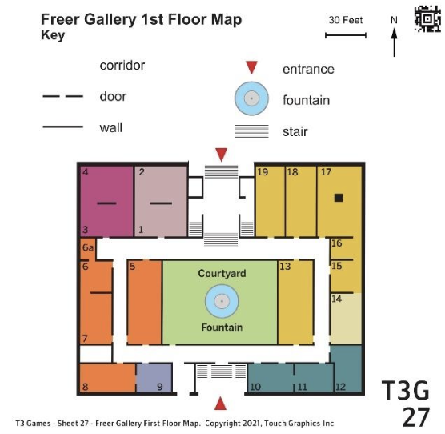

Sheet Description and Objectives
This sheet shows the whole first floor of the art gallery. There is a central courtyard surrounded by corridors and numbered gallery rooms. More items are in the key. The student will be guided to identify title, scale, compass rose.

Student will follow lines, find the title and scale indicator, read a map key, find a compass rose, distinguish areas, texture, line types and shapes, use left/right/top/bottom and cardinal directions for orientation, and compare sizes.

Vocabulary
Title, scale, compass rose, key, cardinal directions and directional corners (e.g., southwest), arrows, solid shape

Teaching Strategies
- Reinforce getting an overview of the graphic with two hands, find title and braille labels.
- Have student explore the key and find how it is arranged and the items it contains.
- Explore how the entrance arrows indicate direction.
- Student could use Sheet 26 to compare where that map is on the zoomed out view on Sheet 27.
- Compare how this map might be similar to other environments the student is familiar with (possibly school, mall, library).

28 Questions FREER GALLERY & NEIGHBORS Map
Level: Intermediate

On previous sheets, we explored the Freer Gallery up close. On this sheet, we'll get a bigger picture of the gallery and its surroundings. There are 13 questions on this sheet, worth 25 points. Explore the graphic with both hands. Press on any shape with one finger to hear its description. Press the braille labels at any time to hear them aloud. Swipe to the right when you are ready to play the game.

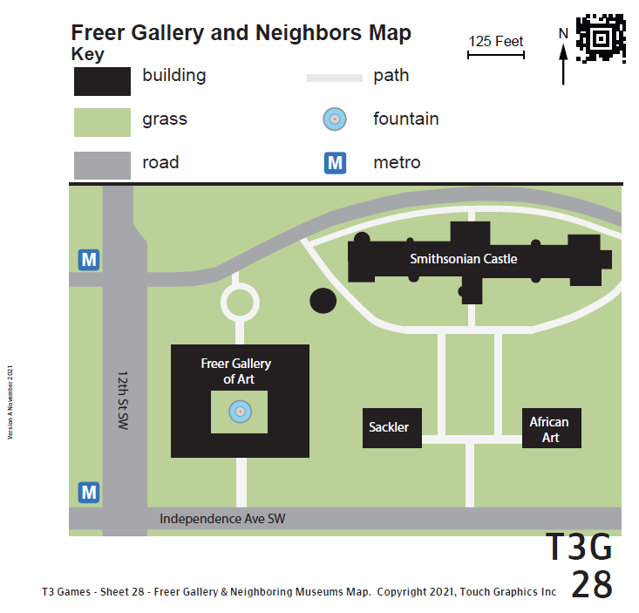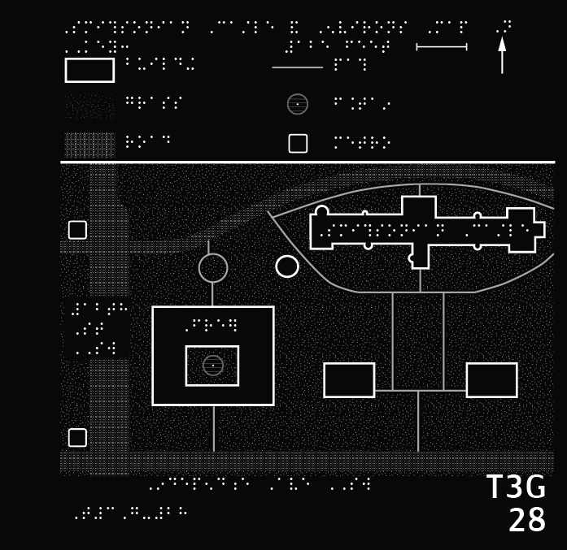
- First, can you find the title of this map in the top left corner? Press and hold on the braille title with one finger for one second.
- Beneath the title, compass, and scale are six key items. Please press on each key item to hear what it represents.
- Let's explore the map. There are two metro stations shown here. Can you find both? Use the key if you want a reminder of what the metro station feels like.
- There are five other buildings on this map. Can you find them all?
- There are three major roads on this map. Press and hold on all three. Use the key if you want a reminder of the road texture.
- Most of this area is covered in grass or other vegetation, shown with a rough texture. There is even vegetation inside of the Freer Gallery. Can you find it?
- A fountain is represented by a circle with a pointy center, as shown in the key. Where is a fountain on this map?
- The compass rose at the top indicates that east is toward the right of the sheet. Can you find the building directly east of the Freer Gallery?
- Which of the five museum buildings is the smallest? Hint: It's a circle!
- Which building is the longest? Press on it!
- Let's plan a visit to the Smithsonian Castle, the long building on this map. We'll take the metro to get there. Can you find the metro station closest to the castle?
- Now, starting from the metro station, which road will take us east toward the castle?
- We're almost there! Trace the road to the castle, then press on the castle to go inside.

28 To the Teacher FREER GALLERY & NEIGHBORS MAP

Sheet Description and Objectives
This sheet shows an even further zoomed out view from the Freer Gallery including the surrounding environment. The key includes buildings and metro stations. Roads are labeled. Textures distinguish roads, buildings, and vegetation.

Student will find the title and scale indicator, read a map key, find a compass rose, distinguish areas, texture, line types and shapes, use left/right/top/bottom and cardinal directions for orientation, compare sizes (small/large, short/long), read map to determine directions from one point to another, and find street names.

Vocabulary
Title, scale, compass rose, key, cardinal directions and directional corners (e.g., southwest), arrows, metro stations

Teaching Strategies
- Reinforce getting an overview of the graphic with two hands, find title and braille labels.
- Have student explore the key and find how it is arranged and the items it contains.
- What indicates this is an outdoor environment and not an indoor environment?
- Student could use Sheet 27 to compare where that map is on the zoomed out view on Sheet 28 and how the Freer Gallery is now smaller and represented with a simple shape.
- What other maps has the student seen with similar elements?

29 Questions NATIONAL MALL DETAIL MAP
Level: Advanced

On this sheet, we'll zoom out to get a bigger picture of the National Mall, the large green space in Washington, D.C. that houses many monuments, memorials, and museums. There are 18 questions on this sheet, worth 29 points. Explore the graphic with both hands. Press on any shape with one finger to hear its description. Press the braille labels at any time to hear them aloud. Swipe to the right when you are ready to play the game.

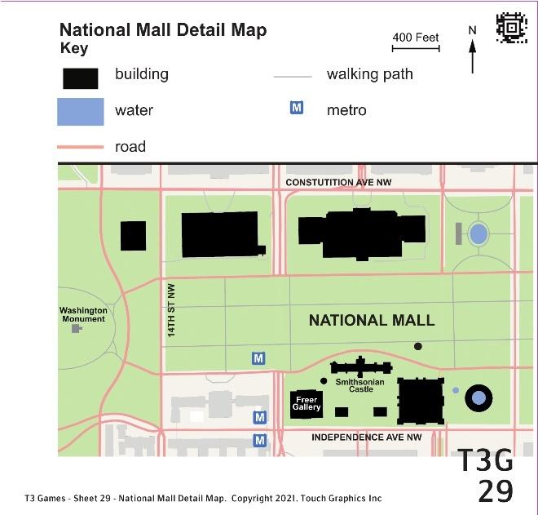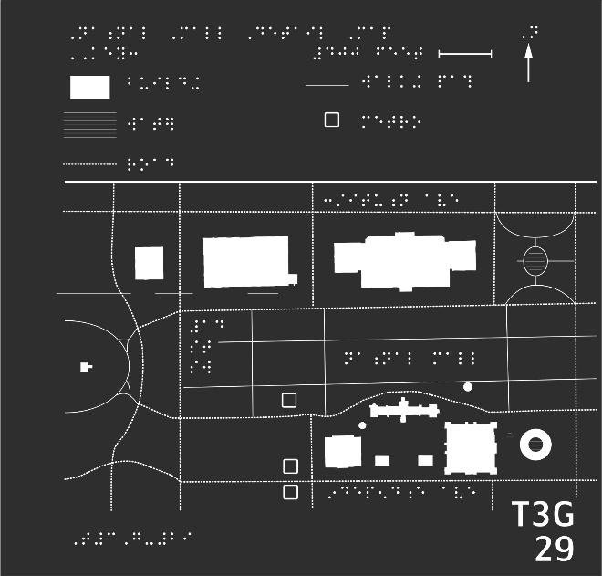

- After playing the previous three games, you are familiar with how to use a map key. Find and press all five symbols in the key. Are any of the symbols different from what you expected?
- Let's get our bearings. Independence Avenue is the street running horizontally across the bottom of the map. Press on Independence Avenue with one finger.
- Trace Independence Avenue. Notice four rectangular buildings along the north side of the street: a big one, two small ones, then another big one. Press each of the four buildings.
- The Smithsonian Castle must be the skinny building northeast (or up and to the right) of the Freer Gallery. Can you press and hold on the castle?
- East of the Freer Gallery, the castle, and the rest is a big circular building. What could it be? Press to find out.
- There's also a little circular building, which is north of the big square Arts and Industries Building and east (or right) of the castle. What is it?
- Next, can you find all three metro stations marked on this map? Hint: they are west (or left) of the buildings we have been exploring.
- Just like on the previous sheet, the Smithsonian metro station is the station directly west (or left) of the Smithsonian Castle. Please press it.
- On the north (upper) side of the map, there are three big museum buildings that weren't shown on previous maps. Press each one to learn about it.
- In the northeast corner is a circle of water. What could it be? Use the key if you want a reminder of the water texture.
- On the far left side, halfway down the map, is a tiny icon of a building. Press it to hear what it is.
- Now that you have the lay of the land, let's go on a trip through the National Mall! Start by pressing the Hirshhorn, the big circular art museum in the south east (or bottom right) corner.
- We'll meander from the Hirshhorn all the way to the Washington Monument. Press on the road just north of (or above) the Hirshhorn to begin our journey.
- As you trace the road west, you'll find the little circular carousel building north of the road. Press it to take a ride!
- As you keep going along the road, you might want a snack. Press on the Smithsonian Castle south of the curving road to stop at the cafe.
- As we continue along the road, we'll find the Smithsonian metro station on the north side. Press on the metro station to check the train schedule.
- We're almost there! Keep following the road until it ends. There's a walking path that goes around the monument. Can you press it?
- You did it! Press on the Washington Monument to end your journey.

29 To the Teacher NATIONAL MALL DETAIL MAP

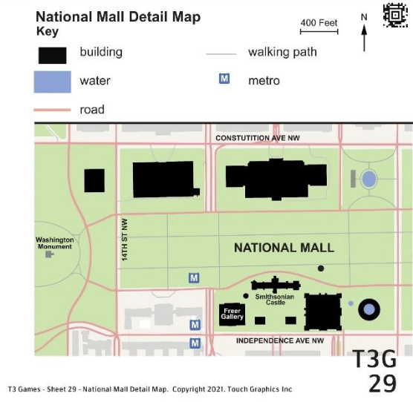

Sheet Description and Objectives
This sheet zooms further out to show a portion of the National Mall. The key includes roads and walking paths. More buildings are shown. Key streets are labeled.

Student will read a map key, find compass rose, distinguish line types, areas and shapes, use left/right/top/bottom and cardinal directions for orientation, compare sizes (big/small), and use details, street names and landmarks shown on map to plan follow directions from one point to another.

Vocabulary
Monument, key, cardinal directions and directional corners (e.g., southwest), horizontal, vertical, metro station

Teaching Strategies
- Reinforce getting an overview of the graphic with two hands, find title and braille labels.
- Have student explore the key and find how it is arranged and the items it contains.
- Where is the section on this map that was shown in the previous Sheet 28? Are those buildings simplified in this zoomed out view?
- Notice that the roads on this map are shown as thin raised lines, not wide textured lines like in the last sheet.
- While following the directions from the Hirshhorn to the National Monument, student may need to go slowly to find landmarks like the carousel and the Smithsonian.
- Student could be encouraged to keep one hand on the road to maintain orientation while using the other hand to locate the nearby details.

30 Questions NATIONAL MALL MAP
Level: Expert

This is a map of the National Mall, from the Washington Monument to the US Capitol. It's meant for map readers who are familiar with using a key. There are 12 questions on this sheet, worth 17 points. Explore the graphic with both hands. Press on any shape with one finger to hear its description. Press the braille labels at any time to hear them aloud. Swipe to the right to play.

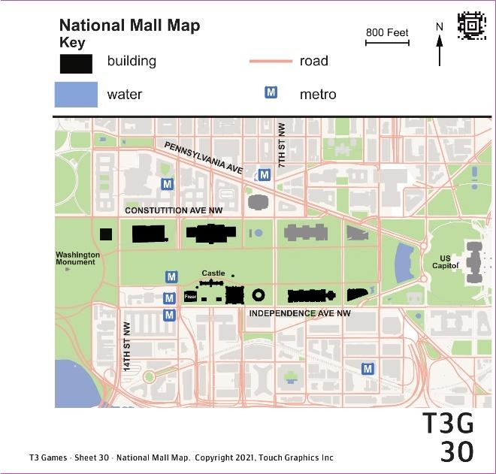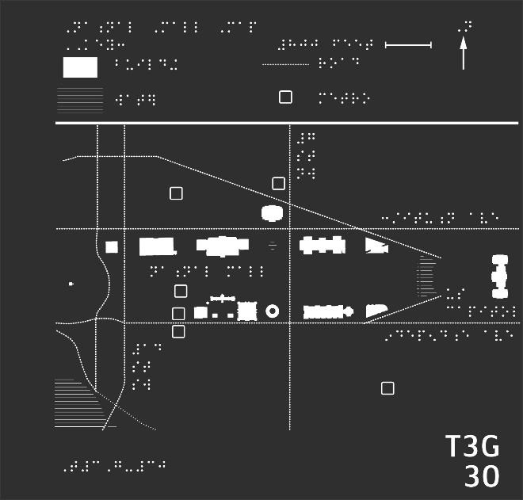

- How big is the National Mall? Using the horizontal line representing the scale in the top right corner, make a guess. Then, press and hold on the scale for one second to hear the answer.
- The Washington Monument is shown as a small building symbol, on the far, west (or left) side of this map. It's so small that it's almost a dot. Can you find it?
- This map also shows a body of water south of (or below) the Washington Monument. Find the water and press on it.
- There are two streets running horizontally above and below the Washington Monument. These streets help form the boundaries of the National Mall. Can you find the two streets?
- To the east (or right) of the monument are many museum buildings, including the circular Hirshhorn Museum. Press on the donut-shaped Hirshhorn building.
- On the east (or right) side of the Hirshhorn Museum is a perfectly straight street. It runs north-south (or vertically) across the map. Can you find that street?
- East of 7th Street, there are five buildings which we have never explored before. Press each building to the right of 7th Street to hear what's inside.
- On the east (or right) side of the sheet, in front of the US Capitol, there is another body of water. Can you find it?
- Can you find the metro station on this map that is closest to the US Capitol? Use the key to remind yourself of the metro station icon, if you want.
- In front of the US Capitol, there is a diagonal street leading up and to the left. Find that street. Press to hear its name.
- There is one metro station north of the diagonal street, Pennsylvania Avenue. Can you find that northernmost station?
- Last map challenge: There is a building just below this metro station. In fact, it's the only building north of Constitution Avenue. What could this mysterious place hold?

30 To the Teacher NATIONAL MALL MAP

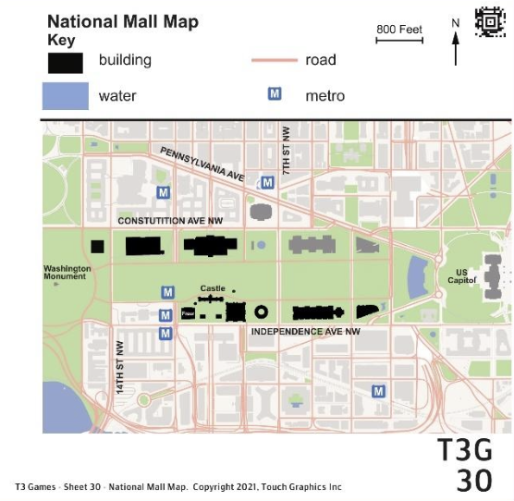

Sheet Description and Objectives
This is the last of the zoomed out views and shows the entire National Mall with the Washington Monument to the west and the US Capital to the east. Buildings shown on previous sheets are now small details. This sheet introduces diagonal streets and textured bodies of water.

Student will read a map key, explore the scale of a map compared to actual distance, distinguish areas, shapes, use left/right/top/bottom and cardinal directions for orientation, locate streets shown as horizontal, vertical and horizontal lines, and identify details, street names and landmarks shown on map.

Vocabulary
Scale, key, cardinal directions and directional corners (e.g., southwest), horizontal, vertical, diagonal

Teaching Strategies
- Reinforce getting an overview of the graphic with two hands. Find the area on this map that was represented on the previous Sheet 29.
- Many questions on this sheet relate to cardinal directions both on the whole page and in relation to elements on the page.
- Water is shown as a bold horizontal line texture for the Tidal Pool and Reflecting Pool. What fountains or pools is the student familiar with? What would be shown around them on a map?

Module 7 Mazes Introduction

Description and Activities
The sheets in Module 7 present fun activities in the form of mazes. Varied line types, arrows, areas, shapes, fills and textures, labels and point symbols are all incorporated in five different environmental settings. All the sheets use a small circle that fits under one fingertip as each stopping point or step along the way. The starting points of each maze have a clear dot in the circle. This module asks the student to follow a series of steps rather than answer questions. These sheets include a baseball diamond, treasure map, cafeteria, grocery store and an airport.

Students can take advantage of the explore feature option before starting each activity to hear descriptions so they can anticipate what they will encounter as they follow the steps. Students can use their imaginations as they follow and trace lines, zig-zag through obstacles, and go around corners. There are things to explore along the way. If students lose their place in the maze as they are exploring surrounding details, they can be encouraged to hold their spot with one hand and explore with the other. The place holder finger will need to be lifted slightly to hear a pressed element. Please see Guide for student learning objectives for each sheet.

Why this is Important
These pages put the student’s skills into practice. While completing specific movements, students need to focus on multi step directions and pay attention to details. They teach following a sequence which is an essential skill for using maps for planning. Organizing information into a sequence is important for understanding many academic graphics and infographics. Images are often used to describe a series of steps, like the life cycle of a butterfly or the circular process of the water cycle.

31 Steps PLAY BALL! Steps
Level: Novice

Take me out to the ball game, take me out with the crowd! This sheet is a maze. You will follow the dotted line, one step at a time, to play a baseball game. You can also veer off path to see what else is going on. There are 8 steps on this sheet, worth 8 points. Explore the graphic with both hands. Press on any shape with one finger to hear its description. Swipe to the right to play.

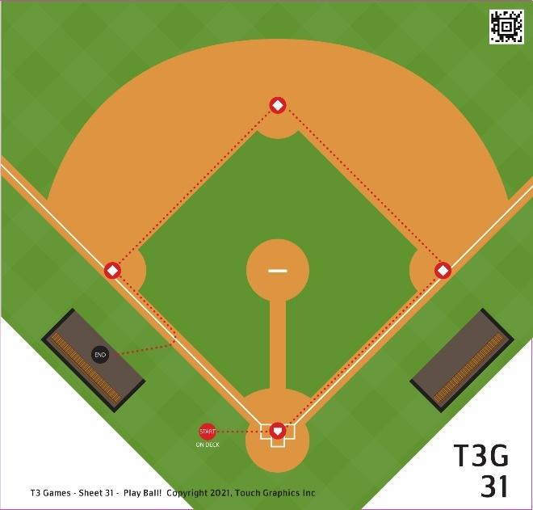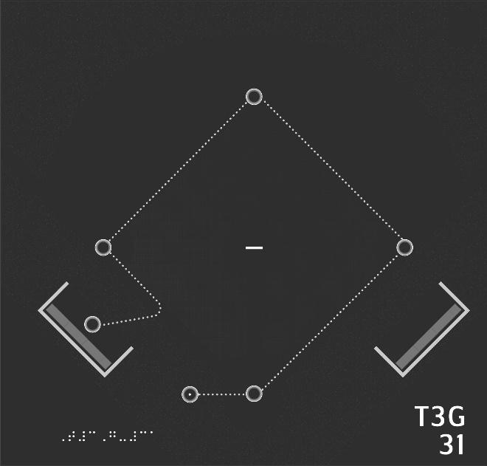

- The sun is hot, the stadium is packed, and someone's yelling, "Get your hot dogs here!" It's time to play ball! Explore the sheet with both hands, looking for a circle with a dot on it. It's near the bottom of the sheet, toward the left. When you find the circle, press and hold for one second.
- It's time! Coach is yelling, "You're up to bat!" The other team is in the lead, there's a runner on first, and it's all up to you! Follow the dotted line right to the next circle to step up to home plate.
- One strike is no big deal. Press home plate again to try again.
- Your coach is getting a little nervous now, but you know you can do it! Press home plate one more time to give it one last try.
- The crowd goes wild. Coach is screaming, "Run!" Quick, follow the dotted line to the right and up to the next circle, to make it to first base!
- Oh my goodness. The other team is fumbling over the ball in the outfield! Follow the line up and to the left to second base, before you get caught!
- Oh no, looks like someone's got the ball! What's coach saying? Let's just make a run for it! Follow the line down and to the left to third base!
- The crowd is stomping their feet. Pretzels and pop cans go flying. The other runner crosses home, and there's no way you're stopping now! Trace the dotted line down until you reach the last circle!

31 To the Teacher PLAY BALL!

Sheet Description and Objectives
This maze sheet is a bird’s eye view of a baseball field. Home plate and the starting point (circle with a dot inside) are at the bottom. The diamond shape of the bases are shown and there is a textured outfield. The pitcher’s mound has a bold line and there are dugouts on the left and right sides.

Given understanding of areas, lines, shapes, and textures in a tactile graphic and using right/left/top/bottom orientation, the student will trace lines and find shapes to complete a maze using a graphic of a baseball field.
Vocabulary
Path, dotted line, trace, follow, left,right, up, down, top, bottom. Setting: baseball stadium, path, bases, up to bat, pitcher, home plate, strike, dugout, etc.
Teaching Strategies
- Get oriented to the maze, what does the title tell us about the graphic?
- This maze has dotted lines with circle stopping points. Student could preview the path.
- It may help the student to preview that the instructions for these pages will be a series of steps to take. There is a starting point, a continuous path to follow, and an ending point.
- What experience does the student have with baseball? Does this graphic help them get a better understanding?

32 Steps TREASURE MAP Steps
Level: Beginner

Welcome, intrepid explorer! Legend tells of gold buried on this island. Can you complete the dotted maze and claim your treasure? There are 10 steps on this sheet, worth 10 points. Explore the graphic with both hands. Press on any shape with one finger to hear its description. Swipe to the right to play.

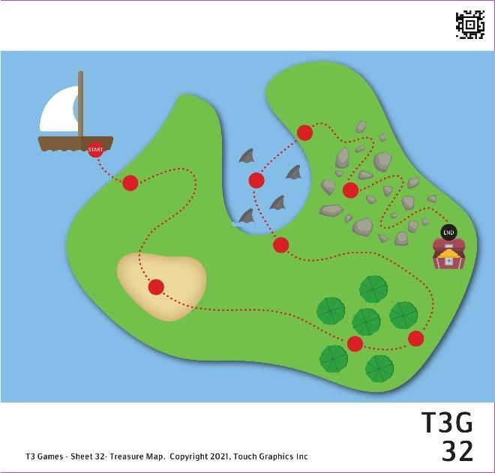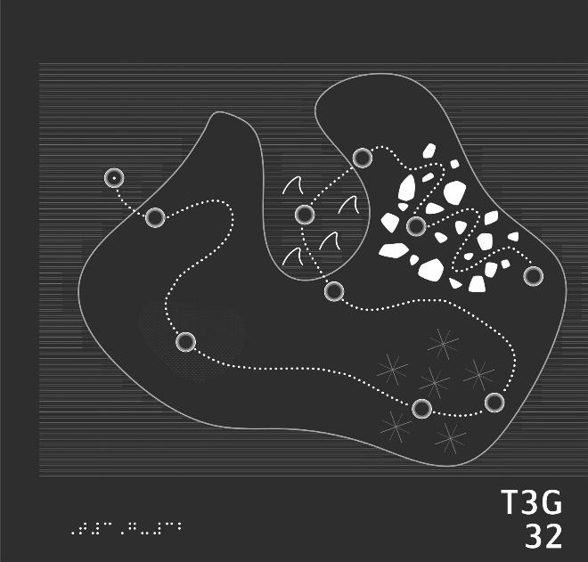

- How lucky - this treasure map will lead you right to the gold! You'll need to visit each circle on the dotted path. The first circle is in the top left. It has a dot at its center. Can you find it and press on it?
- Land ho! Follow the dotted line down and to the right to the next circle to step ashore the island.
- According to this map, the gold is at the end of a long path with many obstacles. Keep tracing the dotted line and press on the next waypoint.
- The sand is finally starting to give way to lush grass. Keep following the path to get out of this desert. Press on the next circle to the right.
- It would be easy to lose your way in here. Continue on the path to the right to get out of this forest!
- According to the map, you're halfway there! Follow the path up to the next spot. Where is it leading you?
- Follow the dotted path up into the water. What could be down there?
- Thankfully, the map is leading you back to the coast. Quick, swim right along the dotted line, lest you become shark bait!
- The map shows a hazardous, rocky terrain ahead. Zig zag through the rocks, following the dotted line, and find the next circle!
- You're so close to the treasure! Find the last circle on the map, and press it to claim your prize.

32 To the Teacher TREASURE MAP

Sheet Description and Objectives
This maze sheet shows a treasure map. There is an island surrounded by textured water. The starting point (circle with a dot inside) is in the top left. There is rocky terrain shown on the island and shark fins in the water.

Given understanding of areas, lines, shapes, and textures in a tactile graphic and using right/left/top/bottom orientation, the student will trace lines and find shapes to complete a maze using a graphic of a treasure map.

Vocabulary
Path, dotted line, follow, left,right, up, down, top, bottom. Setting: desert island, path, rainforest, rocky terrain, treasure, etc.

Teaching Strategies
- Get oriented to the maze, what does the title tell us about the graphic?
- This maze has dotted lines with circle stopping points. Student could preview the path.
- It may help the student to preview that the instructions for these pages will be a series of steps to take. There is a starting point, a continuous path to follow, and an ending point.
- Can the student trace the outline of the island? The area that is like a bay where the sharks are could be confusing.
- Does the student need to go slower or focus more carefully to follow the line through the crowded rocks versus the open areas?
- This sheet could be a good starting point for the student to create a treasure map using tactile drawing and or collage materials. What hazards and treasure would they add? How would they represent those elements?

33 Steps LUNCH TIME Steps
Level: Intermediate

Bon appetit! This is a lunch time maze. You'll follow the dotted cafeteria line, stopping at the circles, to collect your meal. You can also explore objects that are off the path at any time; just press on them! There are 10 steps on this sheet, worth 10 points. Explore the graphic with both hands. Press on any shape with one finger to hear its description. Swipe to the right to play.

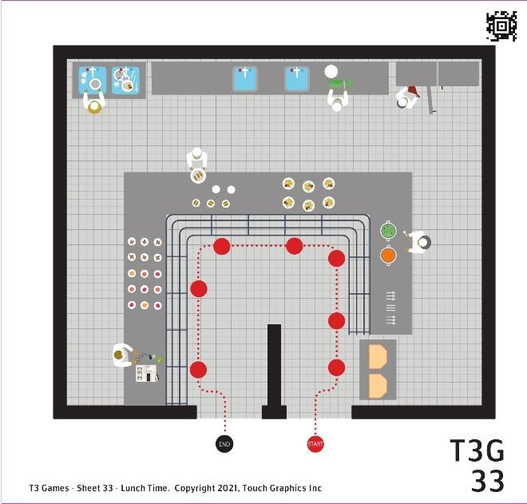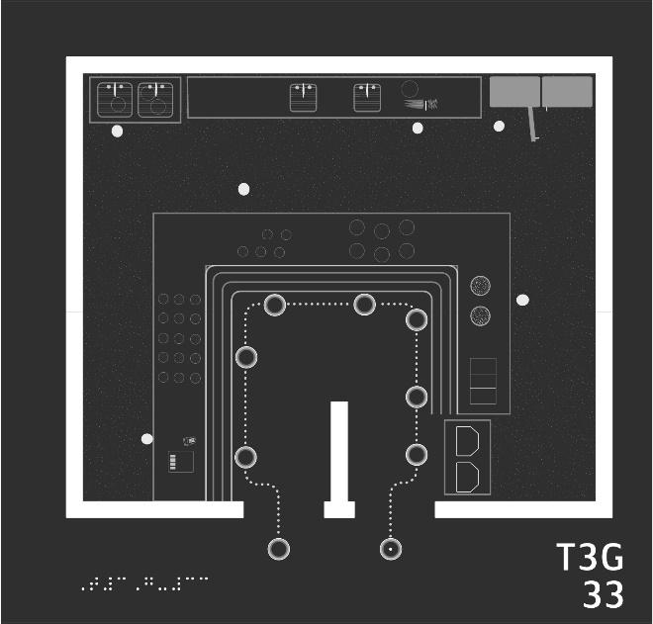

- Let's get in line! At the bottom of the sheet and toward the right, you'll find a circle with a dot in it at the end of a dotted line. Press and hold this starting circle for one second.
- You'll need a tray to put your food on. To find the trays, start at the circle with the dot in it. Follow the dotted line up until you reach another circle. Then press it!
- You'll also need some utensils. Step right up to the next circle along the dotted line to grab a knife and fork.
- The next station has two kinds of soup. Notice the two big pots on the counter! Press the next circle to choose your soup.
- Oops! You'll need a spoon to eat the soup! Go back one circle to the utensil station to grab a spoon.
- Let's grab some more food! Keep following the dotted cafeteria line. Skip past the soup circle and turn the corner to reach the next station.
- Slide on over to the next station on the left. I wonder what's being served there?
- What are all these plates on the counter? Follow the dotted line around the corner to snag a piece of dessert.
- Time to pay for all these goodies! Slide down the dotted line and press on the next circle to reach the cash register.
- Almost there! Follow the dotted line to the very last circle to get out of this cafeteria line.

33 To the Teacher LUNCH TIME

Sheet Description and Objectives
This maze sheet shows a top-down view of a cafeteria. The stations in the cafeteria line are shown. The starting point (circle with a dot inside) is at the bottom of the page. Trays, utensils, food options and other details are shown along the path of the line.

Given understanding of areas, lines, shapes, and textures in a tactile graphic and using right/left/top/bottom orientation, the student will trace lines and find shapes to complete a maze using a map of a cafeteria.

Vocabulary
Path, dotted line, follow, left,right, up, down, top, bottom. Setting: cafeteria, counter, tray, utensils, cash register, etc.

Teaching Strategies
- Get oriented to the maze, what does the title tell us about the graphic?
- This maze has dotted lines with circle stopping points. Student could preview the path.
- It may help the student to preview that the instructions for these pages will be a series of steps to take. There is a starting point, a continuous path to follow, and an ending point.
- There are lots of details on this cafeteria map, including people doing actions like washing dishes. Encourage the student to explore and find new details.
- You could talk about what you find on the perimeter of the graphic and on the interior or inside.

34 Steps FOOD SHOPPING Steps
Level: Advanced

Welcome to T3 Mart! This maze will take you through a grocery store, following the dotted path. You can also explore objects that are off the path at any time by pressing on them! There are 9 steps on this sheet, worth 9 points. Explore the graphic with both hands. Press on any shape with one finger to hear its description. Swipe to the right to play.

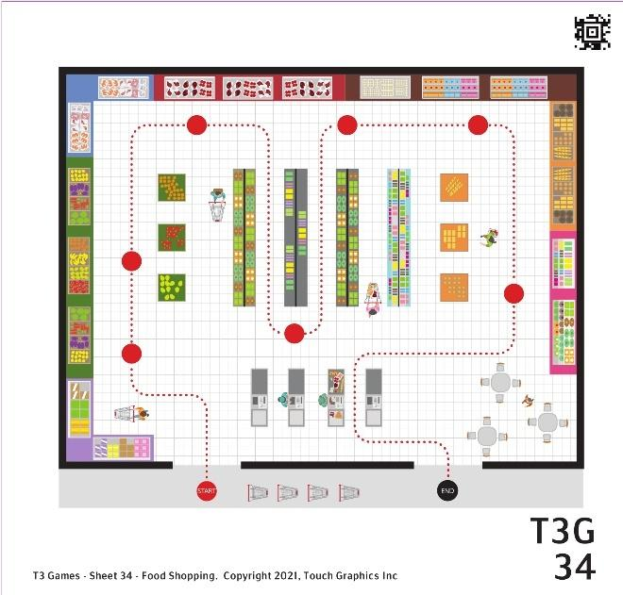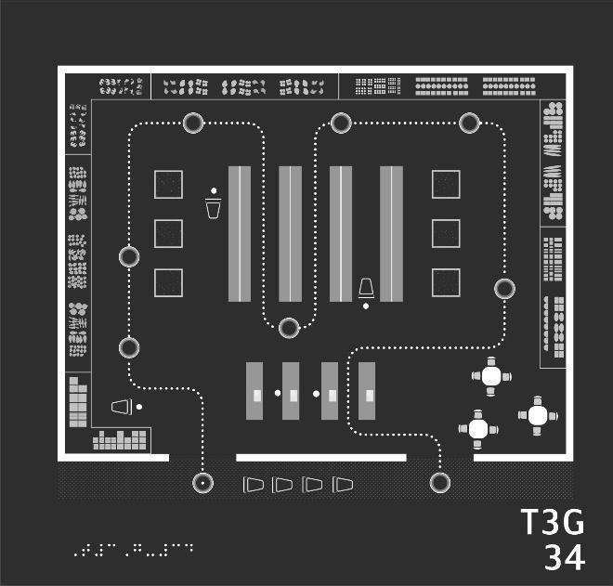

- Let's head inside. Along the bottom of the sheet is a gravelly sidewalk. Move your finger from left to right on the sidewalk until you find a circle with a dot in it, which marks the entrance to the store. Press and hold on that circle!
- Follow the dotted line up and into the store. There's a shopper on your left, pushing her cart. Keep going past her until you reach the next circle. Then, press on it.
- Let's pick up some items for a picnic with friends. Follow the dotted line up to the next circle to shop for produce.
- Meat and seafood is near the top of the sheet. Keep following the dotted line up and around the corner to press on the next circle.
- We should check out the aisles of dry goods. Follow the dotted line down the sheet as it weaves between aisles. Can you find our next stop?
- Maybe we can make cookies for the picnic. The next aisle should have supplies for baking. Trace the dotted path up through the next aisle, until you reach the next circle.
- Move your finger up and to the right, along the counters at the top of the sheet. There are tiny bumpy eggs, and next to them, milk, cheese, and butter. Would any of these be useful? Press the next circle on to find out.
- We've almost explored the whole store. Follow the dotted path around the corner and down to the next stop.
- Time to check out! Trace the path left, past the food court, and down through the check out. Can you find the final circle?

34 To the Teacher FOOD SHOPPING

Sheet Description and Objectives
This maze sheet shows a top-down view of a grocery store. Aisles in the store are shown. The starting point (circle with a dot inside) is at the bottom left of the page. Sections of the grocery store like produce, dairy and baking are shown along the path that winds around the perimeter and through aisles.

Given understanding of lines, areas, shapes, and textures in a tactile graphic and using right/left/top/bottom orientation, the student will trace lines and find shapes to complete a maze using a map of a grocery store.

Vocabulary
Path, dotted line, trace, follow, left,right, up, down, top, bottom. Setting: grocery store, aisles, carts, produce, bakery, etc.

Teaching Strategies
- Get oriented to the maze, what does the title tell us about the graphic?
- This maze has dotted lines with circle stopping points. Student could preview the path.
- It may help the student to preview that the instructions for these pages will be a series of steps to take. There is a starting point, a continuous path to follow, and an ending point.
- Student can explore in a systematic way. For instance, going around the perimeter of the store to find meat, dairy, and produce sections.
- Has the student ever seen a map of a grocery store? What do they notice?

35 Steps CATCHING A FLIGHT Steps
Level: Expert

T3 Airlines is now boarding! Can you navigate the airport to catch your flight? Complete this maze by following the dotted line from circle to circle. You can also explore objects that are off the path at any time by pressing on them! There are 9 steps on this sheet, worth 9 points. Explore the graphic with both hands. Press on any shape with one finger to hear its description. Swipe to the right to play.

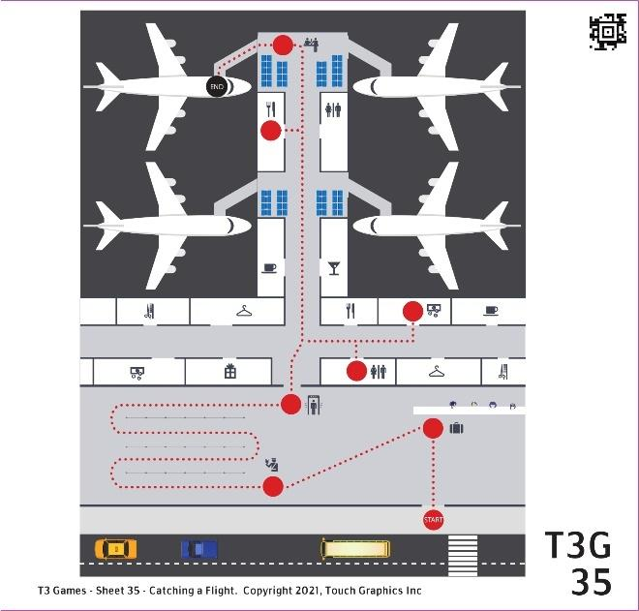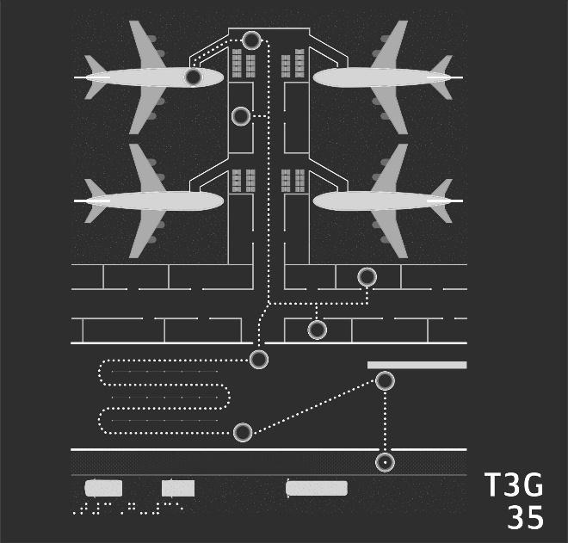

- Let's find the entrance to the airport. Across the bottom of the sheet, you'll find a gravelly street full of cars and, above it, a rough concrete sidewalk. Move your finger from left to right over the sidewalk until you find a circle with a dot in it. Press the circle!
- Next, let's check in at the ticket counter. Begin at the airport entrance, at the circle with the dot in it. Slide your finger up along the dotted line. Can you find the next circle, and press on it?
- Time to get in line for the security check. Follow the dotted line down and to the left and press on the next circle.
- Oh no, this security line seems endless! Weave your way back and forth through the long, dotted line, until you find the next circle.
- Let's find the restroom. Follow the dotted line up until it splits into two. Take the path to the right. Then, move your finger down to find a circle on the restroom.
- Your friend lives in a country that uses different currency. The currency exchange is up and to the right from the bathroom. Can you follow the dotted line and find the circle there?
- You have a bit of time before your plane departs. Let's grab lunch. Trace the dotted line left, back to the center of the airport. Follow the line up, past shops and other gates, until you find a circle in the food court on your left.
- Your gate is at the very end of the hall. Trace the dotted line up to the very end of the terminal to find the circle.
- It's finally time to board! Grab your luggage and trace the dotted line to the left, over the jet bridge and onto the plane.

35 To the Teacher CATCHING A FLIGHT

Sheet Description and Objectives
This maze sheet shows a bird’s eye view of an airport. Areas within the airport, boarding gates, and airplanes are shown. The starting point (circle with a dot inside) is at the bottom right of the page. Areas like the ticket counter, security check, and food court are shown along the path that winds through the airport and to the gates and airplanes.

Given understanding of areas, lines, shapes, and textures in a tactile graphic and using right/left/top/bottom orientation, the student will trace lines and find shapes to complete a maze using a map of an airport.

Vocabulary
Path, dotted line, trace, follow, left,right, up, down, top, bottom. Setting: airport, ticket counter, luggage, boarding, security, etc.

Teaching Strategies
- Get oriented to the maze, what does the title tell us about the graphic?
- This maze has dotted lines with circle stopping points. Student could preview the path.
- It may help the student to preview that the instructions for these pages will be a series of steps to take. There is a starting point, a continuous path to follow, and an ending point.
- This path on this sheet has more turns and requires backtracking. The student will need to listen carefully to the instructions.

Module 8 STEM Applications Introduction

Description and Activities
The sheets in Module 8 represent graphics used in academic materials. They incorporate the graphic elements that the student has studied throughout the T3 activities. Sheets include the life cycle of a butterfly, scaled comparison of planets, water cycle, map of the United States, and a human skeleton. The information on these sheets is more dense. There is more braille labeling in these graphics.

These sheets require the student to incorporate all their skills. They have been encouraged throughout the T3 activities to always get the big picture first. That is especially important in order to understand these STEM graphics. Students will need to find the title and notice how the information is presented. Students will find different areas on the graphics and discover what they represent. Curiosity is often piqued as students uncover new details and information about a topic presented in the graphic. With these sheets, the student is no longer just learning to read a graphic, they are reading a graphic to learn.

Why this is Important
Scientific content and principles are often communicated through diagrams, graphs, and data visualizations. A student synthesizes information from a diagram by analyzing details, labels, symbols, and patterns. They make comparisons, draw connections to prior knowledge, and integrate details to form a comprehensive understanding. Through this process, the student extracts meaningful insights and conclusions from the tactile representation.

36 Questions BUTTERFLY LIFE CYCLE
Level: Novice

This sheet shows a butterfly life cycle. There are 16 questions on this sheet, worth a total of 18 points. Explore the graphic with both hands. Press on any shape with one finger to hear its description. Press the braille labels at any time to hear them aloud. Swipe to the right when you are ready to play the game.

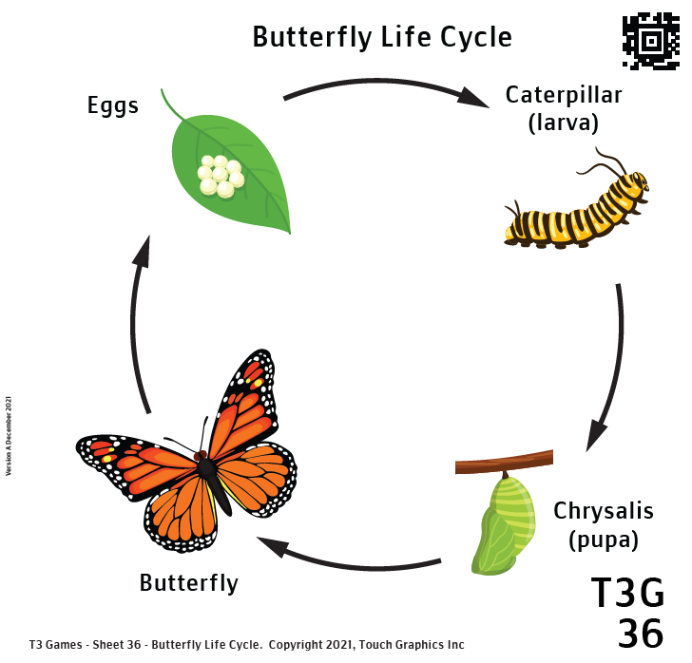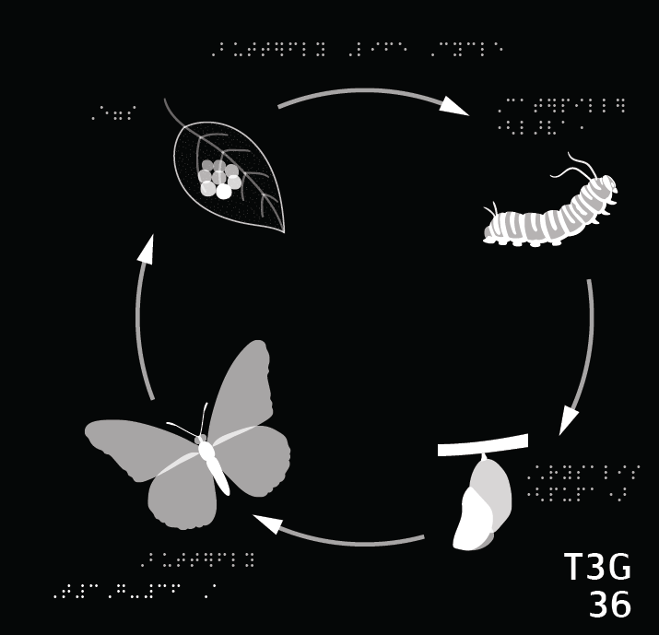

- This sheet shows a diagram like you might encounter in science class. Find the title at the top center of the diagram. Press and hold on it with one finger for one second.
- A butterfly's life has four stages. Let's start with stage one. In the top left corner, there is a teardrop-shaped leaf with butterfly eggs on it. Can you press it?
- A cluster of many eggs sits in the middle of this leaf. Can you find it?
- On this sheet, you'll find braille labels for each of the four life stages. Can you find the braille label for this first stage?
- There is a long curved arrow to the right of the leaf, pointing right to the next stage. Can you press on the arrow?
- What is the next form that the butterfly takes in its life? Follow the arrow to the right of the leaf and eggs to find out. Press on the creature you find there.
- Can you find and press on the two long strands at one end of the caterpillar? What could these be?
- Let's keep going through the life cycle. Follow the next arrow to find the next stage of butterfly development.
- In this illustration, the chrysalis is hanging from a short twig. Where is the twig in the picture?
- Feel the chrysalis hanging from the twig. What do you think a real chrysalis would feel like? Press it to find out.
- Onto the next stage. An adult butterfly emerges from the case! Follow the arrow to the left and press on the adult butterfly you find there.
- This butterfly is symmetrical. It has a left wing and a right wing. Press on each wing.
- Can you find the antennae connected to the butterfly's head?
- Like other insects, the body of the butterfly is comprised of three parts: a head, a thorax, and an abdomen. Can you find the abdomen on the body of this butterfly?
- Butterflies have a distinctive shape. Each wing is subdivided into a fore and hind wing. Can you press on the fore and hind wings on the left side of the butterfly?
- There is one more arrow in this diagram, which completes the cycle. Follow that arrow. Where does it take you?

36 To the Teacher BUTTERFLY LIFE CYCLE

Sheet Description and Objectives
This sheet shows a diagram of the life cycle of a butterfly. The four stages are represented with arrows connecting them in a circle. The sheet has a title and labels.

Using a tactile graphic of a life science diagram, student will use left/right and circular orientation and follow arrows to find labels, areas, shapes, lines, and textures, read labels, explore details, and gain an understanding of the life cycle of a butterfly.

Vocabulary
Eggs, caterpillar (larva), chrysalis (pupa), butterfly, metamorphosis, tentacles, antennae, thorax, abdomen, fore wing, hind wing, symmetrical

Teaching Strategies
- These tactile graphics are academic diagrams and student will need to get an overview that includes noting title and where labels are.
- Does student notice the general layout of circular diagram? Science diagrams may show a process, so it is important to pay attention to the sequence that may be indicated with arrows.
- Symmetrical is an important concept. It can be reinforced through motion also; have student use both hands to trace the outline of each side of the butterfly at the same time and notice the symmetrical motion of the fingers.
- Does the student recognize the leaf and remember exploring the leaves on Sheet 11?
- Ask student questions about the sequence. Can the student retell the process while looking at the graphics using words like, first, next, then, finally, etc.
- What experience does a student have with butterflies or caterpillars? Tactile graphics are great to represent things that may be too delicate to touch like the wings of a butterfly.

37 Questions PLANETS
Level: Beginner

This sheet shows the scaled distances of orbits and scaled size comparisons of the planets. There are 18 questions on this sheet, worth a total of 25 points. Explore the graphic with both hands. Press on any shape with one finger to hear its description. Press the braille labels at any time to hear them aloud. Swipe to the right when you are ready to play the game.

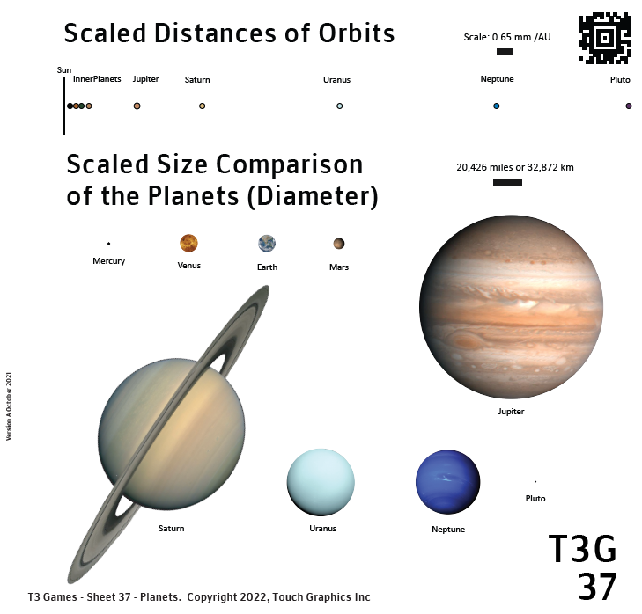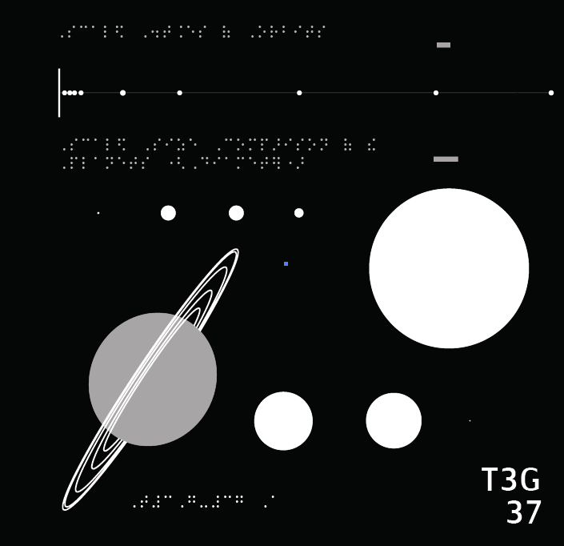

- There are two diagrams on this sheet, one at the top and another below it. Each diagram has a title. Find the title at the top of the first diagram and press it with one finger for one second.
- This first diagram consists of a horizontal line with dots along it. Find the diagram below its title and press the diagram to hear more.
- These dots representing the planets are clearly much smaller than their real counterparts. We need to know the scale of this diagram. Find the horizontal bar to the right of the title and press on it.
- Let's return to the diagram at hand. Can you find the vertical line representing the location of the sun at the far left side of the diagram?
- The four "inner planets" orbit closest to the sun. Can you find this group of planets on the number line and press on them?
- The fifth closest planet to the sun is Jupiter. Where is Jupiter in this diagram?
- The next closest planet is Saturn. How many astronomical units away from the sun is Saturn? Use the scale bar to make a guess, then press Saturn to find out.
- Of all the astronomical objects on this diagram, which is farthest from the sun?
- The first diagram shows the scaled distances of orbits. What does the second diagram show? Find the title of the second diagram below the first diagram, then press it to find out more.
- Once again, we'll need a scale to comprehend the diagram. Press the horizontal bar representing the scale to the right of the title.
- Below the title are images of planets, varying in size, organized in two rows. They are ordered from left to right, top to bottom, based on their distance from the sun. Press on each of the five planets in the first row; that is, the five planets that orbit closest to the sun.
- Feel the image of the Earth, the third planet in this row. How wide is its diameter? Press the Earth to hear the answer. Hint: press the scale if you need a reminder of the distance it represents.
- There are four more planets in the second row of this diagram. Can you find all four and press on each one?
- Now that you've explored the whole diagram, let's answer some questions about the sizes of astronomical objects. Which object in this diagram is the smallest? Press on it.
- Press on the largest planet in this diagram.
- Which planet is most similar in size to Earth?
- Which of the four "inner planets" closest to the sun is the smallest in diameter?
- Finally, where are Saturn's rings?

37 To the Teacher PLANETS

Sheet Description and Objectives
This sheet shows two diagrams, the scaled distance of orbits and the scaled size comparison of planets. The distances are laid out on a horizontal line at the top of the page. The various sized planets are arranged on the rest of the page. There are scale indicators.

Using a tactile graphic of an astronomy diagram, student will compare size and distance, and gain an understanding of the distances and size of the planets in our solar system.

Vocabulary
Horizontal and vertical lines, scale, astronomical unit, inner/outer planets, diameter

Teaching Strategies
- This sheet is unique in that there are two diagrams on one page. Student will need to understand that when getting an overview of the sheet.
- Explore ways the student can use the scale bar to measure the distance between points. Student may be able to use fingertip to move the “bar’s length” in movements or hops. A different unit marker like the narrow side of a paperclip could be used.
- To measure counting increments, two hands can be used to feel the ending and starting points of each motion.
- Reinforce that using the scale to estimate distance this way only provides rough guess, not a precise measurement. Actual distance could be obtained other ways such from a text book or looking it up online.

38 Questions WATER CYCLE
Level: Intermediate

This sheet shows the water cycle. It depicts a nature scene, annotated with arrows and braille labels to show the movement of water. There are 15 questions on this sheet, worth a total of 15 points. Explore the graphic with both hands. Press on any shape with one finger to hear its description. Press the braille labels at any time to hear them aloud. Swipe to the right when you are ready to play the game.

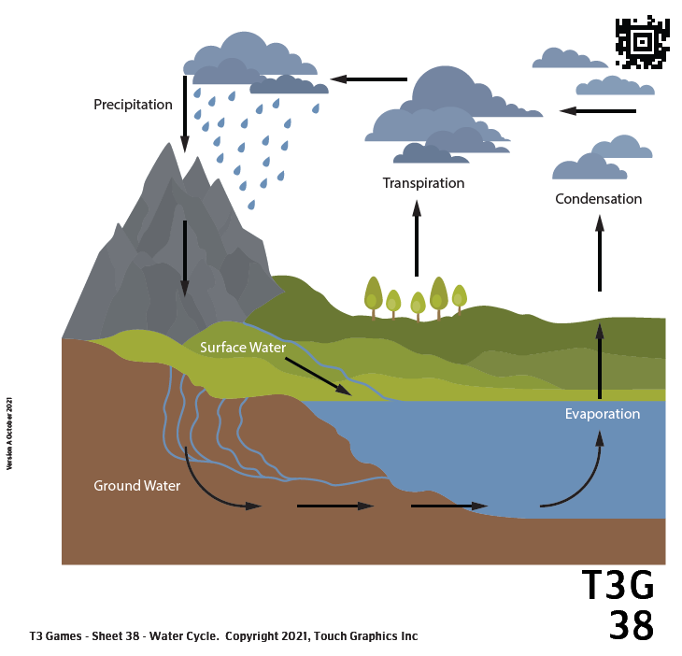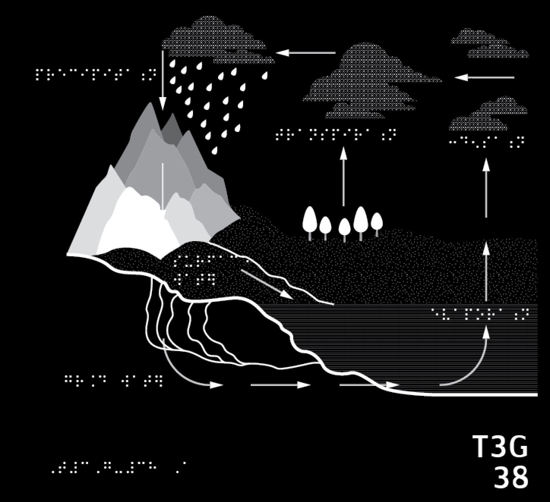

- This is a detailed diagram of the water cycle. Before we delve into the steps of the water cycle, let's get the lay of the land. At the top, there are clumps of clouds in the sky with a lightly dotted texture. Can you find a cloud and press and hold on it with one finger for about one second?
- On the left, a smooth mountain range juts up toward the clouds. Find it and press on one of the mountains.
- Below and to the right of the mountains is a strip of rough-textured grass, stretching toward the far right of the sheet. Can you find this grass?
- Can you find a thin stream of water running through the grass?
- In the middle of the scene, rising up from the grass, is a grove of five small, teardrop-shaped trees. Press on the trees when you find them.
- Below the rough grass, near the bottom right, is a wide body of water, represented with a fine horizontal striped or ribbed texture. Find this body of water.
- We're almost done exploring the scene. There is a wiggly line separating the aboveground area (that is, the mountains, the grass, and the body of water), from the smooth area representing below ground. Find this smooth underground area.
- Rivulets of water flow underground, underneath the grassy area and into the body of water on the right. Find and press them to complete our exploration of this scene.
- Now that we have explored the scene, let's learn about the movement of water, shown by the arrows. Notice the arrows pointing up from the body of water. These represent evaporation. Press the body of water to find out more about evaporation.
- Some water also evaporates from plants. This process is called transpiration. In this diagram, transpiration is represented by the arrow rising from the grove of trees. Press on the trees to hear more.
- The water vapor that results from evaporation and transpiration rises into the atmosphere and condenses into clouds. Follow the arrows up until you find a cloud, then press the cloud to hear about condensation.
- Follow the arrows showing the transportation of clouds through the atmosphere. Eventually, you will find precipitation: raindrops falling from a cloud, back toward the earth. Press these raindrops to hear more about precipitation.
- Follow the arrow pointing down, showing the path of the rain. Notice the stream which takes the fallen water down from the mountain and to the right, over the grassy ground, back into the large body of water. Press on this stream to learn more about surface water.
- Below ground, many streams of water also flow. Press on one of these streams to hear about ground water.
- Follow the path of the groundwater arrows back to the body of water. Press on that water to complete the cycle.

38 To the Teacher WATER CYCLE

Sheet Description and Objectives
This sheet shows several stages in the water cycle. Environmental features like land, surface water, and clouds are represented. There are labels for the processes and arrows leading to the next stage. The sequence follows a counter clockwise motion.

Using a tactile graphic of an environmental science diagram, student will use left/right and circular orientation and follow arrows to find areas, shapes, lines, and textures, read labels, explore details, and gain an understanding of the water cycle.

Vocabulary
Arrows, light texture, smooth, mountains, stream, grove of trees, vegetation, pear shaped, horizontal striped or ribbed texture, rivulets, evaporation, transpiration, condensation, precipitation, runoff, rain

Teaching Strategies
- Unlike the previous diagram showing a sequence which had a distinct picture for each stage, this diagram adds arrows and labels to a large picture of a landscape with hills, mountains, lake, and sky. The student should get oriented to the whole picture.
- The rough grass and ribbed texture can feel similar if you move your finger up and down on each. If you move left and right parallel to the horizontal lines representing water, that unique texture is more obvious. Left and right with a fingernail also clarifies that striped texture.

39 Questions UNITED STATES MAP
Level: Advanced

This is a map of the mainland United States. There are 26 questions on this sheet, worth a total of 32 points. Explore the graphic with both hands. Press on any shape with one finger to hear its description. Swipe to the right when you are ready to play the game.

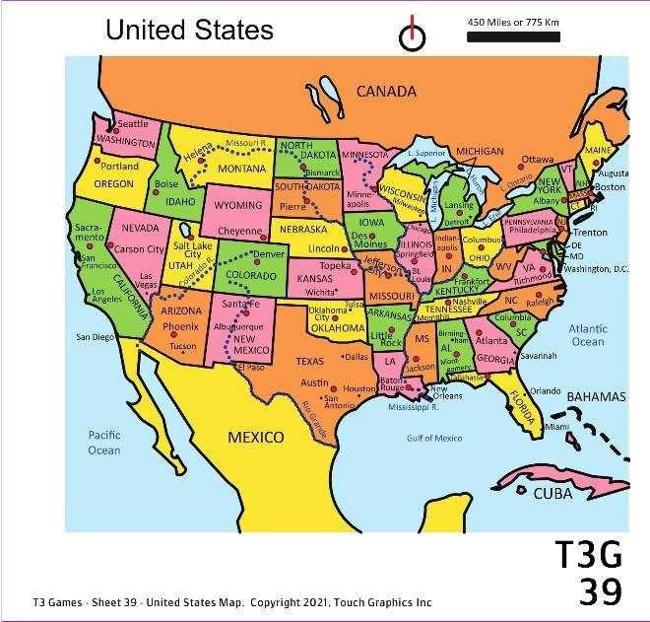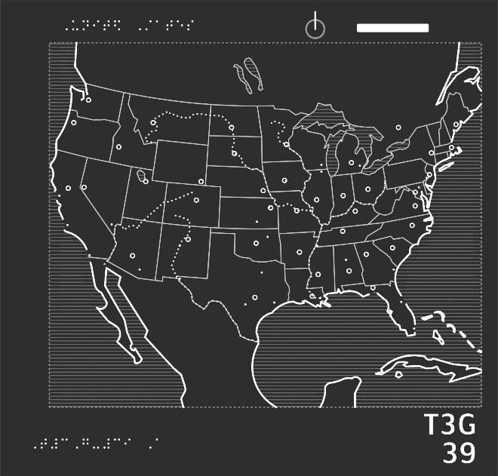

- Most of this sheet is covered by a large, rectangular map. Explore the textures and shapes of the map, then press on the map with one finger for one second to hear about it.
- At the top of the sheet are some tools for interpreting the map. The horizontal bar in the top right corner represents the scale of the map. Can you find the bar and press on it?
- At the top of the sheet, there is also an arrow, which points toward the top of the sheet. This is the compass rose. Please press on it.
- Let's explore the map. At the center is the United States of America. Press on it.
- On this map, bodies of water have a horizontal ribbed or striped texture. The water on the west, or left, side of the map is the Pacific Ocean. Can you find it?
- Now find the Atlantic Ocean, which is on the east, or right, side of the map.
- Canada is north of the mainland US. Can you find Canada on this map?
- Now, can you find Mexico, which is south of, or below, the mainland US?
- On this map, capital cities are shown with large dots. Can you find the capital of Mexico, near the bottom of the sheet?
- The states that border the Pacific Ocean form the west coast of the US. Trace the west coast, then press it to learn more.
- Of the three states that form the west coast, which is the biggest?
- On this map, non-capital cities are shown with small, pointy dots. Can you find three cities in California, along the west coast?
- Let's cross the country and find the east coast of the US, the states that border the Atlantic Ocean.
- Let's go to Florida! Trace the east coast all the way down. Press the thumb-shaped state at the very south end.
- Let's go to Maine! Trace the east coast all the way up. Press the state you find at the very north end, just below Canada.
- It's cold up here! Let's go to the southern border instead. Find the border between the US and Mexico, toward the bottom of the sheet.
- On this map, dotted lines represent rivers. You may have noticed a dotted line along the southern border. This is the Rio Grande. Press it!
- Texas isn't just the largest state on the southern border. It's the largest state in the entire mainland US! Can you find it?
- Where's the capital of Texas?
- There's one river on this map that is west, or left, of the Rio Grande. What is it?
- The Colorado River extends from Colorado down to Mexico. Can you trace the river north to its beginning, to find the state of Colorado?
- As the Colorado River flows west out of Colorado, it passes through the state of Utah. You can recognize Utah by the oval shape in its northwest corner. This is Great Salt Lake. Can you find it?
- We've explored the west, east, and southern borders. Now, can you find the northern border, where the United States touch Canada?
- Here's a challenge: can you find all five Great Lakes, at the border between Canada and the US? Look for the horizontally ribbed water texture.
- West (or left) of the Great Lakes, the Mississippi River travels from the northern border all the way down to the Atlantic Ocean. Can you find the Mississippi River?
- Last question: The Mississippi River empties out into the ocean at the Gulf of Mexico. Trace the Mississippi River from the far north to the far south, then press on the body of water below.

39 To the Teacher UNITED STATES MAP

Sheet Description and Objectives
This sheet is a map of the United States surrounded by Canada, Mexico and oceans. At the top are two map tools, a compass rose and a scale indicator. Countries, states, major bodies of water, state capitals, and large cities have print and auditory labels.

The student will find areas and locations on a tactile map of the United States using left/right and cardinal direction orientation, trace lines types, distinguish similar symbols, and connect how symbol type reflects information (large cities vs. capital cities).

Vocabulary
Maps tools: scale, compass rose, bodies of water: lakes, rivers, oceans, gulfs, borders, horizontal ribbed or striped texture, north/south/east/west, capital cities

Teaching Strategies
- The student will need to get an overview. Finding areas of land and water which are differentiated by texture could be a starting point.
- Subtle tactile observation is needed on this page. Can the students distinguish the small, pointy dots of large cities compared to the large dots of capital cities? On the map, San Antonio and Houston show a large city and capital close together but in an open space so it would be a good spot to compare the tactile symbols. The capital dot feels slightly larger but it is also flat on top rather than pointy. Pulling a fingernail gently across the dots feels and sounds different.
- Student will have to follow river lines carefully as there are many solid lines and dots nearby that could make it tricky.
- Student could share where friends and family live and get help finding those countries, states and cities on the map.

40 Questions SKELETON
Level: Expert

This is a picture of a human skeleton. The bones are labeled in braille and print. Dotted lead lines connect the labels to the bones. There are 18 questions on this sheet, worth a total of 31 points. Explore the graphic with both hands. Press on any shape with one finger to hear its description. Press the labels at any time to hear them aloud. Swipe to the right when you are ready to play the game.

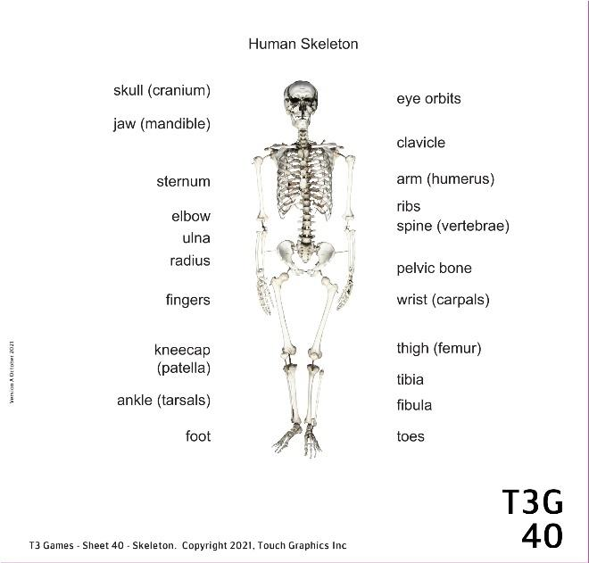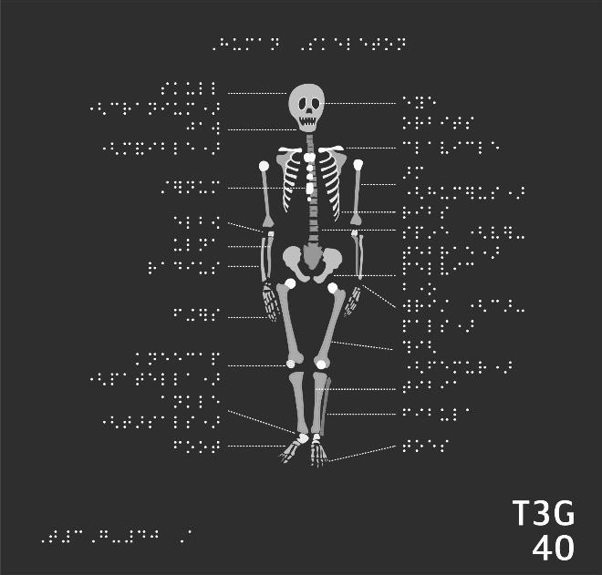

- This sheet shows a skeleton standing up. We'll explore it from head to toe! First, can you find the round head of the skeleton near the top of the sheet and press it for one second with one finger?
- There is a dotted line that connects to the top of the skull. It leads to a braille label on the left side of the sheet. Follow the line and press on the label.
- Can you find the holes where the eyes would be on this skull?
- Only one bone on this skull can move, and that's the lower jaw! It moves up and down when you talk. Find the jaw lined with pointy teeth near the bottom of the skull and press on it.
- Let's move on to the torso. The ribs are a group of long, curved bones that act like the bars of a cage, protecting your heart, lungs, and liver. Find this skeleton's ribs!
- At the front of the ribcage, in the center of the chest, is a long, tall bone called the sternum. Can you find the sternum on this skeleton?
- Your spine forms the bumpy column that runs from your neck all the way down your back. Can you find the skeleton's spine?
- Can you find the pelvic bone at the base of the spine, connected to the legs?
- The thigh bone in the upper leg is also known as the femur. Can you find both femurs on this skeleton?
- The kneecap is a small, rounded bone that protects your knee joint. Find both kneecaps.
- Follow the legs down to find two bony feet. Press on each foot. Notice: are they bumpy or smooth, simple or complicated?
- I've got some arm facts up my sleeve! The upper arm is made of one long, thin bone called the humerus. Can you find both upper arms on this sheet?
- The bones of your upper arm and forearm meet in the middle at the elbow. Can you press on each elbow on this sheet?
- This skeleton has its hands resting by its sides. Press on each hand. Does it remind you of any other body part on this sheet?
- Now that you're well acquainted with the skeleton, it's time for some challenges! What is the longest bone in the body? Hint: you have two of these bones. Press on both!
- Find the bones of the neck. What kinds of bones are these? Maybe a kind of bone we've already seen?
- The collarbone or clavicle is just below the neck, running horizontally from sternum to shoulder. Can you find a bone like that?
- Last challenge! Head, shoulders, knees, and toes: can you find them all?

40 To the Teacher SKELETON

Sheet Description and Objectives

This sheet shows a human skeleton from the front. There are lines connecting the bones to braille labels arranged in two columns to the left and right of the skeleton. Labels may be just the common name or just the scientific name. In other cases, bones may be labeled with the common name and the scientific name in parenthesis.

Using a tactile graphic of an academic diagram, student will explore areas, shapes and labels, compare features, and gain an understanding of the bones in the human skeleton.

Vocabulary
Label, skeleton, skull, torso, various bones

Teaching Strategies
- As always, an overview is important. With an understanding of the general layout of the information, the student will be more efficient at moving around graphic, answering questions, and learning.
- If needed, the student can be encouraged to trace label lines carefully to connect it to the correct bone on the graphic.

Appendix: List of Student Objectives

These objectives can be used as is or as starting points for writing your own goals and objectives. These objectives are written to contain several skills and may be broken down into more specific benchmarks. T3 Games provides a score at the end of each played game. Those scores can be used to track accuracy and plan supporting activities. Caution should be used so that accidental triggers that register as a mistake don’t reflect on a student’s skill level. Although the T3 can be used to track accuracy, observations with school curriculum should be used to get a full picture of a student’s strengths and areas of need. The use of tactile graphics is hopefully happening across a student’s day. Assessment and student goals may include use of graphics for academics and other uses (Orientation and Mobility, games, leisure activities like drawing, and curiosity about topics the student is interested in).

Students can be encouraged to repeat sheets and/or come back to them at a later date which will reinforce their understanding of the concepts and fine-tune the mechanics of reading the graphics. The T3 system allows the teacher to scaffold student learning and know that the student is building good habits and a solid foundation with tactile graphics.

Module 1 Elements

- Student will identify shapes, will find shapes by number of sides and corners, and use left/right orientation and row numbers to find elements.
- Student will identify shapes, will identify filled empty and textured shapes, will use left/right orientation and row numbers, and will match shapes and textures.
- Student will identify line types, use left/right top/bottom orientation, identify rows by number, and find matching lines.
- Student will identify several point symbols, find the same symbol in varied orientation, will navigate by row numbers, and will scan to find multiples of the same element.
- Student will distinguish multiple elements, including points, symbols, line types, textures, and fills to identify specific graphic representations of faces and will use details to interpret what emotion is implied.

Module 2 Variations
- Student will find subtle variations in line thickness and height, and will compare various dashed and dotted lines.
- Student will identify shapes of different sizes and will use row numbers and first/final for orientation.
- Student will identify several variations of arrows and determine direction they are pointing, will use left/right/up/down orientation, and will find horizontal/vertical arrows.
- Student will find subtle variations in texture, will find alike and different textures, will use vocabulary to describe dense, fine, sparse, coarse, rough, and will use row numbers and first/second for orientation.

- Student will find subtle variations in texture, will compare similar items and determine whether they match, and will use row numbers, left/right and first/second for orientation.

Module 3 Categories
- Student will identify complex line types that represent leaf edges such as toothed and lobed, use vocabulary to describe characteristics of leaves (and elements of tactile graphics), compare length and quantity, and will identify elements using concepts such as radiating from a single point and along a central line.
- Student will identify complex shapes, find rough and smooth textures, will use left/right/between and top/bottom orientation, will compare and contrast like representations (such as leaves) with unique details but still fit into one category
- Student will find large and small items, will compare salient features for similarities and differences, will identify directionality and which way a representation of a shark is facing.
- Student will compare and contrast complex graphic representations, will use right/left and top/bottom orientation, will identify salient features of group examples (antennae, six legs), will count lines and elements, will categorize information and apply that to a related example (find thorax on each insect).
- Student will find shapes, lines and tactile features as representations of bicycles, will identify similarities and differences between items in the same category, will use right/left and top/bottom orientation, will count elements, will recognize salient, common features of items in a group.

Module 4 Point-of-View
- Student will associate specific graphics with a braille label, use left/right/middle orientation, will explore representation of object from top, side and bottom views, will use descriptive words for textures and shapes, and will share how the salient features of a tactile graphic relates to their experience with those objects.
- Student will use top/bottom/left/right/middle orientation, will identify braille labels, will explore representation of object from top, side and bottom views, will use descriptive words for textures and shapes, will compare sizes and shapes.
- Student will use left/right orientation, will show understanding of different perspectives in 2D tactile images and identify top, bottom, and side views, will locate specific tactile details on tactile representation of a shoe and make connections to the real object, and use detailed language to label an object.
- Student will use left/right side, front/back, and top/bottom orientation related to a represented object, will use detailed vocabulary to describe features, will identify specific textures, will relate features in tactile graphic to their own experience with real and toy cars.
- Views are labeled. Many details and features of the turtle are explored.

Module 5 Zoom Out
- Student will use left/right side, front/back, and top/bottom orientation related to a represented object, will use detailed vocabulary to describe features, will identify specific textures.
- Student will demonstrate understanding of "zooming out," identify shapes and textures, and use left and right directions.
- Student will identify shapes and textures, use left/right directions, distinguish thick and thin lines, and find elements that are far and close.
- Student will identify shapes and textures, navigate page using left/right/top/bottom, trace an outline, find horizontal and vertical lines, and find corners.
- Student will identify shapes and textures, explore elements presented in an array, navigate page using left/right/top/bottom, use north/south/east/west orientation, follow horizontal and vertical streets, use directional corners (e.g., northwest).

Module 6 Maps
- Student will find title, follow lines, read a map key, find a compass indicator, distinguish texture, line types and shapes, use left/right and cardinal directions for orientation, and explore 3D artwork presented in 2D tactile representation.
- Student will follow lines, find the title and scale indicator, read a map key, find a compass rose, distinguish texture, line types and shapes, use left/right/top/bottom and cardinal directions for orientation, and compare sizes.
- Student will find the title and scale indicator, read a map key, find a compass rose, distinguish texture, line types and shapes, use left/right/top/bottom and cardinal directions for orientation, compare sizes (small/large, short/long), read map to determine directions from one point to another, and find street names.
- Student will read a map key, find compass rose, distinguish line types and shapes, use left/right/top/bottom and cardinal directions for orientation, compare sizes (big/small), and use details, street names and landmarks shown on map to plan follow directions from one point to another.
- Student will read a map key, find compass rose, distinguish line types and shapes, use left/right/top/bottom and cardinal directions for orientation, compare sizes (big/small), and use details, street names and landmarks shown on map to plan follow directions from one point to another.

Module 7 Mazes
- Given understanding of areas, lines, shapes, and textures in a tactile graphic and using right/left/top/bottom orientation, the student will trace lines and find shapes to complete a maze using a graphic of a baseball field.
- Given understanding of areas, lines, shapes, and textures in a tactile graphic and using right/left/top/bottom orientation, the student will trace lines and find shapes to complete a maze using a graphic of a treasure map.
- Given understanding of areas, lines, shapes, and textures in a tactile graphic and using right/left/top/bottom orientation, the student will trace lines and find shapes to complete a maze using a map of a cafeteria.
- Given understanding of lines, areas, shapes, and textures in a tactile graphic and using right/left/top/bottom orientation, the student will trace lines and find shapes to complete a maze using a map of a grocery store.
- Given understanding of lines, areas, shapes, and textures in a tactile graphic and using right/left/top/bottom orientation, the student will trace lines and find shapes to complete a maze using a map of a grocery store.
- Given understanding of areas, lines, shapes, and textures in a tactile graphic and using right/left/top/bottom orientation, the student will trace lines and find shapes to complete a maze using a map of an airport.

Module 8 STEM Applications
- Using a tactile graphic of a life science diagram, student will use left/right and circular orientation and follow arrows to find areas, shapes, lines, and textures, read labels, explore details, and gain an understanding of the life cycle of a butterfly.

- Using a tactile graphic of an astronomy diagram, student will compare size and distance, and gain an understanding of the distances and size of the planets in our solar system.

- Using a tactile graphic of an environmental science diagram, student will use left/right and circular orientation and follow arrows to find areas, shapes, lines, and textures, read labels, explore details, and gain an understanding of the water cycle.

- The student will find areas and locations on a tactile map of the United States using left/right and cardinal direction orientation, trace lines types, distinguish similar symbols, and connect how symbol type reflects information (large cities vs. capital cities).

- Using a tactile graphic of an academic diagram, student will explore areas, shapes and labels, compare features, and gain an understanding of the bones in the human skeleton.

